 **SUPPER**

**CALZONE**

**WAFFLE FRIES**

**PEARS**

**ITALIAN BAKED SANDWICH**

**CHIPS**

**MANDARIN ORANGES**

**CHICKEN CORDON BLEU**

**BROCCOLI & RICE CASSEROLE**

**STRAWBERRIES**

**TACO BOWL**

**(W/ MEAT, CHEESE,**

**REFIRED BEANS,**

**LETTUCE)**

**CHURRO**

**CHOPPED CHEESE SANDWICH**

**POTATO WEDGES**

**PEACHES**

**CALZONE**

**ITALIAN VEGETABLES**

**FRENCH FRIES**

**APPLESAUCE**

**TACO SALAD W/**

**TOPPINGS**

**PEARS**

**CHEESY MASHED POTATO**

**AND HAM BAKE**

**ROLL**

**STRAWBERRIES**

**PHILLY CHEESESTEAK**

**FRENCH FRIES**

**PEACHES**

**CHICKEN QUESADILLA**

**CORN**

**GRAPES**

**CHILI DOG**

**ONION RINGS**

**PEACHES**

**CHICKEN ALFREDO**

**BREADSTICK**

**PEAS**

**APPLESAUCE**

**DRUMSTICK**

**SCALLOPED POTATOES**

**CINNAMON APPLES**

**NO SCHOOL**

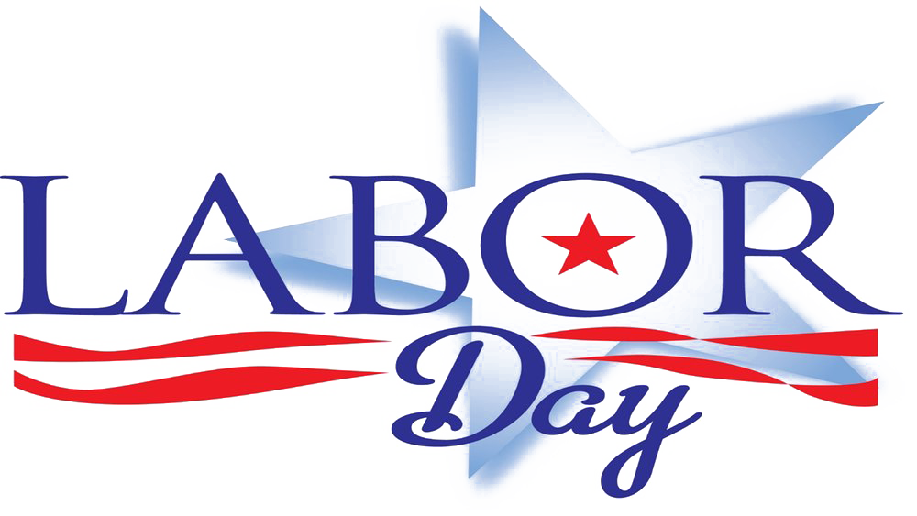

Questions????

Contact Cindy Rawie, Food Service Director Due to availability, substitutions to the menu may occur.

[crawie@kssdb.org](mailto:crawie@kssdb.org) This institution is an equal opportunity provider.

**SEPTEMBER 2024**

**KANSAS STATE SCHOOL FOR THE BLIND**

**SLOPPY JOE ON BUN**

**CHIPS**

**GREEN BEANS**

**PINEAPPLE**

**HOMESTYLE PIZZA**

**W/ MARINARA**

**MIXED VEGETABLES**

**STRAWBERRIES**

**LIL SMOKIES W/**

**MAC & CHEESE**

**PEAS**

**FRUIT COCKTAIL**