

**MINI STRAWBERRY BAGEL**

**CHEESY CHICKEN BURRITO**

**CORN**

**SPANISH RICE**

**PEARS**

**BREAKFAST PIZZA**

**CORN DOG**

**CHIPS**

**COLESLAW**

**MELON**

**BREAKFAST**

**ENCHILADAS**

**GRILLED CHICKEN SANDWICH**

**SCALLOPED POTATOES**

**STEAMED BROCCOLI**

**APPLESAUCE**

**OMELET**

**& HASHBROWNS**

**CHICKEN STRIPS**

**SWEET POTATO TOTS**

**GREEN BEANS**

**MELONS**

**FRENCH TOAST STICKS**

**VEGGIE PIZZA**

**FRENCH FRIES**

**MIXED VEGETABLES**

**TROPICAL FRUIT**

**MINI WAFFLES**

**SALISBURY STEAK/ROLL**

**MASHED POTATOES W/ GRAVY**

**PEAS**

**STRAWBERRIES**

**MINI WAFFLES**

**TURKEY CLUB WRAP**

**CHIPS**

**CUCUMBER AND RANCH**

**STRAWBERRIES**

**BISCUIT & GRAVY**

**PEPPERONI PIZZA**

**MIXED VEGETABLES**

**MIXED SALAD**

**PINEAPPLE**

**BREAKFAST BURRITO**

**CHICKEN FRIED STEAK/ROLL**

**MASHED POTATOES W/ GRAVY**

**MINI CORN COB**

**MANDARIN ORANGES**

**PANCAKE**

**QUESADILLA**

**REFRIED BEANS**

**CORN**

**PEACHES**

**BREAKFAST PIZZA**

**BEEF AND BROCCOLI**

**BROWN RICE**

**MIXED VEGETABLES**

**PEARS**

**EGG, BACON & TOAST**

**TILAPIA**

**ROASTED POTATOES**

**MINI CORN COB**

**CINNAMON APPLES**

**MINI FRENCH TOAST**

**BAKED CHICKEN**

**BAKED SWEET POTATO HALF**

**PEAS**

**PEARS**

**APPLE TURNOVER**

**ENCHILADAS**

**BLACK BEANS**

**MIXED VEGETABLES**

**MANDARIN ORANGES**

**PUMPKIN BREAD**

**& CHEESE OMELET**

**CHEESE PIZZA**

**CORN**

**FRENCH FRIES**

**STRAWBERRIES**

**BAGEL, EGG**

**& TURKEY SAUSAGE**

**HAM & CHEESE ON HOAGIE**

**CHIPS**

**CARROTS & RANCH**

**FRUIT COCKTAIL**

**BACON SCRAMBLE PIZZA**

**BEEF STROGANOFF BAKE**

**ROLL**

**BROCCOLI**

**TROPICAL FRUIT**

**SAUSAGE, EGG**

**& CHEESE BISCUIT**

**HAMBURGER ON BUN**

**WAFFLES FRIES**

**MIXED VEGETABLES**

**MANGOES**

**PANCAKE**

**ENCHILADAS**

**CORN**

**GRAPES**

**CHURRO**

Questions????

Contact Cindy Rawie, Food Service Director Due to availability, substitutions to the menu may occur.

[crawie@kssdb.org](mailto:crawie@kssdb.org) This institution is an equal opportunity provider.

**Served every day with breakfast:** Milk (Skim or 1%), Fruit and !00% Juice

**Offered every day with lunch:** Variety of additional

vegetables and fruits and Milk (Skim or 1%)

**SEPTEMBER 2024**

**KANSAS STATE SCHOOL FOR THE BLIND**

**NO SCHOOL**

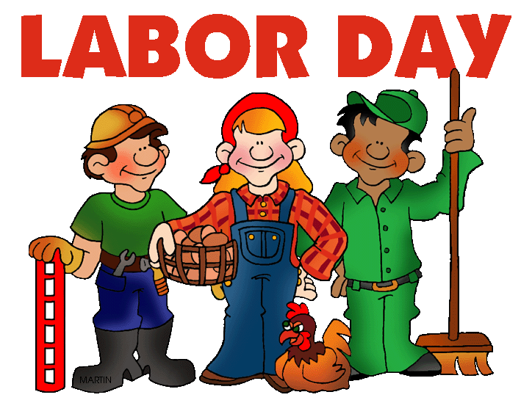

**CHOCOLATE CROISSANT**

**MEATBALL SUB**

**SCALLOPED POTATOES**

**GREEN BEANS**

**PEACHES**