Ignite the STEM Fire!
Schedule the Kansas State School for the Blind Mobile STEM Unit for an inclusive classroom event. We bring quality, hands-on, and interactive STEM activities which includes students who are blind or visually impaired. Using access technology and simple adaptations, ALL students have the opportunity to explore, analyze, & engage in trial and error investigations while experiencing the joy of discovery.
Activities are appropriate for 1st through 8th grade students.
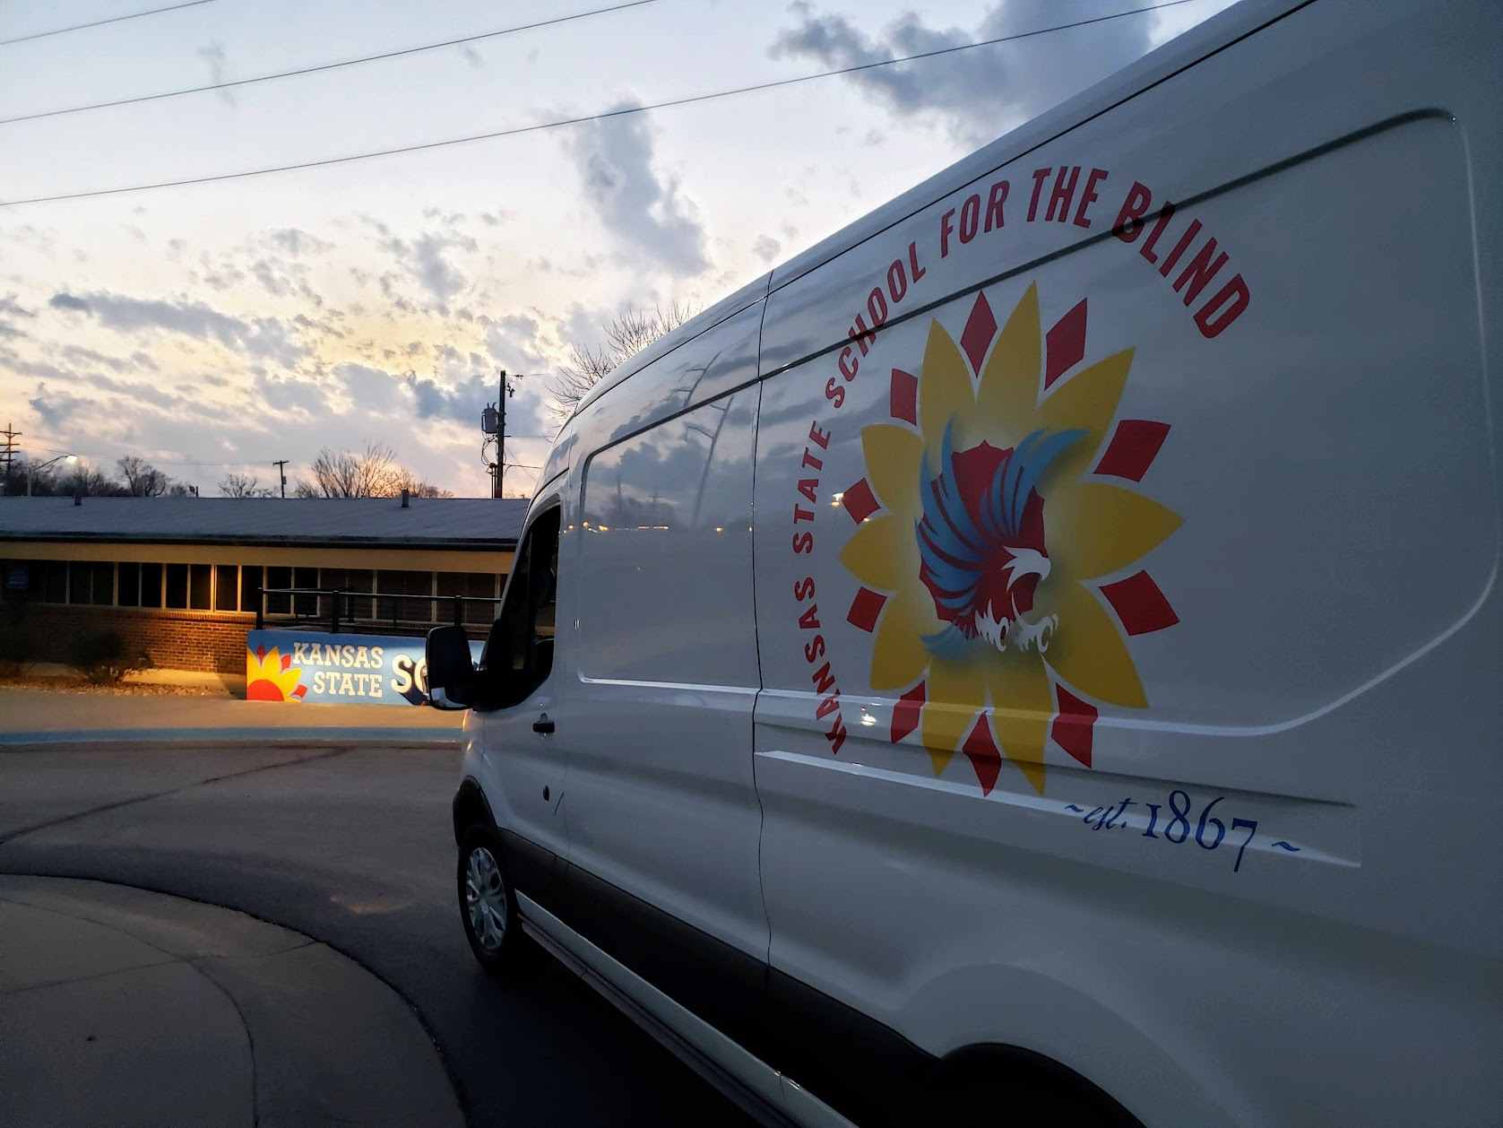

The goals for the KSSB Mobile STEM Unit are:
- Deliver Active, Learner-Centered Activities for Students in Kansas Communities
- Model Collaborative Teaming
- Create Pathways to Higher Learning
- Have Fun!
Depending on the space, grade level, and identified goals, the STEM Activities may include Cubelets, Sphero, Rube-Goldberg, OzBots, drones, maker space equipment, and accessible technology. If interested - please REGISTER HERE!
For questions about KSSB Mobile STEM Unit in your area, contact Lydia Knopp at lknopp@kssdb.org or Aundrayah Shermer at ashermer@kssdb.org.

