2021-2022 ANNUAL REPORT

KANSAS STATE SCHOOL FOR THE BLIND
Image: Teacher sitting on the floor with boy wearing glasses in her lap; the teacher is painting circles on a window and the boy is touching the circles with one hand and holding the paint brush with the teacher with the other hand.
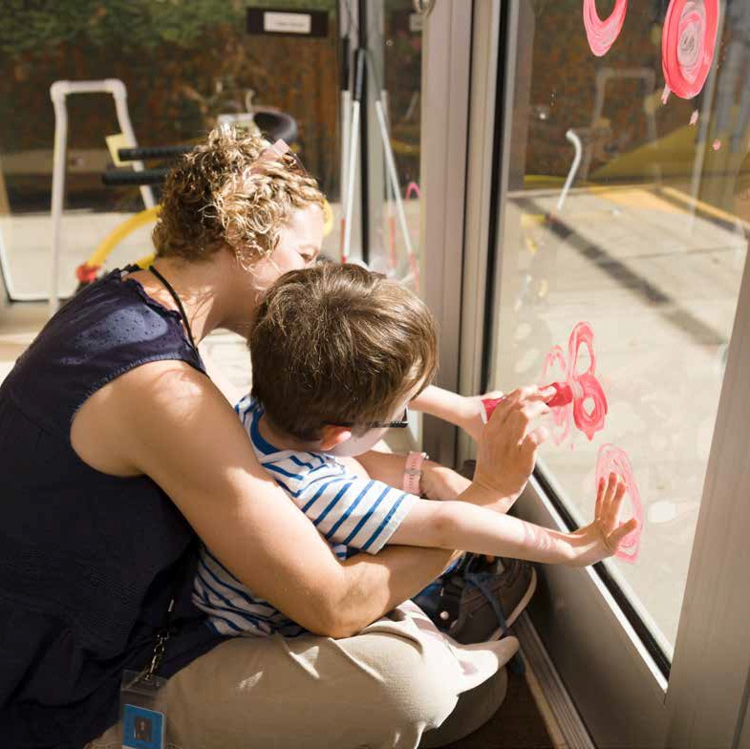

Letter from the Superintendent
Dear Friends,
Jon Harding, Ed.S. – Superintendent – Kansas State School for the Blind
The annual report presents an opportunity to reflect on the past year’s successes and challenges, the wins and the losses. Those of us who are fortunate enough to work at KSSB have an overwhelming sense of gratitude for the chance to help students define their dreams, build skills, and plan their future. We do not do this work alone, but rather in partnership alongside schools, businesses, and individuals who take the time to invest in youth who are blind in Kansas.
What sets KSSB apart are the highly skilled people who work here. We have over 80 employees who dedicate themselves, every day, to helping students succeed. KSSB reaches over 800 students in the state via our network of services. We have approximately fifty (50) students who attend our PreK-12 school program, and we serve nearly 100 students in our Extended School Year programs in June. The commitment to serving runs deep, and it can be felt in our hallways, in our classrooms, and in our interactions with one another.
As an innovative agency, we are particularly excited about our projects and activities related to STEM. One example is a collaboration with the STEMIE Center, resulting in two video demonstrations on engaging young children with visual impairments in storybook conversations. For older students, our campus Makerspace and Mobile STEM Unit provide hands-on learning experiences with high-tech equipment, coding tools, and games that promote design thinking. Our Microsoft TEALS online computer science course offers students who are blind or low vision accessible content, using Python as the core coding language.
Our signature events like the Braille Celebrations, the Vision Symposium, Extended School Year, White Cane Day, Low Vision Clinics, CVI classes, and Family Forum bring together teachers, parents, and students in meaningful dialogue, engagement, and learning that is not available elsewhere in our state.
KSSB has outstanding support from the KC Blind All-Stars (KCBAS), a non-profit organization that has leveraged community support to improve our programs, services, and facilities. KCBAS has helped KSSB secure a new playground, provided student scholarships, funded student trips to Space Camp, contributed to our Extended School Year Program, and pays for staff recognitions. KCBAS is focusing on fundraising for a new gym and track repairs for the next few years. We are so fortunate to have this ten-member board in our corner.
With skilled staff, strong partnerships, and community support we know the best days are ahead for KSSB. We invite you to visit our campus or volunteer on one of our committees to see, and feel, the positive energy and impact we have on Kansas students who are blind or visually impaired!
Jon Harding

Who We Are | Our Services
Since 1867, KSSB has opened its doors to students from across the state who need specialized instruction in braille, independent living, vocational skills, mobility, and academics. While we still maintain a vibrant campus as the hub of our school, we can now deliver many of these specialized skills to students in their home schools and communities. KSSB Field Services specialists can visit students’ homes and schools to provide instruction, administer assessments, or to partner with regular and special education teachers. We also offer remote instruction for those students who prefer learning at a distance or who are unable to receive help in more traditional ways. KSSB is ready to serve today’s students who are blind or have low vision, regardless of location.
Even if a student who is blind never steps foot on our campus, they are likely to receive a service or product from KSSB that helps them along their journey to independence. As examples: our Low Vision Clinics are offered across the state; we offer braille and accessible instructional materials to students in their home schools via the Kansas Instructional Resource Center; and our Mobile STEM Unit is offered to all 286 school districts in Kansas. Looking ahead, we intend to expand remote instruction in braille, technology, and low vision skills for students who do not have access to a vision teacher in their home school.

Number of Students Served
- 1200 students served throughout the year
- 45+ students served daily on campus
- 27 dormitory students
- 800 served by Field Services
Our vision to “provide the right help, at the right time, in the right location” is lived out daily and delivered by our highly qualified vision teachers, braillists, and orientation and mobility specialists. Sixteen Field Service specialists, placed in Western, South Central, North Central, Southeast, and the Northeast regions of the state provide local support to schools, teachers, and families. Services provided include assessment, braille instruction, cane travel instruction, Low Vision Clinics and STEM workshops. For students who do not attend KSSB daily, we sponsor weekend events, extended school year options, and special activities including the Braille Challenge Regionals in Kansas City and Wichita.

Counties Served
Image: A map of Kansas with counties labeled by color based on the 2018 population. Fifty-six counties are labeled with colored circles. The colors represent the number of students who participated in KSSB activities.
- Population of 91,000 - 10,100,000 the count of students served in the following counties: Johnson (100), Sedgwick (150), Shawnee (193), Wyandotte (50), Douglas (50).
- Population of 36,800 - 91,000 the count of students served in the following counties: Finney & Reno (193), Butler (100), Saline (150), Riley (1), Leavenworth & Crawford (50)
- Population of 36,800 - 9,060 the count of students served in the following counties: Cherokee, Jackson, Labette, McPherson (80); Cowley, Rice, Harvey (60), Dickinson, Ford, Montgomery (40); Atchison, Barton, Ellis, Marion, Marshall, Nemaha, Pottawatomie, Seward, Sumner (20); Allen, Bourbon, Brown,, Geary, Osage, Pratt, Linn, Lyon, Miami, Neosho (>1)
- Population of 9,060 - 75 the count of students served in the following counties: Clay (80); Republic (60); Washington (40), Chautauqua, Clark, Coffey, Meade (20), Doniphan, Ellsworth, Hodgeman, Lincoln, Norton, Ottawa, Phillips, Wabaunsee (>1)

Total Number of Direct Services to Students
- Assessment (35)
- IEP Meeting (82)
- Consultation (139)
- Direct Instruction (1171)

Total Hours of Direct Services to Students (by age group)
- 348: Kindergarten to 5th grade
- 319: 6th – 8th grade
- 171: 9th – 12th grade
- 123: Birth – 2 years
- 79: 3 – 5 years

Total Number of Services Provided
- 1427 Direct Services
- 401 Technical Services
- 117 Expanding Our Reach
- 53 Signature Events
- 10 COP Facilitation

Our People | Professional Development
With over 22 TSVIs and COMS and 11 additional staff who are licensed in other areas of teaching, KSSB has an incredible amount of talent and expertise at our disposal. Certified teachers on campus provide daily instruction to our students in core academic subjects and the Expanded Core Curriculum. In addition to our campus teaching staff, KSSB also employs a Social Worker, a Physical Therapist, an Occupational Therapist, a Speech Language Therapist, Music Therapists, and licensed Nurses.
Our Regional Field Services team offers technical assistance to schools and direct services to students throughout the state of Kansas. The goal is to partner with educational teams to address the unique educational needs of students who are blind or have a visual impairment. The most common technical assistance topics requested are related to assessment procedures, technology that will provide the student access to the curriculum and addressing the needs of students who have a visual impairment and additional disabilities.

Number of Vision Certified Individuals
- 11 TSVI only
- 9 TSVIs and COMS
- 2 COMS Only
- 22 Total

Technical Services to Professionals (YTD)
- 43% Coaching
- 49% Mentoring
- 7% General Training

Technical Assistance (# of Participants)
- 197 Mentoring Events
- 174 Coaching Events
- 30 Training Sessions

Direct Services to Students (# of Participants)
- 35 Assessments
- 86 Counties Served
- 82 IEP Meetings
- 1427 Total Events

Special Projects | Kansas Instructional Resource Center (KIRC)
The Kansas Instructional Resource Center (KIRC), is funded through the Kansas State Department of Education (KSDE), the American Printing House for the Blind (APH), and the Kansas State School for the Blind. KIRC resources include: instructional materials of braille and large print textbooks; library books and educational aids; Braille transcription of educational materials; continuing education and professional development opportunities for teachers; and adaptive equipment for students. KIRC conducts an annual APH registration for Kansas students, and it was finalized on March 15, 2022. 784 individuals were registered in the 2022 APH annual count. This year, approximately 2,007 items (Large Print and Braille textbook sets, professional materials and equipment) were circulated, with an estimated value of $418,800. These materials and equipment allow children who are blind to have low vision access to the same content as their peers, in their home schools and communities.
- STATE YEAR 2021
  - $418,800 = 2,007 items
  - Value of items shipped from KIRC for use with students
- STATE YEAR 2020
  - $406,260 = 1,702 items
  - Value of items shipped from KIRC for use with students

Total Number of Students Registered with KIRC
- 674 Public School
- 70 Infant and Toddler
- 38 KSSB
- 2 Private School
- 784 Total

Kansas Deaf-Blind Project
The Kansas Deaf-Blind Project provides technical assistance to improve services for children and youth who are deaf-blind between the ages 0-21. The KS Deaf-Blind Project is sponsored by the U.S. Department of Education, Office of Special Education Programs. The Deaf-Blind Project maintains a statewide child count of children and youth with combined hearing and vision loss, provides training to families and professionals, and acts as a resource on deaf-blindness. As of June 2022, the Project listed 150 students on its registry.
The Project hosts “Discover CVI” for parents of children with Cortical Visual Impairments, and “Music and Me” (an online playgroup for young children, ages birth to three who are deaf-blind). Music and Me uses music such as familiar songs and nursery rhymes to encourage socialization, exploration, communication, motor development and relaxation.
The Project started “Parents Encouraging Parents”, a community of support for one another, a safe place to connect and share ideas, information, and resources for parents and families of deaf-blind children and young adults.
The Project presented at the 2021 Virtual STEMIEFest conference about Storybook Conversations for Young Children with Significant Disabilities including Visual Loss and Deaf-Blindness in collaboration with KSSB. The conference had 800 participants from the United States and at least 17 from other countries.
The Project sponsored eight webinar opportunities for service providers across the state. The topics included Orientation and Mobility, Transition, Assessment, Cortical Visual Impairment, and Communication.
KSSB partnered with Kansas Deaf-Blind Project and the Kansas Instructional Resource Center to conduct a statewide Vision Symposium. One hundred two service providers participated from all regions in Kansas.

TSVI/COMS Training Project
The goal of the TSVI/COMS Training Project is to increase the number of Teachers of Students with Visual Impairment (TSVIs), and Certified Orientation & Mobility Specialists (COMS) in Kansas. The TSVI/COMS Preparation and Mentorship Project is funded through a Kansas TASN Grant in partnership with the Kansas State Department of Education, and administered by the Kansas State School for the Blind. In fall of 2021, 14 students were enrolled in university training programs. Twelve were working on earning TSVI licensure endorsements, and two were working on COMS licensure. Of these, one completed O&M after summer 2020, and four completed TSVI after spring 2021. The remaining teachers will continue their coursework in FY22 and are on target to earn their endorsement/licensure.

Partnerships
- MICROSOFT PHILANTHROPIES TEALS
  - KSSB offered an online Computer Science course tailored for students who are blind or low vision in partnership with Microsoft Philanthropies. We are expanding this program beginning in Fall 2022 to include students from across the United States

- BISHOP WARD HIGH SCHOOL
  - KSSB, Bishop Ward High School & Topeka Public Schools came together to create a partnership during 2021-2022 school year. Students who attend KSSB can take courses at Bishop Ward High School in Kansas City, KS part time if their educational team deems it appropriate.
- GREENBUSH
  - This past year, KSSB expanded our partnership with Greenbush, also known as Southeast Kansas Education Service Center. Our Mobile STEM Unit visited schools in Greenbush’s extensive service area, providing on-site, inclusive and accessible Science, Math, and Computer Science activities to elementary students. In June, students in KSSB’s Extended School Year program visited Greenbush’s campus in Lawrence, KS to participate in fun, engaging summer camp activities with typical peers.
- MAKE 48
  - Make 48 brings inventors and makers together to compete and develop a new commercial product in a 48 hour event-a-thon weekend. Teams have 48 hours to plan, prototype, and pitch a new idea, within the specifications of a challenge. Working alongside our nonprofit, the KC Blind All-Stars, Make48 will host a "hybrid" competition on KSSB's campus in December of 2022, with students who are blind or low vision participating as team members. Businesses from the Kansas City community will help sponsor this event, which will highlight what students can do in STEM when the "playing field" is made accessible.
- PROJECT SEARCH
  - Project SEARCH is an educational and employment training program for students with developmental disabilities in their last year of high school eligibility or young adults who recently completed high school. KSSB is only the second school for the blind in the United States to partner with Project Search. The YMCA of Greater Kansas City has agreed to serve as a host site for KSSB's students, who will be developing job skills in a community-based setting. Project Search improves employment outcomes for young adults who complete the program.
- STATE FARM NEIGHBORHOOD ASSIST
  - The KC Blind All-Stars were awarded a grant in the amount of $25,000.00 from the State Farm Neighborhood Assist Program. Applicant finalists were chosen and voters across the country voted on their favorite project. Proceeds from the grant will be used to repair and replace the surface of our track, which is used almost daily by our students

Preschool Program
KSSB's preschool program provides students who are blind or low vision experiences that are tailored to their developmental needs. Our certified early childhood TSVIs assemble learning activities that promote curiosity, exploration, and movement. We provide a literacy-rich environment, including pre-braille activities, that promote tactile awareness and sensitivity. Our students learn through structured play activities that involve the use of multiple senses. Social skills, self-regulation, and orientation skills instruction is embedded throughout the curricular activities. Our early childhood program is designed as an "enrichment" experience, meaning that our students also attend their public-school preschool with typically- developing peers. This allows a "best of both worlds" experience for our students.
- Preschool Details
  - 6 students
  - 3 Teachers/aides
  - 3 Mornings per week (M, W, F)
  - 3 Hours (8:45 – 11:45 am)
"Atticus has seemed so much more confident and less stressed, and has flourished before our eyes every day. It warms our hearts that everyone at KSSB genuinely cares for every kid and helps them grow in so many ways.”
- Leah Buennek
Image Description: A smiling boy with blonde hair smiling and sitting on a teeter totter and woman with long blonde hair behind the boy holding him on teeter totter.
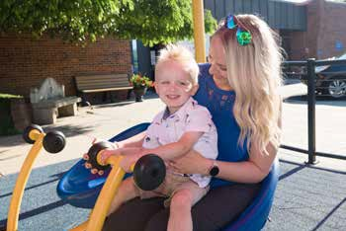
Image Description: A blonde haired boy sitting on the ground and holding a grey and white bunny with a teacher helping to hold the bunny.
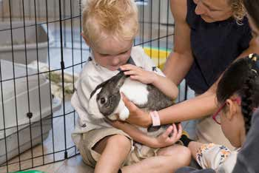

Student Profile: Gabe Reyes-Gonzalez
Image Description: Jon Harding, Hillary Joy-Sims, Gabe Reyes-Gonzales, and Leah Enright smiling for the camera

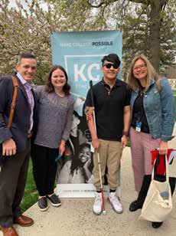

"I want to thank everyone that has helped me reach this point. Being awarded this scholarship is a huge financial relief."

In May 2022, close to 300 area Kansas City juniors from 40+ high schools were awarded $50,000 college scholarships from KC Scholars. One of those juniors was KSSB and Bishop Ward High School student Gabe Reyes-Gonzales. During the 2021-2022 school year KSSB, Bishop Ward High School formed a partnership that allowed students attending KSSB to take courses at Bishop Ward High School in Kansas City, KS part-time if their educational team deems it appropriate.

Gabe, originally from Topeka, KS, started attending Bishop Ward as a sophomore in September 2020. During his time at Bishop Ward, Gabe’s classes have included Chemistry, English, Biology, Algebra II and Finance. While Gabe still has another year at Bishop Ward, he will start visiting college campuses this fall before he decides where to pursue his higher education. Although he is undecided about where he will attend college, he said he would like to study Biomedical Engineering.

Gabe is grateful for this assistance for college and said “I thank everyone that has helped me reach this point. Being awarded this scholarship is a huge financial relief.”

We want to wish Gabe good luck during his senior year of high school and in all of his future endeavors.

Signature Events | Low Vision Clinic
The KanLovKids Project offers Low Vision Clinics to children from ages birth through 21 who reside in Kansas. Students, parents, teachers and related service providers are invited to share perspectives, identify needs, and obtain answers to questions about vision loss from optometrists and ophthalmologists. This collaborative approach provides an opportunity to identify the devices to best address low vision needs in the school, home and community. During the 2021-2022 school year, a total of 78 students and 182 individuals attended 30 low vision clinics in six locations in Kansas as well as virtually.

Low Vision Clinic Locations
  - Virtual Clinics
  - Emporia
  - Hays
  - Kansas City
  - Lawrence
  - Salina
  - Wichita
- Vision Clinic Attendees
  - 78 Students
  - 76 TSVI/COMS
  - 71 Parents
  - 22 Teachers
  - 11 Others
Image Description: A boy wearing glasses and mask sits on a chair holding an eye chart while a doctor wearing glasses looks on

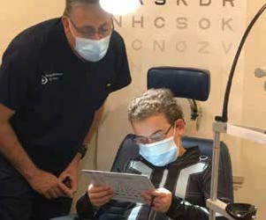
Image Description: A young girl sits in a chair with mask, glasses, and her right eye covered looks straight ahead as the doctor is pointing at a board and looking that the girl.

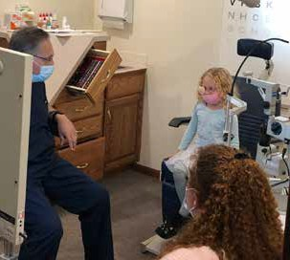

White Cane Day & Braille Challenge

In 1964, President Johnson established October 15th as White Cane Day to “... promote continuing awareness of the significance of the white cane to blind persons.” On Friday, October 1, 2021 we held the 2nd annual Kansas White Cane Awareness webinar. Panel members Kelly Miller, Christian Puett and Sheila Styron answered questions about life as a person with low vision/ blindness, and their experiences with canes and guide dogs. Students, families, and teachers look forward to this annual event as a way to celebrate independence and to educate fellow citizens about the importance of the white cane.

The Braille Challenge is the only competitive braille competition in North America. It shares the same goals both locally and nationally: to promote braille literacy, provide resources for families, and create an experience participants will not forget.

The academic Braille Challenge includes students in grades 1 through 12 who read and write braille. Students compete in contests including: spelling, reading comprehension, proofreading, speed and accuracy, and interpreting tactile charts and graphs. The Kansas regional events also celebrate young students and new braille readers by providing additional sessions for these students.

Participants from all over Kansas are eligible to participate in regional events with a chance to go on to the national competition at the Braille Institute in Los Angeles. KSSB is extremely proud of our regional participants who qualified to attend the final competition in California. This signature event helps motivate students to practice and sharpen their braille literacy skills, which are essential to academic and employment success.

White Cane Day Participants

60 Students

24 Others

20 TSVI/COMS

12 Families

Image Description: 3 students wearing masks and holding canes smile at the camera and they are joined by 2 teachers wearing masks as well.

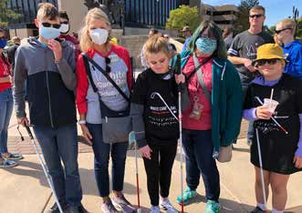
- Braille Challenge Participants
  - 9 Grades First through 4th
  - 2 Grades 5th through 9th
  - 7 Grades 10th through 12th
Image Description: A young girl with long blonde hair sits at a desk with her arms around her braillewriter smiles for the camera.
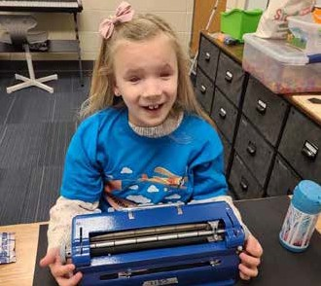
Family Forum
KSSB hosted our first Family Forum event on April 23, 2022 in Kansas City. This conference for families featured guest speakers who presented on a variety of topics.
Dave Wilkinson was the keynote speaker and was able to give his perspective and share his experiences as a digital accessibility expert and blind triathlete. Anthony Blades, TSVI/COMS, presented a session regarding Incorporating Tactile Object Calendar Systems into Daily Routines. Information was also shared by Madeline Bowen from the Working Healthy Program that assists families with their questions regarding benefits and Leslie Girard from Families Together discussed the importance of family empowerment and education so they can be effective advocates for their children.
A panel of college students and young professionals engaged in a discussion of the variety of access technology that panelists use in their everyday lives; including college classes, shopping, transportation, and access to documents used in the workplace. Participants had the opportunity to ask questions and learn how young adults are navigating college and employment.
KSSB plans to host this event each spring to inform and empower parents to advocate for their children.
Image Description: KSSB TSVI sits on a bench watching a student wearing glasses and a backpack read a book, and the student's mom sits by him holding his cane and looking on as well.
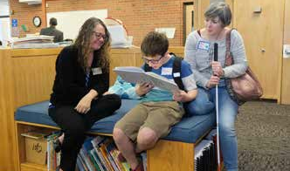
"This was a fantastic forum! I wish more families had attended and were given this information."
KC Blind All-Stars
For families, KSSB assembled “activity boxes’’ that contained engaging, accessible activities for children who are blind or have low vision, delivered straight to their homes. For children, the boxes included games, STEM materials, hands-on academic activities, and a host of tactile materials to promote student-directed learning. The boxes also contained informational materials for families who are interested in KSSB’s activities, programs, and services. Students were delighted and surprised to receive these boxes during the 2021-22 school year.
KSSB, with the help of the KC Blind All-Stars, sponsors students to attend Space Camp every year. In September 2021, two students chaperoned by two KSSB staff members, received scholarships from KCBAS and attended “Space Camp for Interested Visually Impaired Students” (SCIVIS) in Huntsville Alabama. This experience is a once- in-a-lifetime opportunity for students to explore rocketry, a gravity chair, challenge courses, scuba diving, aircraft simulators and improve their communication and problem-solving skills with other students who are blind or have low vision from around the world.
- Run/Walk had 341 Participants
- Run/Walk raised $60,000
Image Description: 3 students run on a track with guide wires.
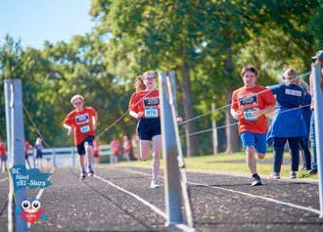

Image Description: A student wearing headphones sits at and works on a computer with 2 screens.
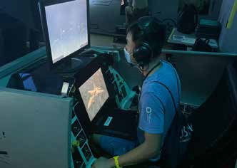
Boys/Girls Weekend
Forty-six students from around Kansas gathered on KSSB’s campus for two weekends with their peers who also have visual impairment. These dynamic weekends are for students age 14 and up who do not attend KSSB year-round. The areas of the Expanded Core Curriculum (ECC) are at the forefront of these signature events.
The fall weekend ran concurrently with the KC Blind All-Stars 5k run/1 mile walk. Attendees in the Girls/Boys weekend participated in the run/walk on Saturday and the remainder of the weekend was spent engaged in activities focusing on recreation, leisure, and living a healthy active life as an individual with a visual impairment. Budgeting, shopping, preparing and clean-up of all meals is a popular part of the weekend as many students have never used a stove, or cut a watermelon … these weekends provide them with opportunities to try something new!
The spring weekend’s theme was April Fool’s Has Begun: A KSSB Weekend of ECC Tricks and Fun. In addition to shopping and preparing of all meals - which they all LOVE to do, students participated in adventures in the metro area, such as going to the Escape Room where teams had to solve a variety of problems presented to “escape” the room. The ECC Olympics were a hit as well, as students had the chance to not only compete in various job skills, but try something they had never done before. During the Olympics students rotated through job interviews, resume writing, laundry sorting, setting a table, and ten more stations that focused on ECC domains.
- 46 Weekend Participants
- Participants from:
  - Andover
  - Ark City
  - Auburn-Washington
  - Baldwin City
  - Basehor-Linwood
  - Blue Valley
  - Buhler
  - Derby
  - Dexter
  - Ellsworth
  - Emporia
  - Goessel
  - Holton
  - Lawrence
  - Maize
  - McPherson
  - Olathe
  - Onaga
  - Osage City
  - Oxford
  - Salina
  - Shawnee Heights
  - Topeka
  - Udall
  - Wichita
Image Description: Group of students of all abilities gather and smile for the camera.
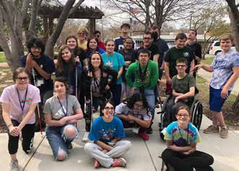
Image Description: 2 students work in a kitchen cracking eggs open.
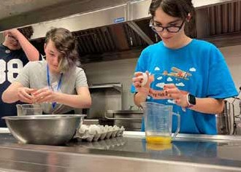

Extended School Year
KSSB hosted 93 students this summer for the Extended School Year (ESY). Students participated in activities with other students with visual impairment from across the state. They worked specifically on the Expanded Core Curriculum (ECC) domains of: Social Interaction, Daily Living Skills, Access Technology, and Recreation & Leisure. Braille and Orientation & Mobility are embedded throughout the program. These functional skills are important for future success in school and in the workplace. They often need to be intentionally taught as students don’t learn them through observation. The ECC are considered the “specialized skills of blindness” and are as crucial to student success in life as academic skills.
Image Description: A student holds money in a grocery store checkout with a teacher helping her
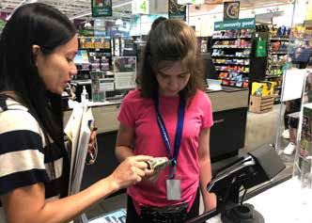

Image Description: A student stands on an escalator, holding a cane, and teacher stands behind the student helping.
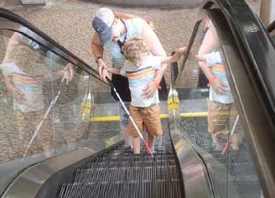
"Mara had such a great time at PREP and learned so much... She really enjoyed volunteering in the makerspace and has become interested in pursuing nursing and has been actively doing research about college programs ON HER OWN!"
KANSAS STATE SCHOOL FOR THE BLIND
WWW.KSSB.NET
1100 STATE AVENUE, KANSAS CITY KS 66102 • (913) 305-3000 • TOLL FREE: 1-800-572-5463

