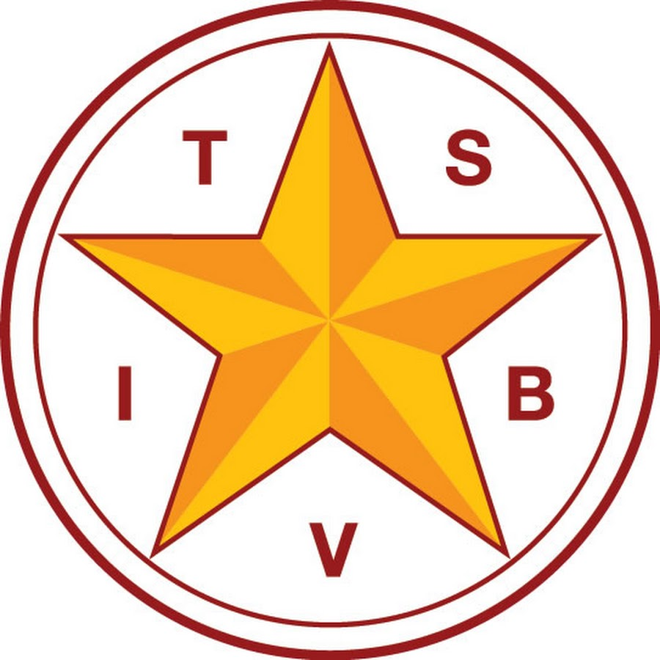
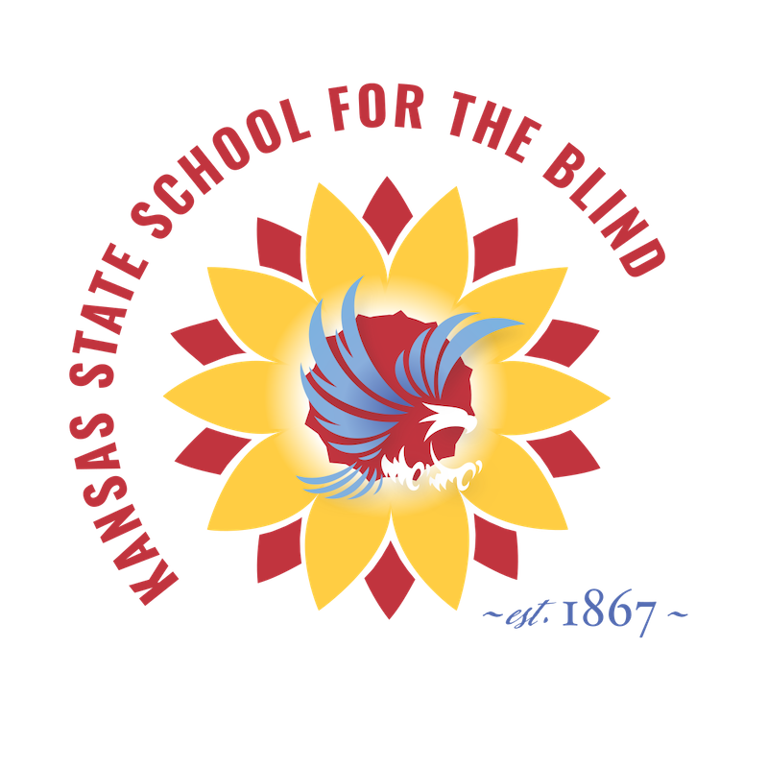
Friday, April 8, 2022

9:00 a.m. - 2:30 p.m.

Lakewood Discovery Center

250 Lakewood Dr, Salina, KS 67401

Presented by Dr. Cindy Bachofer and Lynne McAlister from TSBVI

Kansas State School for the Blind Field Services
Middle and high school students will spend the day learning about their eye conditions, participating in activities using their prescribed devices, and interacting with other students with low vision. Professional development points will be provided for TSVI/COMS who attend with their students.
Attendance is limited to 15 students. Register today!
Schedule of Activities
9:00 a.m. - 11:30 a.m. Activities at Lakewood Discovery Center
11:30 a.m. - 12:30 p.m. Lunch at a local restaurant (provided)
12:30 p.m. - 1:45 p.m. Grocery Store Scavenger Hunt
2:00 p.m. - 2:30 p.m. Closing at Lakewood Discovery Center

