2020-2021 ANNUAL REPORT, KANSAS STATE SCHOOL FOR THE BLIND
Image: Student reading the large outdoor tactile and brailled map of the KSSB Campus.
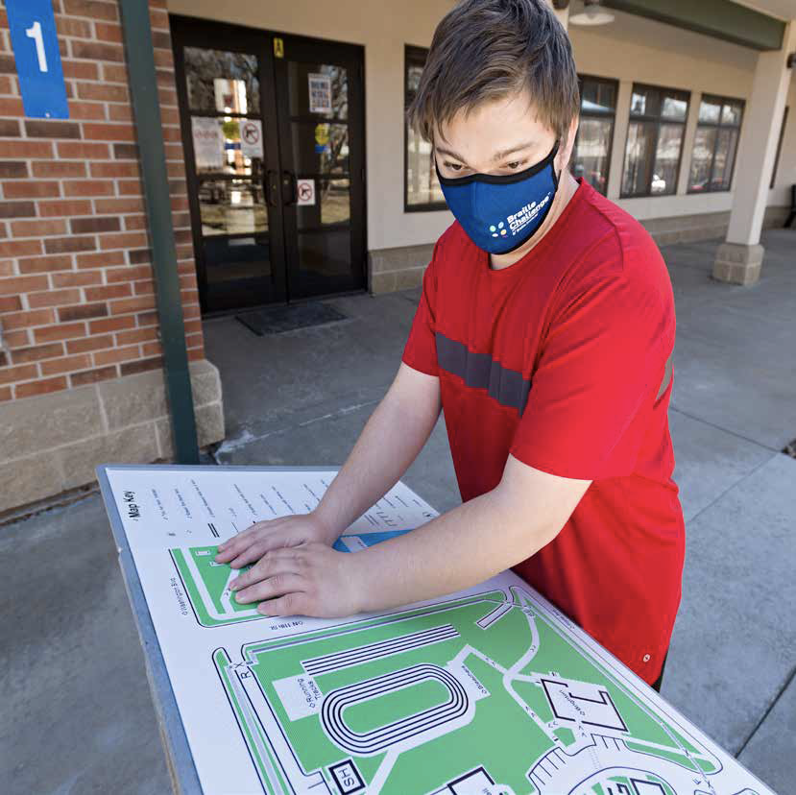

Letter from the Superintendent
Dear Friends,
Jon Harding, Ed.S. - Superintendent - Kansas State School for the Blind

We are pleased to present Kansas State School for the Blind’s Annual Report for fiscal year 2021. KSSB has so much to be proud of, and we want to share the progress we are making on our goals. We are committed to fulfilling our agency vision of “Right Help, Right Time, Right Location”. KSSB is fortunate to be administered by the Kansas State Board of Education, composed of ten members who are dedicated to improving education for all of Kansas’ students.

KSSB has provided over 153 years of service to children with visual impairments and their families. We continue to build on this legacy by offering innovative programs that meet the needs of today’s students and parents. KSSB is growing: we expect to serve 50 students who are blind or have low vision in our campus programs in the 2021-2022 school year. We will serve over 70 students during our Extended School Year, and we reach over 800 students across the state with our Field Services.

This year, with the help of our non-profit, KC Blind All-Stars (KCBAS), we redesigned our website and raised money for a beautiful, new, accessible playground. We unveiled a state-of-the-art wayfinding system for our campus and developed an online computer science course that is accessible for those who are blind or visually impaired. We have converted part of Brighton Rec Center into a “Maker Space” for students to learn skills in STEM (Science, Technology, Engineering, and Math), offering equipment such as a laser engraver, a sublimation heat press, vinyl cutter, 3-D printers, and embroidery machines. With help from Akido Labs/Future Communities Institute, we implemented a new app called Pulse that allows us to better target services to our students and families.

We continue to add highly qualified vision professionals to our team, which translates into improved services to students in their home schools and communities. KSSB serves as an ‘anchor’ for new teachers who enter the profession and need mentorship as they grow and develop their skills. Our Deaf-Blind Project, Kansas Instructional Resource Center, and Low Vision Clinics reach hundreds of students and families who benefit from the information and specialized services.
I invite you to visit our gorgeous 10-acre campus and see for yourself the difference we are making in the lives of our students. There are many opportunities to support our school, and our KCBAS 5k Run/Walk in September is one of the most rewarding. We hope to see you soon, and we remain humbled and grateful for your support.

Jon Harding
Pages 1-2

INVESTING IN ...Our Reach
Since 1867, KSSB has opened its doors to students from across the state who need
specialized instruction in braille, independent living, vocational skills, mobility, and academics. While we still maintain a vibrant campus as the hub of our school, we can now deliver many of these specialized skills to students in their home schools and communities. KSSB Field Services specialists can visit students’ homes and schools to provide instruction, administer assessments, or to partner with regular and special education teachers. We also offer remote instruction for those students who prefer learning at a distance or who are unable to receive help in more traditional ways. KSSB is ready to serve today’s students who are blind or have low vision, regardless of location.
Even if a student who is blind never steps foot on our campus, they are likely to receive a service or product from KSSB that helps them along their journey to independence. As examples: Our Low Vision Clinics are offered across the state; we offer braille and accessible instructional materials to students in their home schools via the Kansas Instructional Resource Center, and our Mobile STEM Unit is offered to all 286 school districts in Kansas. Looking ahead, we intend to expand remote instruction in braille, technology, and low vision skills for students who do not have access to a vision teacher in their home school.
NUMBER OF STUDENTS SERVED
- 800 served by Field Services
- 1200 students served throughout the year
- 45+ students served daily on campus
- 27 dormitory students

INVESTING IN ….Our Services
Our vision to “provide the right help, at the right time, in the right location” is lived out daily and delivered by our highly qualified vision teachers, braillists, and orientation and mobility specialists. Sixteen Field Service specialists, placed in Western, South Central, North Central, Southeast, and the Northeast regions of the state provide local support to schools, teachers, and families. Services provided include assessment, braille instruction, cane travel instruction, Low Vision Clinics, and STEM workshops. For students who do not attend KSSB daily, we sponsor weekend events, extended school year options, and special activities including the Braille Challenge Regionals in Kansas City and Wichita.

COUNTIES SERVED
Image: A map of Kansas with counties labeled by color based on the 2018 population. Fifty-six counties are labeled with colored circles. The colors represent the number of students who participated in KSSB activities.
- Population of 91,000 - 10,100,000 the count of students served in the following counties: Johnson (124), Sedgwick (100), Shawnee (80), Wyandotte (60), Douglas (20).
- Population of 36,800 - 91,000 the count of students served in the following counties: Finney (124), Reno (100), Leavenworth & Saline (80), Butler (40), Crawford & Riley (20)
- Population of 36,800 - 9,060 the count of students served in the following counties: Cherokee, Jackson, Labette, McPherson (80); Cowley, Rice, Harvey (60), Dickinson, Ford, Montgomery (40); Atchison, Barton, Ellis, Marion, Marshall, Nemaha, Pottawatomie, Seward, Sumner (20); Allen, Bourbon, Brown,, Geary, Osage, Pratt, Linn, Lyon, Miami, Neosho (>1)
- Population of 9,060 - 75 the count of students served in the following counties: Clay (80); Republic (60); Washington (40), Chautauqua, Clark, Coffey, Meade (20), Doniphan, Ellsworth, Hodgeman, Lincoln, Norton, Ottawa, Phillips, Wabaunsee (>1)

TOTAL NUMBER OF DIRECT SERVICES TO STUDENTS
- Assessment (43)
- IEP Meeting (60)
- Consultation (85)
- Direct Instruction (908)
TOTAL HOURS OF DIRECT SERVICES TO STUDENTS (by age group)
- 108: Birth - 2 years
- 142: Kindergarten to 5th grade
- 113: 9th - 12th grade
- 47: 3 - 5 years
- 167: 6th - 8th grade

TOTAL NUMBER OF SERVICES PROVIDED
- 1096 Direct Services
- 464 Technical Assistance
- 84 Expanding Our Reach
- 28 Signature Event
- 19 COP Facilitation

INVESTING IN ...Our Events
The KanLovKids Project offers Low Vision Clinics to children from ages birth through 21 who reside in Kansas. Students, parents, teachers, and related service providers are invited to share perspectives, identify needs, and obtain answers to questions about vision loss from optometrists and ophthalmologists. This collaborative approach provides an opportunity to identify the devices to best address low vision needs in the school, home, and community. During the 2020-2021 school year, a total of 38 students and 156 individuals attended 23 low vision clinics in five locations in Kansas as well as virtually.
In 1964 President Johnson established October 15 as White Cane Day to “promote continuing awareness of the significance of the white cane to blind persons.” This year KSSB organized White Cane Day virtual events in Topeka, Hutchinson, Wichita, Garden City, and Kansas City. Students, families, and teachers look forward to this annual event as a way to celebrate independence and educate fellow citizens about the importance of the white cane.
Our Braille Challenge events are held in February and March of each year and celebrate braille literacy for children and youth of all ages. This past year the Braille Challenge was held virtually, due to COVID restrictions, but 33 students from across Kansas still participated in the online events. This year’s theme was “Cell-a-brate Braille” and competitions were held across two different days. In subsequent years, KSSB will host the Braille Challenge as a part of our larger, more expansive “Braille Celebration” events that will emphasize the non-competitive aspects of learning the braille code.
For families, KSSB assembled “activity boxes’’ that contained engaging, accessible activities for children who are blind or have low vision, delivered straight to their homes. For children, the boxes included games, STEM materials, hands-on academic activities, and a host of tactile materials to promote student-directed learning. The boxes also contained informational materials for families who are interested in KSSB’s other activities, programs, and services. Students were delighted and surprised to receive these boxes in the spring of 2021. As COVID restrictions ease, KSSB anticipates hosting a “Family Forum'' event each spring to inform and empower parents to advocate for their children.
KSSB, with the help of the KC Blind All-Stars, sponsors students to attend an international space camp every year. While no students participated in 2020, KSSB will chaperone students to the space camp in 2021. Officially known as the “Space Camp for Interested Visually Impaired Students” (SCIVIS), this experience is a once-in-a-lifetime opportunity for students to explore rocketry, a gravity chair, challenge courses, scuba diving, and aircraft simulators with other students who are blind or low vision from around the world.
BRAILLE CHALLENGE - 33 participants
Image: Two students sitting at a table reading braille on paper rolled into their braille writers.
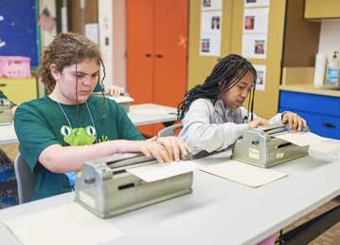
EXTENDED SCHOOL YEAR - 74 participants
Image: Students forming a conga line in the KSSB gym.
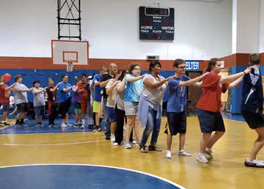
LOW VISION CLINICS (# of participants)
- 65 parents
- 54 students
- 50 TSVI/COMS
- 27 Others
- 13 Teachers

WHITE CANE DAY (# of participants)
- 60 Students
- 24 Others
- 20 TSVI/COMS
- 12 Families
BOYS/GIRLS WEEKEND - 22 participants
Image: Students wearing blue shirts standing in front of a Sporting Chance sign.
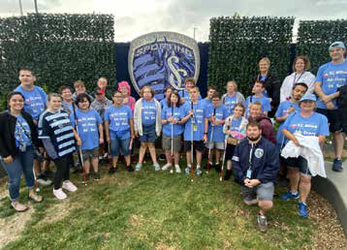
ALL-STAR RUN/WALK - 279 participants
Image: Students standing in front of a dinosaur statue holding a KC Chiefs sign and wearing a Chiefs mask.
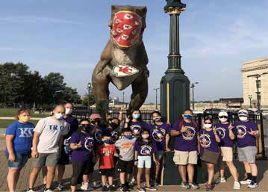

INVESTING IN Special Projects

K.I.R.C.
The Kansas Instructional Resource Center (KIRC), is funded through the Kansas State Department of Education (KSDE), the American Printing House for the Blind (APH), and the Kansas State School for the Blind. KIRC resources include instructional materials of braille and large type textbooks; library books and educational aids; Braille transcription of educational materials; continuing education and professional development opportunities for teachers; and adaptive equipment for students.
KIRC conducts an annual APH registration for Kansas students, and it was finalized on March 15, 2021. Seven hundred forty one Kansas students were registered in the 2021 APH annual count. This year, approximately 1,702 items (large print and braille textbook sets, professional materials, and equipment) have been distributed, with an estimated value of $406,260. These materials and equipment allow children who are blind and have low vision access to the same content as their peers, in their home schools and communities.

TSVI/COMS Training Project
The goal of the TSVI/COMS Training Project is to increase the number of Teachers of Students with Visual Impairments (TSVIs), and Certified Orientation and Mobility Specialists (COMS) in Kansas. The TSVI/COMS Preparation and Mentorship Project is funded through the Kansas State Department of Education, in partnership with, and administered by, the Kansas State School for the Blind. In FY21, 14 students were enrolled in a university training program; 12 were working on earning TSVI endorsements and 2 working on certification in orientation and mobility. Of these, one completed O&M after summer 2020, and 4 completed TSVI after spring 2021. Nine participants will continue with their required coursework in FY22 and are on target to earn their endorsement/certification.

Kansas Deaf-Blind Project
The Kansas Deaf-Blind Project provides technical assistance to improve services for children and youth who are Deaf-Blind between the ages 0-21. The KS Deaf-Blind Project is sponsored by the U.S. Department of Education, Office of Special Education Programs. The Deaf-Blind Project maintains a statewide child count of children and youth with combined hearing and vision loss, provides training to families and professionals and acts as a resource on deaf-blindness. In 2021, the Project listed 130 students on its registry. The Project hosts “CVI Connect” for parents of children with cortical visual impairments, “Music and Me” (an online playgroup for young children who are deaf-blind, ages birth to three), workshops with content experts, and an annual family retreat.

TOTAL NUMBER OF STUDENTS REGISTERED WITH KIRC - 741
658 public school
58 infant and toddler
23 School for the Blind
02 private school

STATE YEAR 2020
$406,260 = 1,702 items
VALUE OF ITEMS SHIPPED FROM KIRC FOR USE WITH STUDENTS

STATE YEAR 2019
$452,782 = 1,781 items
VALUE OF ITEMS SHIPPED FROM KIRC FOR USE WITH STUDENTS

INVESTING IN ...Our Partnerships
KSSB identifies like-minded organizations in our local community, across the state, and sometimes around the world to further our mission. Through the commitment of time, resources, and personnel, our partners send a powerful message to others about the shared values of inclusion, equity, and social justice in our larger society.

AKIDO LABS/FUTURE COMMUNITIES INSTITUTE
Image: Left hand holding an iphone while a right hand finger touches the screen.
This year, Aikido Labs brought our Pulse app online for our Field Services team. The app
allows our staff to enter data via their mobile phones as part of their “work flow”. Data
captured include: school districts visited; number of students contacted; content provided;
workshops presented, and others. The Pulse app will allow KSSB to better tailor our
services to student needs across the state and, ultimately, to improve student outcomes.

CLICKANDGO WAYFINDING
Image: Hands reading braille on a tactile and large print map.
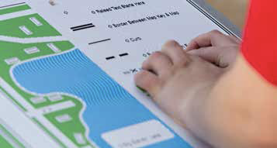
KSSB’s campus-wide navigation system, ClickandGo Wayfinding, realized its full functionality
this past year. This is a layered system composed of artisan tactile maps, low vision maps, and audio and braille narratives that provide location support and real-time navigation via a mobile app. Low-energy, bluetooth iBeacons provide audible information for visual signage and prominent landmarks. KSSB hosted an open house April 30th to showcase this one-of-a-kind navigation product to the larger Kansas City community.

GREENBUSH
Image: Teacher and student sitting on the floor with blocks and tubes creating a bridge and ramps.
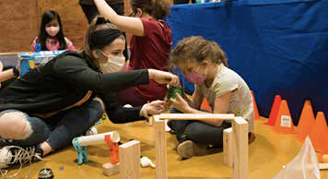
This past year, KSSB expanded our partnership with Greenbush, also known as Southeast
Kansas Education Service Center. Our Mobile STEM Unit visited schools in Greenbush’s
extensive service area, providing on-site, inclusive and accessible science, math, and
computer science activities to elementary students. In June, students in KSSB’s extended
school year program will visit Greenbush’s campus in Girard to participate in fun, engaging
summer camp activities with typical peers.

MICROSOFT PHILANTHROPIES TEALS
Image: Student sitting with a PC computer laptop on his/her lap with hands on keyboard.
Last year, for the second consecutive year, KSSB offered an online computer science
course tailored for students who are blind or low vision in partnership with Microsoft
Philanthropies TEALS (Technology Education and Literacy in Schools). Computer science
has become a program of emphasis nationwide for schools, and we view this as an opportunity
to expand access to a growing field for students who are blind or have low vision.
Our computer science program continues to evolve and next year the program will utilize
Python as the programming language, which is industry-recognized and prepares students
for the next stage in the development of their skills.

INVESTING IN ...Our Students
the right HELP
the right TIME
the right LOCATION
Image: Student and teacher sitting on a bench exploring a Library of Congress audio tape player.
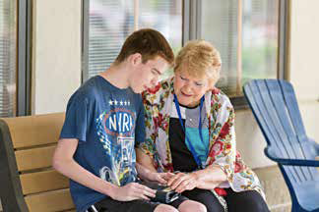
KSSB offers support to any student in the state of Kansas who might need a little help at some point along their educational pathway to adulthood and independence. Supporting students is always a shared venture between a student’s local school and KSSB. By working together, we can leverage the strengths of our respective schools to find unique solutions that otherwise wouldn’t be possible. While most students can, and do, succeed in their home schools and communities, other students may require more intensive training and support that only our campus programs can provide. Either way, KSSB staff work to ensure that each student can access the same programs and educational opportunities that are available to their typical peers.
Image: Teacher guiding a student’s hand over a stovetop. Student is wearing oven mitts and holding a large pot over a stovetop.
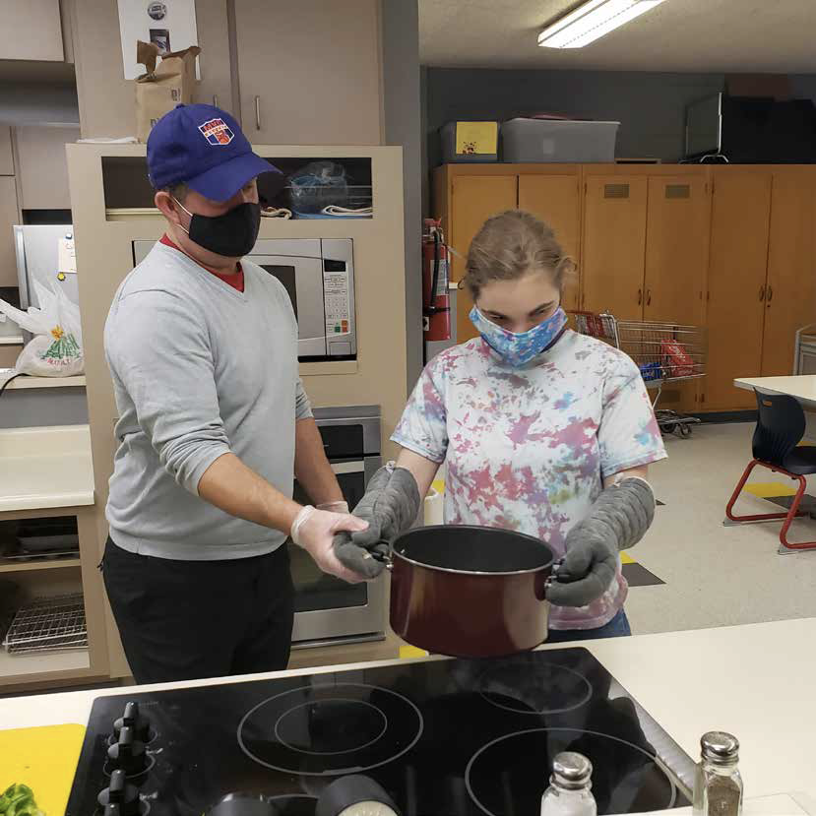

Playground
Our dream of a new, safe, and accessible playground was realized last year, thanks to help from a group of local donors. While KSSB is fortunate to receive generous support from the state of Kansas, we also seek help from organizations in our community who see the results of our work, recognize improvements that are needed to our facilities and programs, and respond to our requests for help.
Image 1: Two students sitting in the double swing.
Image 2: A student sitting in a single swing.
Image 3: A bright red, yellow and blue playground with a slide, swings, and multiple seat seesaw.
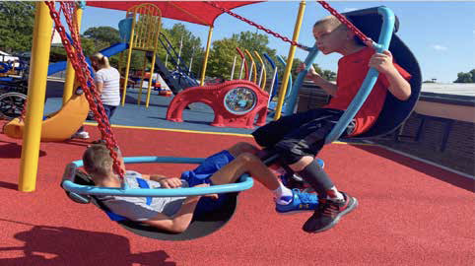
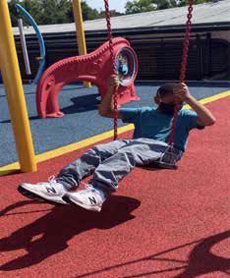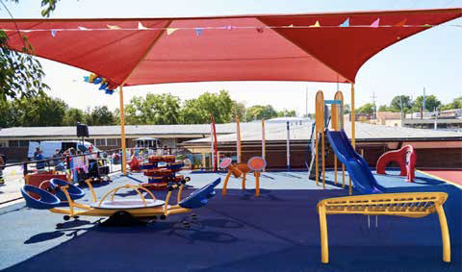

PLAYGROUND FACTS
- Accessible for ages 3-12
- A surface that is soft and porous, allowing water to drain away from the play area
- A beautiful red awning provides shade during the heat of the day
- The play area includes slides, musical instruments, accessible swings, and a climbing structure
- Braille, tactile, and high-contrast features are embedded throughout the playground

Preschool
KSSB opened a preschool last year to provide high-quality instruction to our youngest students. While many schools now offer preschool programs for all children, students who are blind or have low vision benefit from instruction that is specially tailored to meet their unique needs. Our preschool emphasizes tactile, hands-on learning and ensures that materials are accessible for children who may need alternate formats, materials, and experiences. Presently the program is offered as an “enrichment” to students who also attend their local preschool, but we expect the program to expand to a five-day a week schedule.
Image 1: Bubbles floating around a small child standing with arms out-stretched.
Image 2: Two children playing with translucent shapes on a large lightbox.
Image 3: A teacher holding a child and looking at words on a bulletin board.
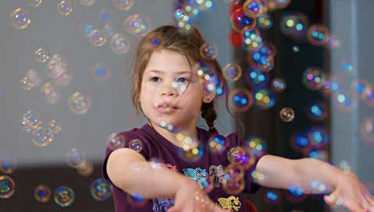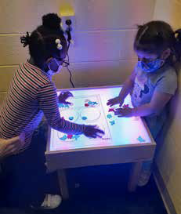

PRESCHOOL FACTS
- FREE (no cost to parents)
- For children ages 2 - 5
- Age appropriate skill building
  - braille readiness
  - communication
  - orientation and mobility
  - social skills
  - sensory efficiency
  - self-determination

Wayfinding
KSSB’s campus-wide navigation system, ClickandGo Wayfinding, realized its full functionality this past year. This is a layered system composed of artisan tactile maps, low vision maps, and audio and braille narratives that provide location support and real-time navigation via a mobile app. Low energy Bluetooth iBeacons provide audible information for visual signage and prominent landmarks.
KSSB hosted an open house April 30th to showcase this one-of-a-kind navigation product to the larger Kansas City community.

WAYFINDING FACTS
- Three artisan, tactile maps for route planning
- High-contrast low vision maps for use with text-based route narratives
- 200+ step-by-step route narratives
- Bluetooth iBeacons making visual signage and prominent landmarks “audibly accessible”
- Available via Apple devices using KSSB’s Wayfinding app
Image 1: Large outdoor tactile map of KSSB on a stand.
Image 2: Student using hands to read and explore the tactile and brailled outdoor KSSB map.
Image 3: Student using an iphone.
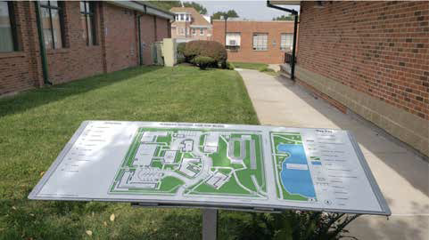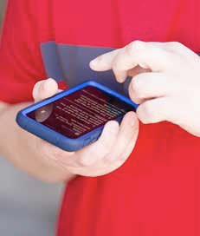
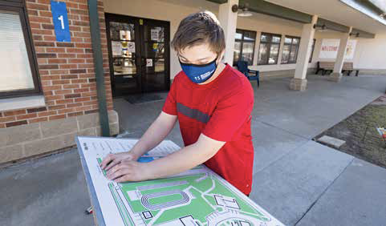

MAKER SPACE TECHNOLOGIES
- Vinyl cutters
- 3-D printers
- Laser engravers (2)
- Heat presses
- Sublimation heat pressing
- Direct-to-garment digital printing
- Heat printing
- Poster printing
- Embroidery machine
Image 1: Mugs with label “Vision Symposium” and a line drawing of an eye.
Image 2: Large room with tiled floor, tables, chairs and 3-D printers, and other tools.
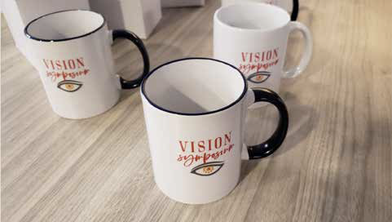
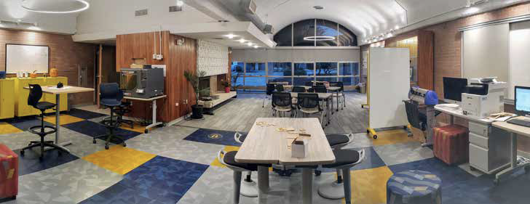

STEM
Our investment in STEM (Science, Technology, Engineering, and Math) is rooted in the belief that children who are blind should be given the same access to high-quality learning opportunities as all children. KSSB makes it easy and fun for children to experience the joy of learning to create, design, build, and invent. Our new campus Maker Space (above) is housed in an area of Brighton Building that has been remodeled and upgraded to accommodate high-tech devices such as laser engravers, 3-D printers, embroidery machines, etc. Classes are held daily, exposing children to iterative learning practices, entrepreneurial skills, and prevocational skills.
Our Mobile STEM Unit (a modified Ford Transit F250) allows KSSB to take the fun and learning on the road to local schools across the state. (continued)
Image 1: White van with door open and the KSSB large logo printed on the side.
Image 2: Student, wearing headphones and a mask, sitting at a table in front of a microphone.
Image 3: Teacher and student exploring snap circuits.
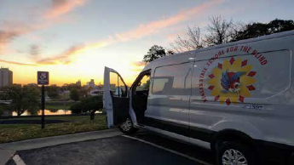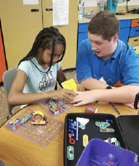
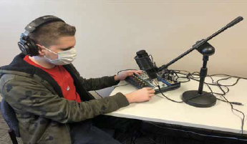

STEM (maker space, podcasting, mobile stem)
Activities offered include robotics, coding games, drone demonstrations, chain-reaction STEM kits, and others. KSSB also showcases accessible science and math materials for regular and special education teachers during these visits, as a way to promote inclusivity and access.
KSSB has a student-run podcast called “Discover Podcasting”. Each episode is produced, hosted, and edited by our students. To date, 22 episodes have been completed. Students have interviewed guests who are often blind and accomplished in professions such as: athletics (paralympic), architecture, engineering, CEOs, and the arts. The Discover Podcasting crew have been featured in Ed Week, and have contributed a podcast to the Perkins School for the Blind “e-Learning’ site.
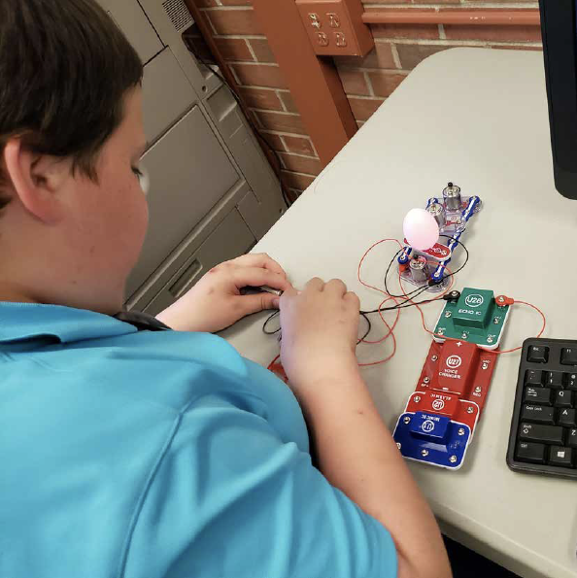
Image: Student exploring connecting circuits to turn on a lightbulb.

INVESTING IN ...Our People
With over 20 TSVIs and COMS and 11 additional staff who are licensed in other areas of teaching, KSSB has an incredible amount of talent and expertise at our disposal. Certified teachers on campus provide daily instruction to our students in core academic subjects and the Expanded Core Curriculum. In addition to our campus teaching staff, KSSB also employs social workers, a physical therapist, an occupational therapist, a speech language therapist, music therapists, and licensed nurses.
Our regional Field Services team offers technical assistance to schools and direct services to students throughout the state of Kansas. The goal is to partner with educational teams to address the unique educational needs of students who are blind or have a visual impairment. The most common technical assistance topics requested are related to assessment procedures, technology that will provide the student access to the curriculum and addressing the needs of students who have a visual impairment and additional disabilities.
NUMBER OF VISION CERTIFIED INDIVIDUALS
11 TSVI Only
09 TSVI & COMS
02 COMS Only
22 TOTAL
TECHNICAL SERVICES TO PROFESSIONALS (YTD)
General Training 10%
Coaching 56%
Mentoring 34%
PROFESSIONAL DEVELOPMENT (# OF PARTICIPANTS)
TECHNICAL ASSISTANCE
260 Coaching sessions
159 Mentoring events
46 Training sessions
19 Community of Practice
DIRECT SERVICES TO STUDENTS
1096 Total events
908 Teaching events
68 Counties served
55+ Districts served
60 IEP meetings
43 Assessments
SIGNATURE EVENT PARTICIPATION
279 KC Blind All-Stars Run/Walk
74 Extended school year
60 Family Activity Boxes
50 Low Vision Clinics
30 Braille Challenge
22 Boys and Girls Weekend (Spring only)

INVESTING IN ... Our Future
KSSB responded this past year to the realities of a pandemic with talented staff who innovated, adapted, and welcomed student participation in whatever format worked best for them. Whether online, in-person, or hybrid, KSSB teachers and staff rose to the challenge and provided quality instruction, every day.
While focusing on present needs, we also have an eye on future opportunities in our state. We will expand our online class offerings in braille, music braille, access technology, and mathematics. Students can remain in their local schools, while receiving intensive, specialized instruction in each of these areas from qualified teachers at KSSB.
Due to a shortage of Certified Orientation and Mobility Specialists (COMS) in our state, students may not always have access to specialized instruction in travel skills. In these instances, KSSB can provide on-site “Community O&M” group experiences with qualified COMS providing hands-on activities that promote skills in residential travel, street crossings, using landmarks and compass directions, problem-solving skills, and using public transportation (when available).
Planned upgrades to our campus facilities include a covered walkway that connects our dormitory (Edlund Building) with our classrooms (Johnson Building); a new elevator to our pool (Brighton Building); and a renovated stage and gymnasium (Johnson Building).
Image 1: Large gym with stage on one end and the KSSB logo on the floor.
Image 2: View of gym with goal ball fence around the floor.
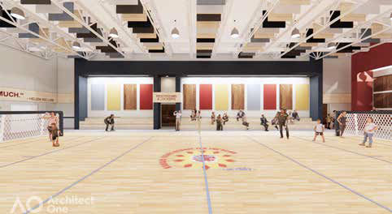
GYMNASIUM RENOVATIONS WILL INCLUDE:
- Tactile art with braille labeling
- Accessible, multipurpose court
- ADA-accessible performance stage
- Safe and protective flooring
- High contrast colors and materials
- Acoustic enhancements
- Retractable bleachers
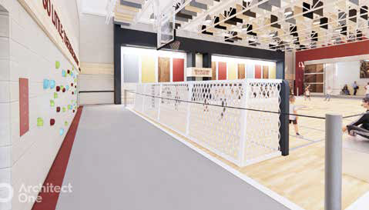
KSSB’s future is bright!
We look forward to welcoming you to our campus soon.
You will see the work our dedicated and talented staff do on behalf of Kansas’ students who are blind and have low vision.
We are humbled and grateful for your support!
Image: KSSB logo sunflower with a flying eagle in the center.
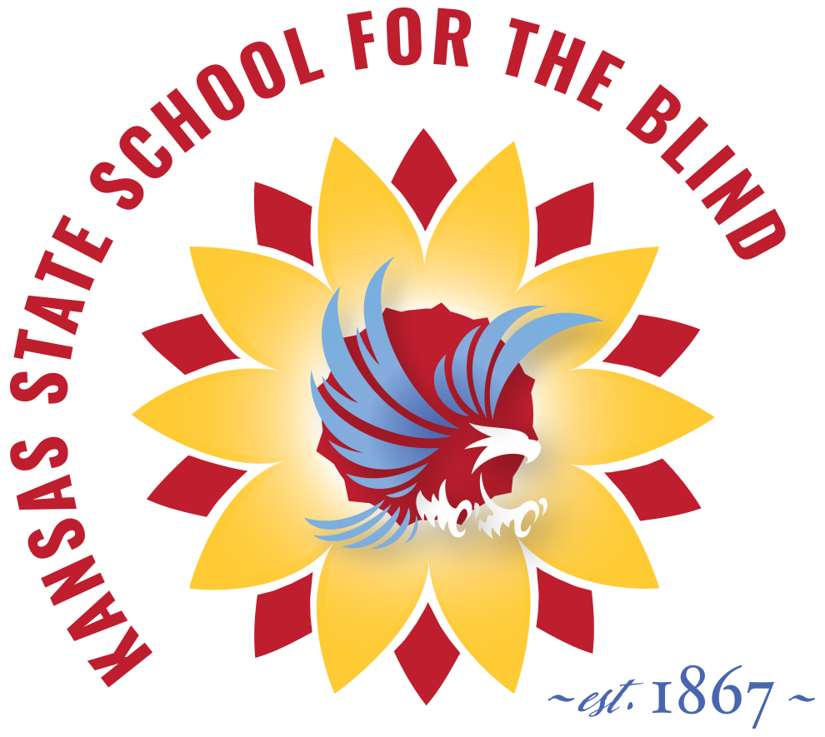
KANSAS STATE SCHOOL FOR THE BLIND
WWW.KSSB.NET
1100 STATE AVENUE, KANSAS CITY KS 66102
(913) 305-3000
TOLL FREE: 1-800-572-5463

