Kansas State School for the Blind
is pleased to announce
Preschool Summer Enrichment

OUR VISION: To provide enrichment opportunities for children ages 3 to 5 who are blind or visually impaired.
- Tuesdays and Thursdays, June 8-24
- Three hours each day
- 8:45am-11:45am
- NO COST
- Transportation provided by parents
- 1:1 student supports are not available
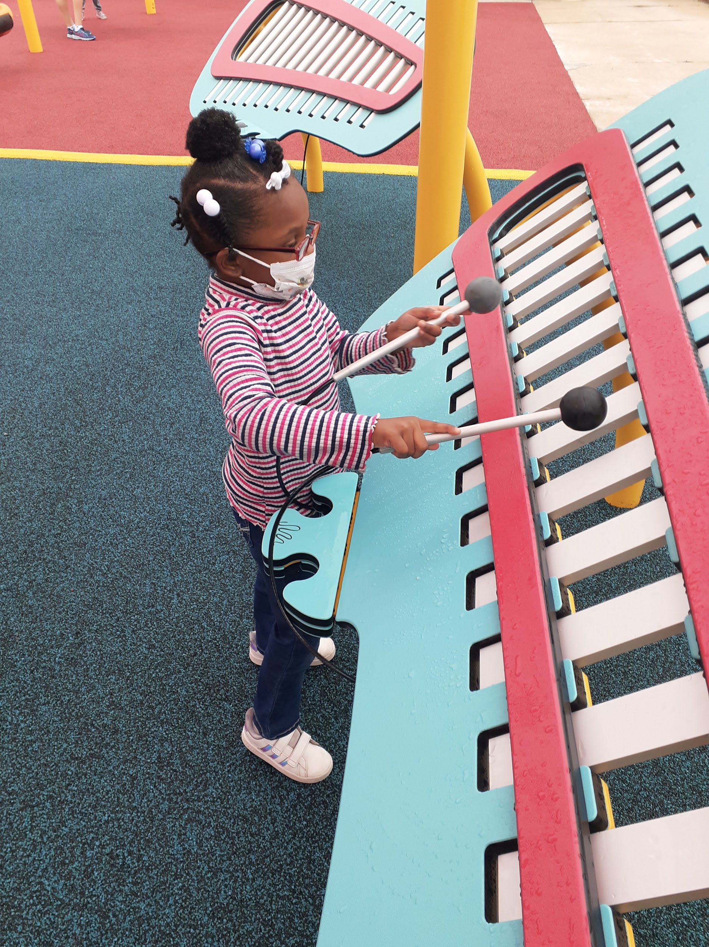
OUR FOCUS: Emphasize Expanded Core Curriculum (ECC) domains which are unique to students with a visual impairment. These include age-appropriate braille readiness, communication, orientation and mobility readiness, social skills, independent living skills, technology, sensory efficiency skills, self-determination, and much more!
OUR GOAL: To increase concepts and skills through intentional instruction and experienced-based learning in a safe, nurturing environment. Play-based therapies (SLP/OT/PT) are available.
READY TO APPLY?
For more information contact:
Jeanne Goodin, Teacher, TSVI, M.A.E.
jgoodin@kssdb.org
816.808.6175
Hillary Joy-Sims, Teacher, MT-BC, M.S. E.D., TSVI
hjoy-sims@kssdb.org
913.530.1853
Jon Harding, Superintendent, ED.S.
jharding@kssdb.org
913.645.5456
Link to Registration: http://bit.ly/PreSchoolApp

