KSSB Family Activity Box - Story Boxes
A Story Box for the book “Very First Nursery Rhymes”

What is a Story Box?
A story box is a collection of objects that go along with objects mentioned in a book. Most books for young children contain pictures and images and children who is blind or have low vision may not be able to access those beautiful enhancements. However, by adding objects to go along with the story our children can experience the story in a fun and interactive way. They will be engaged!

This Family Engagement Box includes objects that go along with some of the nursery rhymes in the book: Very First Nursery Rhymes. The objects allow children to explore (touch and feel) the objects while the nursery rhyme is being said or sung. This gives children a more hands-on approach to learning about the book instead of just listening.

Using a Story Box
- Take a “Picture Walk” through the story with your child. (See “Walking Through Stories” Article below.) Together with your child, turn the pages of the book one by one and talk about the pictures and other words in the nursery rhymes. Explore the objects that correspond to each nursery rhyme.
- If your child will tolerate it, use hand under hand technique to help your child to explore the objects as independently as possible. Or possibly explore the braille dots on the pages of the book. (see Hand Under Hand article below).
- Sing the nursery rhyme as you explore each object. Have fun and encourage active exploration - use the objects in a variety of ways - make noise with the shakers, smell the flower, feel the softness of the fabric, feel the long legs of the spider, squeeze the star, drop the tools in the bucket, etc.
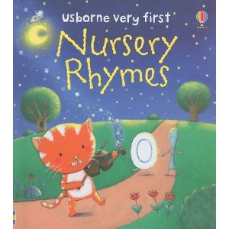
We purposefully did not include objects for every nursery rhyme so that if you want, you may add to or find objects that will go with the rest. Hope you enjoy your story box for the Usbone Book - “My First Nursery Rhymes” book

Object | Photo | What it represents
Shaker Egg | 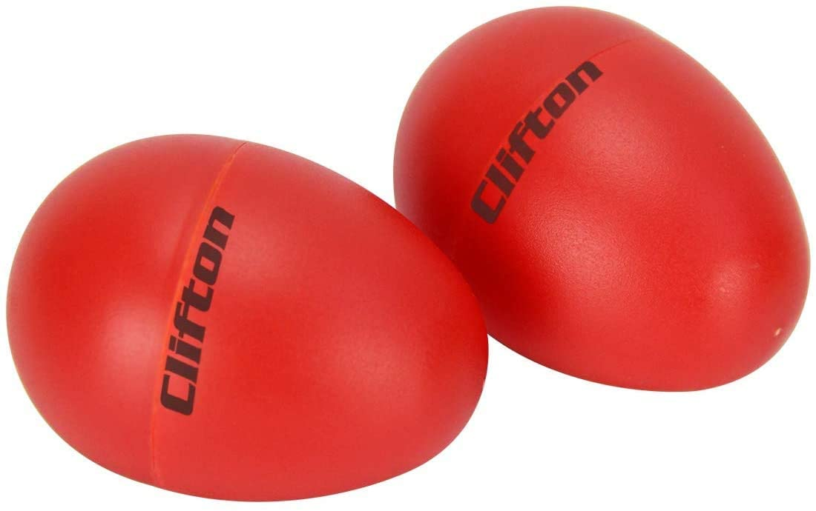 | Humpty Dumpty
Artificial Flower | 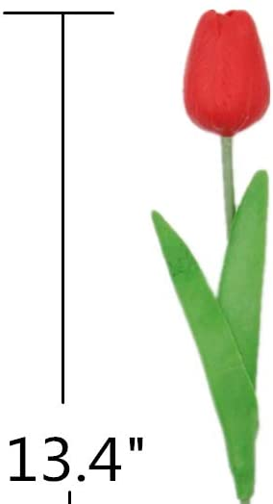 | Mary, Mary
Piece of Wool |  | Mary Had a LIttle Lamb
Spider | 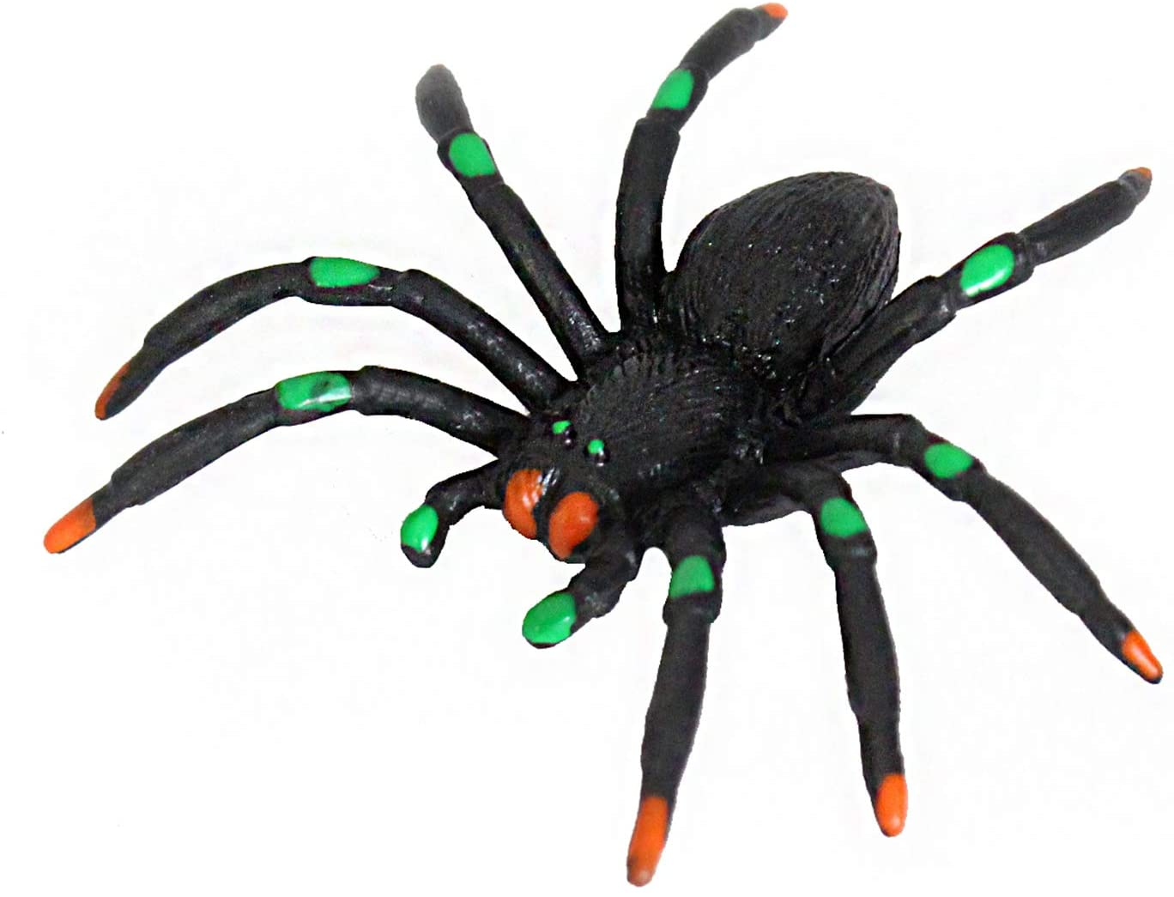 | Little Miss Muffet
Star |  | Twinkle, Twinkle, Little Star
Bucket | 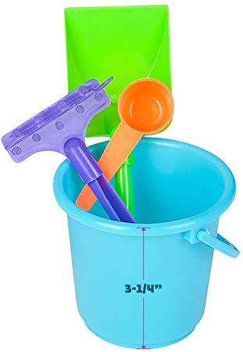 | Jack and Jill

**Provide Parental Supervision at all times when using materials from the KSSB Parent Engagement box. Some materials included in the box contain small objects which may cause a choking hazard for young children or children who frequently mouth objects. Please keep small objects out of the reach of young children who are not being supervised.

***For more information regarding story boxes, you may visit https://www.pathstoliteracy.org/storybox-ideas-norma-drissel

****Be on the lookout for an upcoming Music & Me virtual program in August 2021 which will be highlighting the Nursery Rhyme story box. Music & Me is a free program for children ages birth to 3 with a visual impairment or combined vision and hearing loss provided by the Kansas State School for the Blind and the Kansas Deaf Blind Project.

Using the QR Code
For additional activities - please use your phone to scan the tactile QR Code created in the KSSB MakerSpace. to find links to KIDZBop Channels.

A mobile phone with a QR Code scanner built into the camera:
- Open the Camera app on your smartphone.
- Hold your phone so the QR code appears on the screen.
- A QR code pop-up notification will appear on the screen.
- Tap the notification to open the QR Code link.
Note: If that does not happen automatically, check the settings on your phone so that the camera allows "Scan QR Codes."

A mobile phone without a QR code scanner built into the camera:
- Go to the app store to download and open a QR code scanner app
- Hold your phone so the QR code appears on the screen.
- A QR code pop-up notification will appear on the screen.
- Tap the notification to open the QR Code link.

Walking Through Stories: A Literacy Strategy for Reading to Young Children and Early Readers
By Kate Borg - Please Vision Paths to Literacy Website for more information!
Once upon a time, there lived a spleeth. This spleeth was the lipliest spleeth in all the land. One morning, the spleeth decided that he needed to haynder to see if he could get some rukyas. Sadly, the plupet did not have any rukyas, so the spleeth knew that he was trased. Walking home, the spleeth heard a rukya! The day was saved! The spleeth and his family could have breakfast.
Do you know what a spleeth is? How about a rukya? Before the last sentence, did you think it was something to eat? What does it mean to haynder or to be trased? Does your town have a plupet? If the story had pictures of a spleeth and rukya, would that have helped you understand more quickly?

Understanding Concepts is Key!
When reading, understanding is key; it is not enough to hear or read the words. Those words need to have meaning, and that meaning is dependent on our experiences and understanding of concepts. If I have never heard of a bear and had never seen a picture of one, would Goldilocks and the Three Bears have the same meaning?
For children with vision, a common strategy that familiarizes students with a text prior to reading is to take a Picture Walk. Children and students preview images to activate prior or background knowledge and to enhance comprehension (Learn Alberta, 2019). Students are able to make sense of unfamiliar vocabulary and concepts prior to engaging with the text and can therefore gain greater meaning from the story, because they can connect the visual images to their own experiences (Milne, 2014). Taking a picture walk also helps students anticipate what they will read (Vanderbilt University, 2019). As they explore a book’s front and back covers, images, and learn the title, students can use what they have gathered from the book to make predictions.
But what do we do for a child who cannot see the pictures well, or at all? How can we develop concepts and activate their background knowledge and experiences? For students with a vision impairment, this process of taking a “picture walk” with a new text is just as, if not more important in order for them to gain understanding and make connections with the text. We need to move beyond the illustrations and help students recall concrete experiences, or provide some if needed.
To illustrate the process of taking a book or picture walk with a child who is blind or visually impaired, we will refer to the popular book, The Very Hungry Caterpillar by Eric Carle. This is a fantastic story that is available in various media (i.e. braille, tactile, YouTube, etc.) and is certainly one of my favorites.

Step1: Explore the Title
The first part of any story or book is the title. This is a great opportunity to stir your child’s interest in what you are about to read. Asking, “What do you think this book will be about?” will help to build prediction skills.
Examples:
- “Our story today is The Very Hungry Caterpillar. Have you ever held a caterpillar? What do you know about caterpillars?”
- “Remember that time we found the caterpillar in the garden? What did it feel like?” (Or even better, “Here is a caterpillar. Let’s let it crawl on your hand.”)
- “This caterpillar eats and eats! What do you think will happen as he keeps eating? What kinds of things do you think he eats?”

Step 2: Picture/Book Walk
Slowly flip the pages of the book and explore some of the pictures. You can go page by page, or for longer books, choose a handful of pictures in advance. For children with some vision, ask questions about what they see. “What is going on here?” “Who is this?” “Why do you think they are there?” For children without vision, describe the picture and ask similar questions. Use this time to make sure your child understands key vocabulary they will encounter in the story. For The Very Hungry Caterpillar, some of the important vocabulary words might include:
- the days of the week
- fruit names such as plum, pear, apple
- egg
- Leaf
- cocoon
It will be important to have as many real examples of the core words as possible to build your child’s concept development. For this story, letting your child touch, explore, and taste the different fruit the caterpillar eats will give them concrete experiences and enhance their understanding of the story.
Examples:
- “On this page, there is a picture of a big, red apple. What do you think the caterpillar does with the apple? Do you like apples? What do they taste like?”
- “This page has a picture of two pears. Here is a pear. Tell me what it feels like. Let’s see what it tastes like.”
- “Here the caterpillar has a stomachache. Why do you think he is going to get one?”
Remember, don’t give away the story! Let your responses to your child be vague. “That’s very possible!” and “We’ll have to read and find out!” are some good phrases to encourage dialogue without giving away too much of the story.

Step 3: Read the Story
Now it’s time to read the story! Use some of the same questioning strategies as you read. Refer back to statements your child made as they predicted what might happen in the story. This is very beneficial because it reinforces critical thinking skills that you activated during the picture walk. As with the picture walk, build in moments of interacting with real objects as much as possible. Make sure to ask open-ended questions instead of yes/no questions, and ask questions that both require fact recall (who, where, what) and inference (why, how). Guide your child to think of memories that remind them of characters or events in the story. These connections help build their concept development and can make reading experiences more dynamic.
Examples:
- After reading what the caterpillar eats on Monday, Tuesday, and Wednesday, pause and ask, “What do you think he is going to eat on Thursday? How many will he eat?”
- “Remember after Thanksgiving when everyone’s tummies felt so full? I bet that’s how the caterpillar feels!”
- When he builds the cocoon around himself ask, “What do you think will happen when he comes out?”
Finally, when you come to the end of the story, “walk backwards” with your child. Ask them if their predictions were correct. Discuss any surprises in the plot and ask why they think the story ended that way. Take a few minutes to review the new words and concepts that you reviewed before reading. If necessary, eat more fruit!
Using this strategy of “walking” through a story is a great way to pique a child’s interest and improve their comprehension of the story. Providing them with descriptions and concrete examples of what is in the pictures and then asking them questions helps to stir their imagination while building their concept development. Remember, literacy is much more than being able to read words on a page…it is about building understanding and providing experiences with those words.

References
- Learn Alberta. (2019). "Picture Walk". Retrieved from Strategies that make a difference:
- Milne, E. (2014). "Taking a Picture Walk". Retrieved from Hands and Voices:
- Vanderbilt University. (2019). "Taking a Book Walk". Retrieved from Iris Center:

Hand-Under-Hand and Hand-Over-Hand Instruction for Blind Babies
Visit the American Foundation for the Blind Family Connect Website for more information.
If your child has a visual impairment, she can utilize the senses of touch, hearing, and smell to obtain information that typically sighted children gather visually. To help her learn about the world and the things in it, try to involve all her senses when you are engaged with her and explaining something new.
If you are introducing your child to an unfamiliar safe item, describe the item to your child and encourage her to explore it using all of her senses. It is through these experiences your child becomes an active, engaged learner.
Only after your child has independently explored (if time permits, to her heart’s content), you can invite your child to let your hands demonstrate proper use of the item. Utilizing your hands to guide your child’s hands is called hand-under-hand and hand-over-hand instruction.
Some examples of activities in which your child will benefit from using hand-under-hand or hand-over-hand to learn include using a measuring spoon to scoop out baking soda when making cookies, pushing a button through a button hole when dressing, or positioning a pair of scissors to cut a line.
When using hand-under-hand or hand-over-hand, work from behind your child so that your hands and hers will be moving in the same direction. If she is young, you can sit her on your lap. When she is older, sit behind her or next to her and reach your arms around her.
Before you show your child how to do something using either method, try it yourself with your eyes closed. Pay attention to the steps you are taking to do the activity. Try to pick out things to point out to your child, such as the fact that buttonholes are near the edge of a blouse or shirt.
Most children need multiple demonstrations of a new task to learn it. Because your child may not be able to see another person doing a task clearly or at all, the only demonstration she may receive is the one she feels through the use of hand-under-hand or hand-over-hand. Be patient and give her many opportunities to practice a new skill when you are using either technique.
Some children are resistant to trying new activities. They’ll pull their hands away and won’t want to touch. Try to respect the message your child is giving you if she does this. However, if she is never encouraged to try new things, she won’t expand her understanding and interest in the world around her. Another option is to talk with your child’s early intervention team, if she has one, about what strategies may work best for your child to get her to try new activities. You might want to lovingly, yet firmly, encourage her to try new activities using either hand-under-hand or hand-over-hand guidance.

Hand-Under-Hand Technique
When you use the hand-under-hand technique, your hands perform the activity while your child’s hands rest on top of yours—in this way, your child can feel what your hands are doing. If the activity is new to your child, and she is hesitant to try it, she may feel more secure touching your hands rather than the unknown object or activity. Also, because her palms are on your hands, she’ll be able to focus her energy on feeling the movements of your hands. She may also feel more comfortable and in control because she can freely remove her hands if she wants to. As you perform the activity, verbally describe what you are doing with your hands.

Hand-Over-Hand Technique
When you use the hand-over-hand technique to help your child do an activity, you place your hands over your child’s hands. Your child is the one who is touching the materials, and your hands guide her as she manipulates the materials to complete the activity. As you find she is able to do small parts of the activity, you can lessen the support your hands are providing by either pulling your hands away or moving them to her wrist or arm. This way, your hands are ready to come back and lend support if she needs assistance.

Final Thoughts
Whether you choose to use hand-under-hand or hand-over-hand instruction, remember the important first step of allowing your child to explore and learn independently. Without this active engagement, your child can become a passive learner who is less likely to comprehend the lesson and is less enthused about the learning process.

