Emergency Safety Intervention Parent Information

If an emergency safety intervention occurs, parents are strongly encouraged to schedule a
meeting to: 1) discuss the incident and 2) discuss prevention of future use of emergency safety interventions. The district contact listed below is available to assist in scheduling this meeting. This meeting will be scheduled no later than ten (10) school days from when the parent makes
the request unless the parent cannot meet within that time frame.

Kansas State School for the Blind http://www.kssb.net/
Jon Harding 913.305.3015
jharding@kssdb.org Documents Included in this Packet
District Emergency Safety Intervention Policy Including dispute resolution process

Standards for the Use of Emergency Safety Interventions

A Family Guide to the Use of Emergency Safety Interventions and Parental Rights: Seclusion and Restraint in Kansas

Local Dispute Resolution Guide for Parents State Board Administrative Review Process State Administrative Review Guide for Parents State and Community Resources

District Emergency Safety Intervention Policy Including dispute resolution process

KANSAS STATE SCHOOL FOR THE BLIND

Dear Parents and Guardians:

The Kansas School for the Blind (KSSB) serves students with a variety of needs. Regardless, any student at some point in time could have problem behaviors. Creating a safe environment for all our students is our primary concern. Through

the use of best practices, prevention and de-escalation strategies, most behaviors are addressed without incident. However, on extremely rare occasions, a student's actions may possibly cause harm to others. We make every effort to address the behavioral needs of a student to prevent the need for Emergency Safety Interventions - ESI (seclusion and restraint).

Seclusions are not used at this school. The only time physical restraint is permitted at KSSB is when a student presents an immediate danger to himself or others, or destroys property. The use of ESI is discontinued the moment immediate danger has passed.

KSSB trains school employees in the Crisis Prevention and Intervention (CPI) program. We have a certified CPI trainers who is available to train school employees annually.

Physical restraint means bodily force used to substantially limit a student's movements. The use of prone (face down) or supine (face up) restraint, or any physical restraint that impacts a student's primary mode of communication is PROHIBITED. Chemical restraint and mechanical restraint are PROHIBITED at KSD (except those protective or stabilizing devices either ordered by a person appropriately licensed to issue the order for the device or required by law, any device used by a law enforcement officer in carrying out law enforcement duties, and seatbelts and any other safety equipment when used to secure students during transportation). Physical restraints are never used for discipline or punishment.

Physical restraint does not include physical escort (temporary holding the hand, wrist, arm, shoulder, or back of a student who is acting out, for the purpose of inducing the student to walk to a safe location).

In-school suspension is not seclusion because the student is not isolated from adults and peers.

Time-out is not seclusion. Time out is defined in the regulations as a behavioral intervention in which the student is temporarily removed from a learning activity without being confined.

If an ESI is used with a student, it must be documented, reviewed by school administration, and reported to the Department of Education. School personnel will notify you about the use of ESI on the same day when ESI is used with your child.

Go to our website (www.kssb.net) and find the ESI policy. Please visit http://ksdetasn.org/ to access the ESI law, guidance documents, webinars, and handouts.

If you are concerned about the use of Emergency Safety Interventions, please call us. You ultimately have the right to file a formal complaint with the superintendent about your concerns.

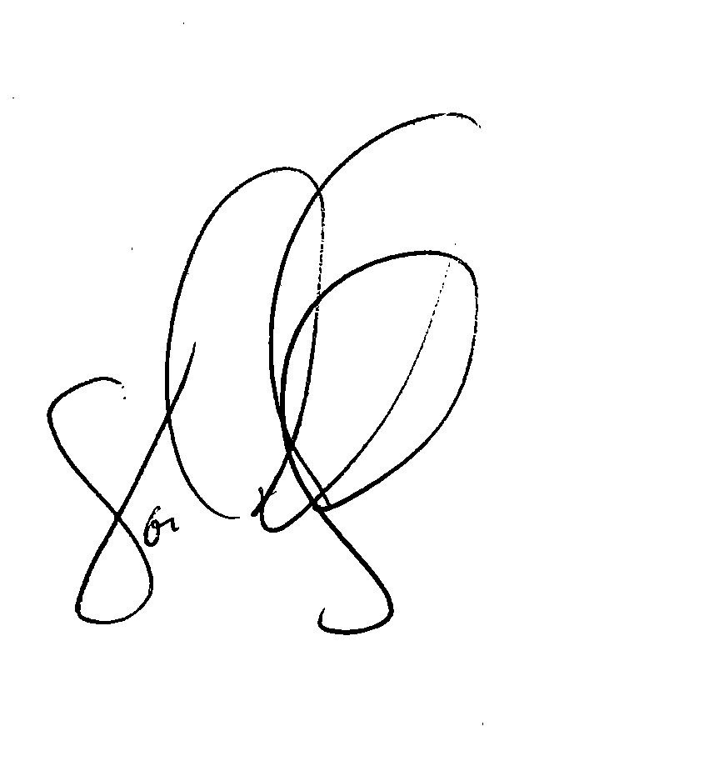
Sincerely Yours,
Jon Harding

Superintendent, Kansas State School for the Blind

Standards for the use of Emergency Safety Interventions

Emergency safety interventions law sets forth standards for the use of restraint and seclusion to ensure that all Kansas students and staff have a safe learning environment. The standards
found in the emergency safety intervention statutes and regulations are required to be followed in all Kansas public school districts and accredited private schools.

An emergency safety intervention is the use of seclusion or physical restraint. The use of an emergency safety intervention shall cease as soon as the immediate danger of physical harm and violent action ceases to exist.

Before using an emergency safety intervention, a school employee witnessing the student’s behavior must have determined that less restrictive alternatives to emergency safety interventions, such as positive behavior interventions support, were inappropriate or ineffective under the circumstances.

An emergency safety intervention shall be used only when a student presents a reasonable and immediate danger of physical harm to such student or others with the present ability to effect such physical harm. Violent action that is destructive of property may necessitate the use of an emergency safety intervention if there is a reasonable and immediate danger of physical harm. An emergency safety intervention may not be used for purposes of discipline, punishment, or for the convenience of a school employee.

Physical restraint means bodily force used to substantially limit a student’s movement. Physical restraint is NOT:
- Consensual, solicited or unintentional contact and contact to provide comfort, assistance or instruction;
- physical escort;
- prescribed treatments for a student’s medical or psychiatric condition by a person appropriately licensed to issue these treatments;
- protective or stabilizing devices either ordered by an appropriately licensed professional or required by law;
- any device used by a law enforcement officer in carrying out law enforcement duties; and
- seatbelts and any other safety equipment when used to secure students during transportation.

Prohibited types of restraints:
  - Prone, or face-down, physical restraint;
  - supine, or face-up, physical restraint;
  - any physical restraint that obstructs the airway of a student;
  - any physical restraint that impacts a student’s primary mode of communication;
  - chemical restraint (‘‘chemical restraint’’ means the use of medication to control a student’s violent physical behavior or restrict a student’s freedom of movement.); and
  - mechanical restraint (‘‘mechanical restraint’’ means any device or object used to limit a student’s movement).

Seclusion means placement of a student in a location where:
  - The student is placed in an enclosed area by school personnel;
  - the student is purposefully isolated from adults and peers; and
  - the student is prevented from leaving, or the student reasonably believes that such student will be prevented from leaving, the enclosed area.

An emergency safety intervention may not be used with a student if the student is known to have a medical condition that could put the student in mental or physical danger as a result of the use of an emergency safety intervention unless not using an emergency safety intervention would result in significant physical harm to the student or others. The medical condition must be indicated in a written statement from the student’s licensed health care provider, and a copy of which shall be provided to the school and placed in the student’s file.

When a student is placed in seclusion, a school employee shall be able to see and hear the student at all times.
If a seclusion room has a locking door it must be designed to ensure that the lock automatically disengages when the school employee viewing the student walks away from the seclusion room, or in cases of emergency, such as fire or severe weather.
A seclusion room must be a safe place. The room must have good ventilation and lighting, and be free of any condition that could be a danger to the student. The room must also be similar to other rooms where students frequent.

Seclusion is not time-out, which is a behavioral intervention in which a student is temporarily removed from a learning activity without being confined.

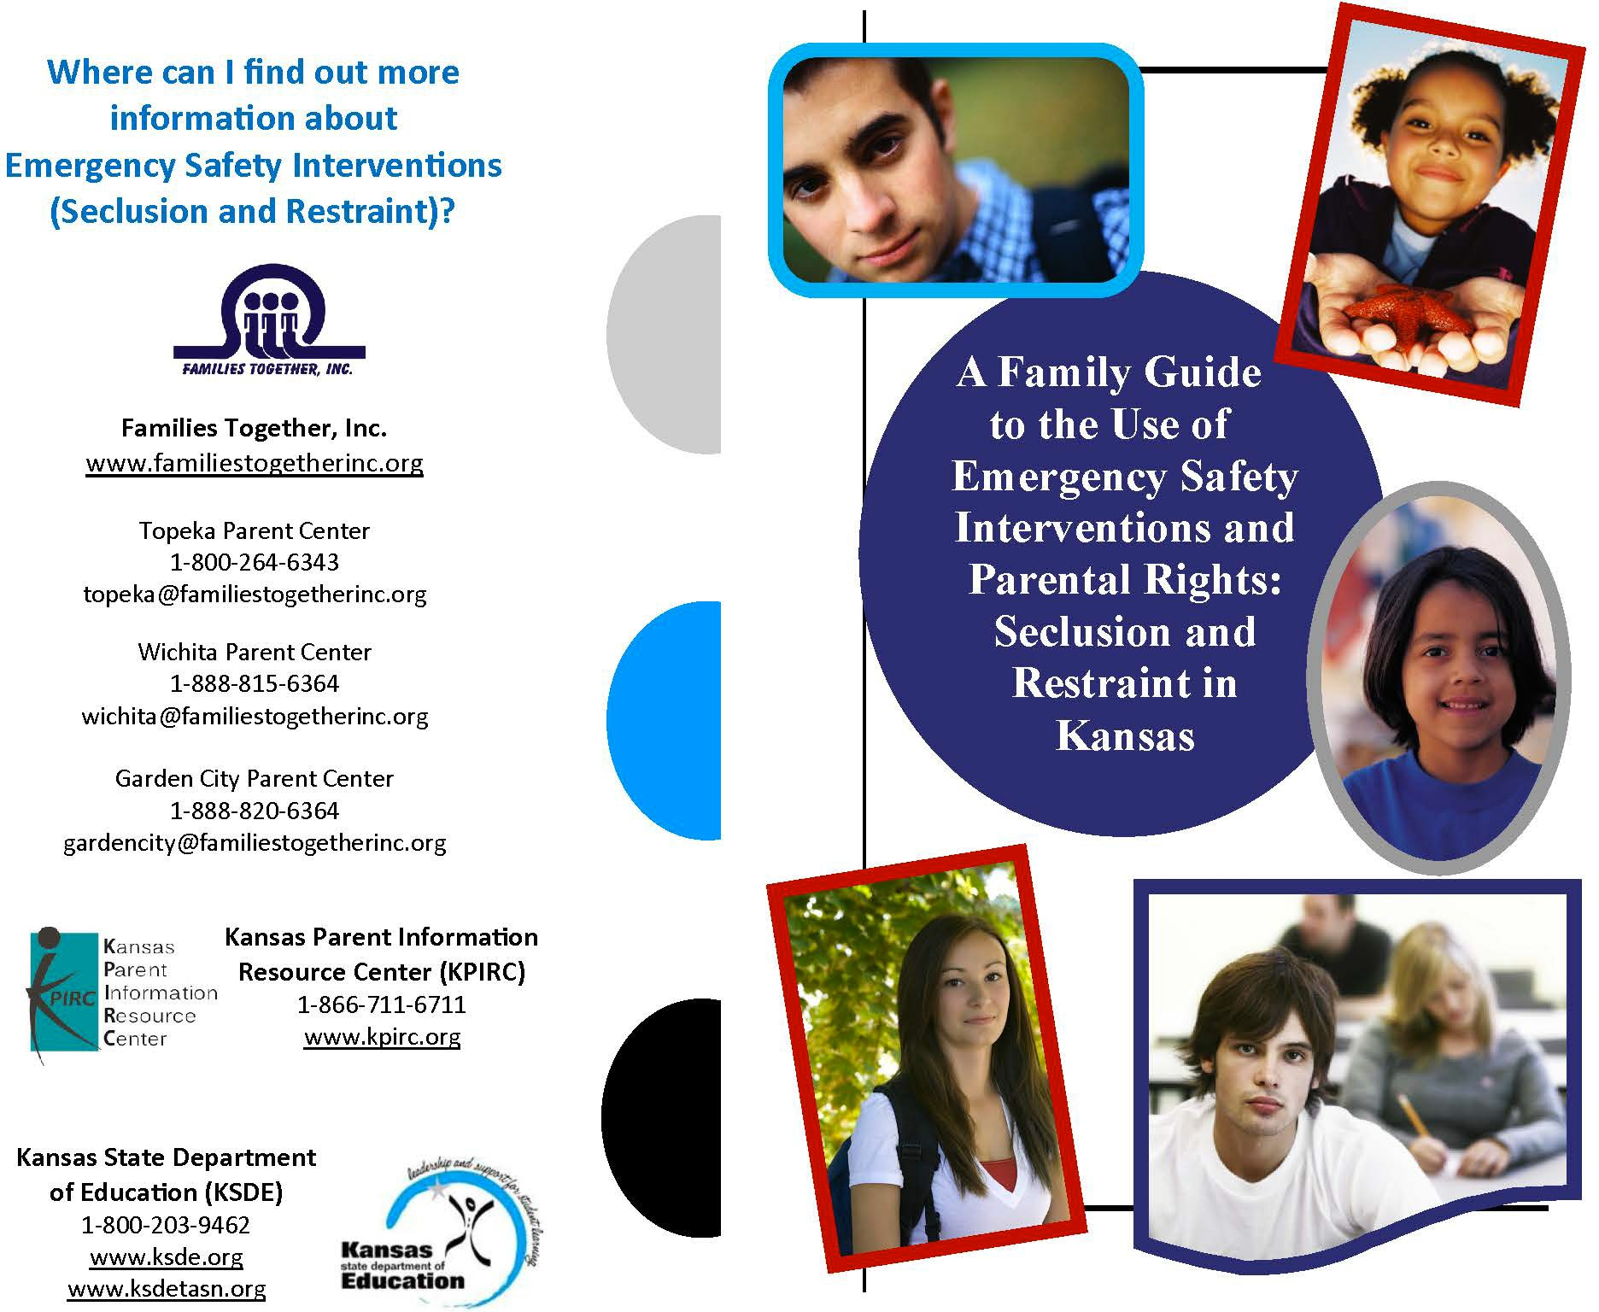

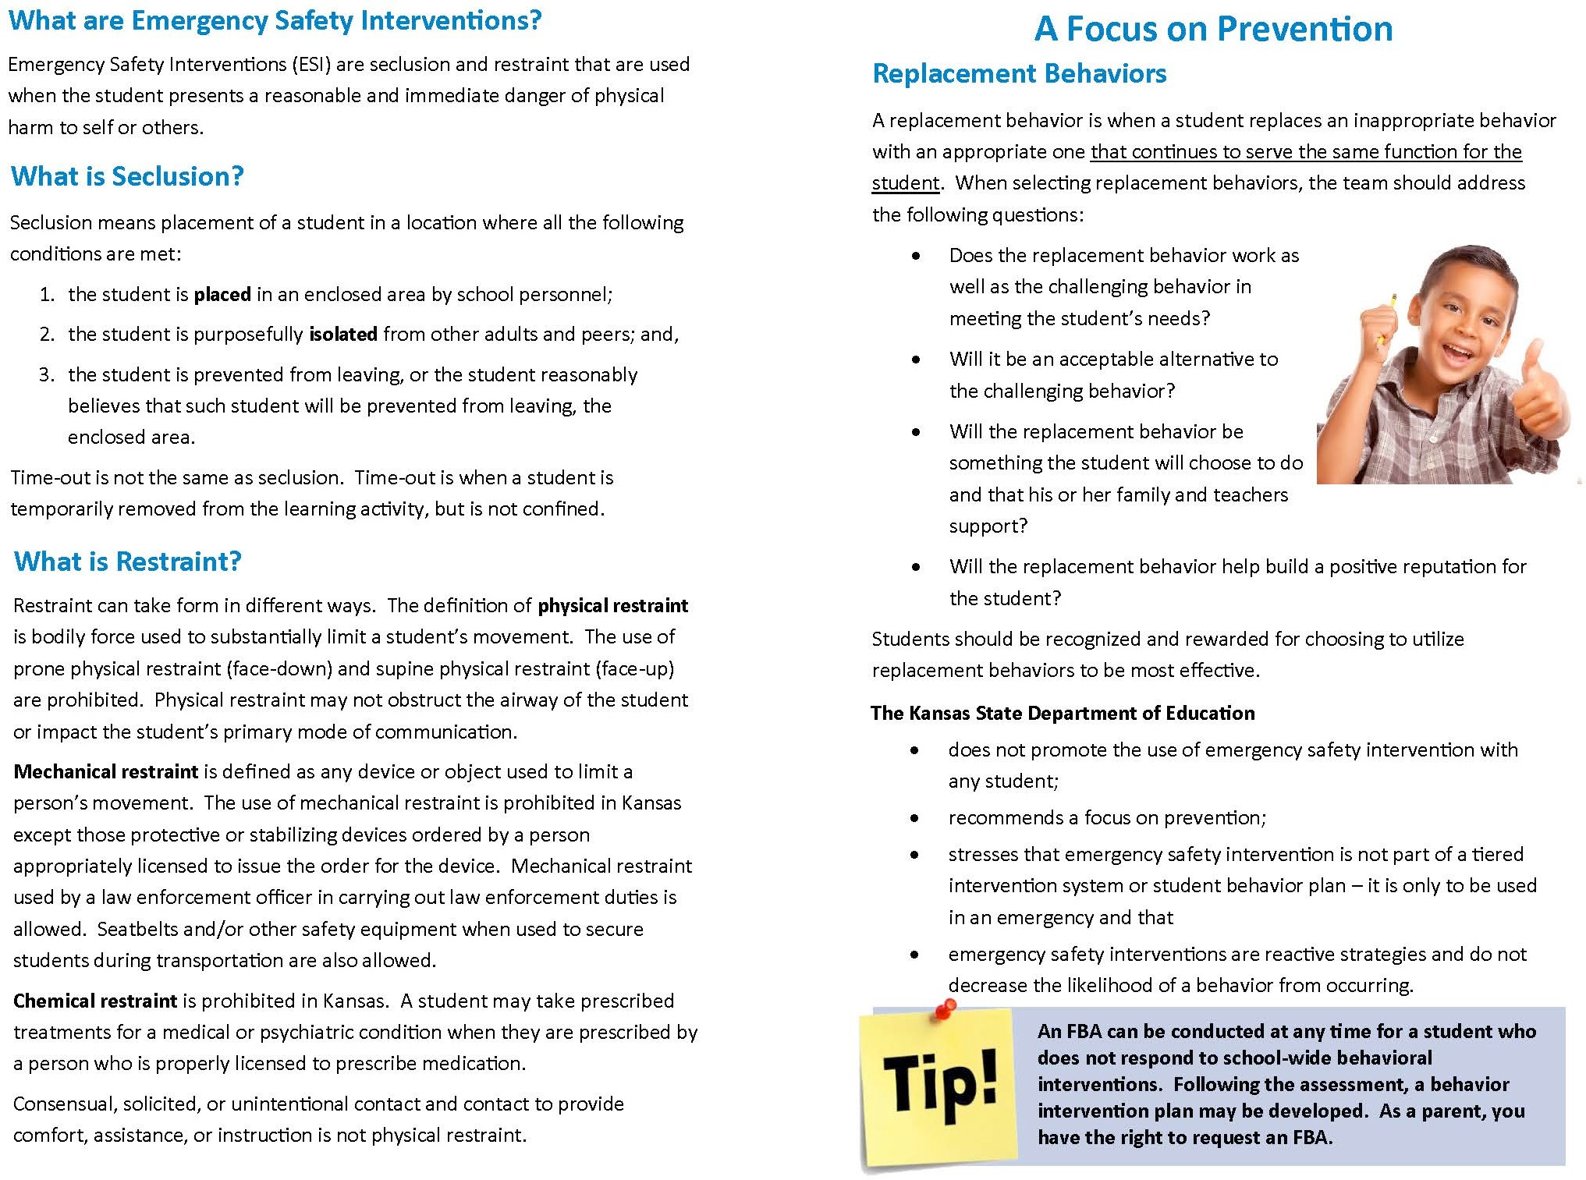

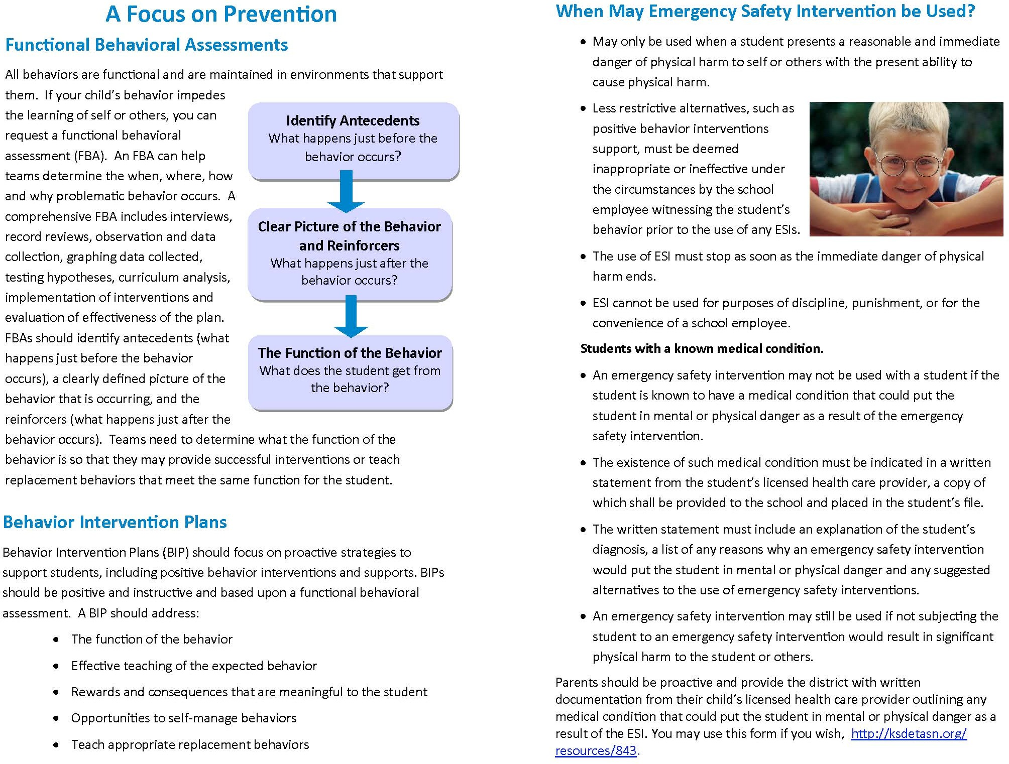

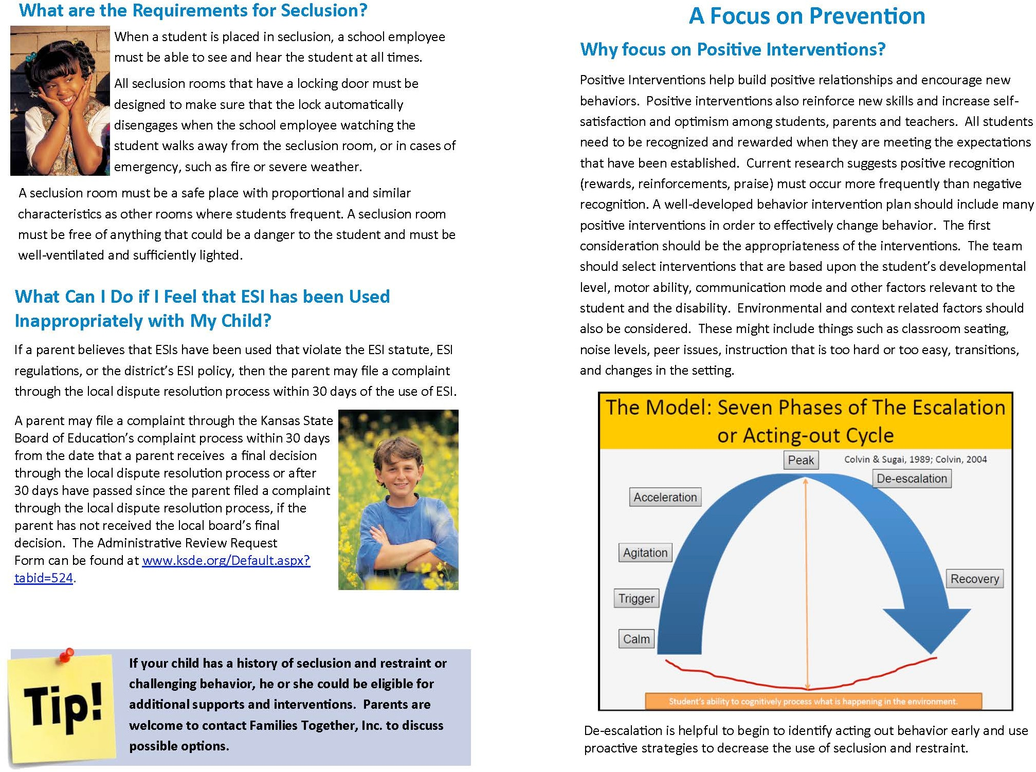

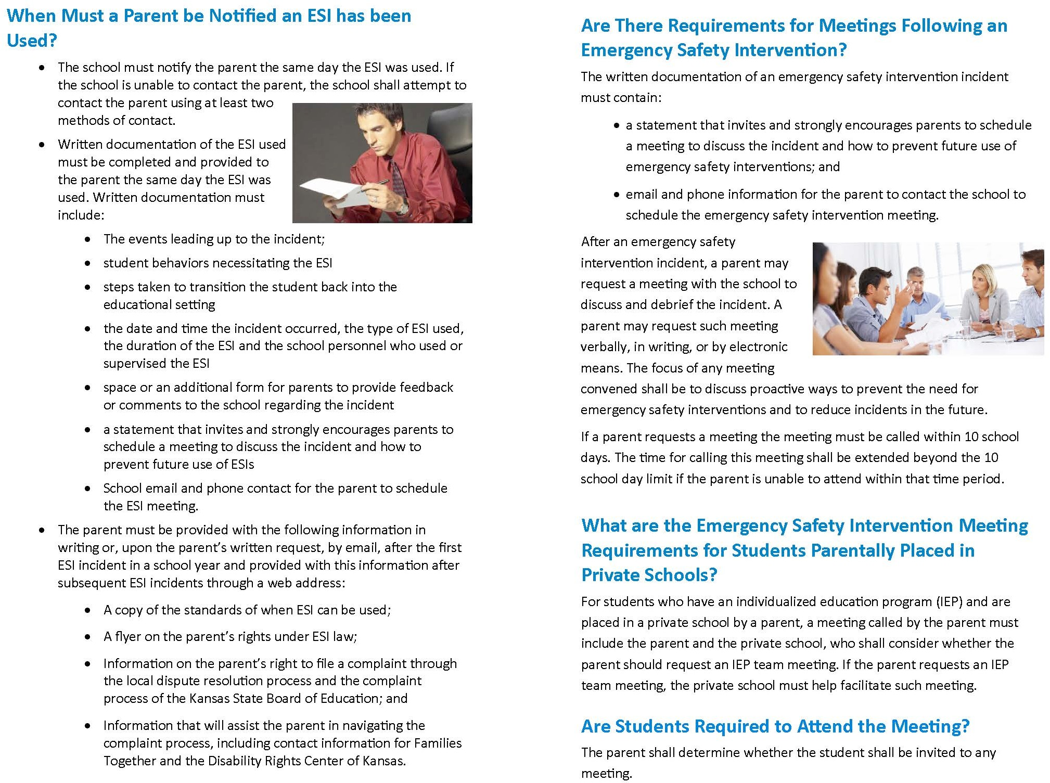

Local Dispute Resolution Guide for Parents

Emergency safety intervention incident occurs; parent notified

You receive documentation and feel emergency safety intervention was used appropriately.
You feel the use of emergency safety intervention did not follow the district's emergency safety intervention policy or emergency safety intervention law.

You are strongly encouraged and invited to schedule a meeting, using the contact information in this document, to discuss the incident and how to prevent future use of emergency safety interventions.

If the local board does not issue a written decision, you may proceed to the state board administrative review process.

You may file a written complaint with your local board of education within 30 days of being informed of the use of emergency safety intervention.

Upon receiving a complaint, the local board will desginate an individual to oversee an investigation, maintaining confidentiality

The local board must mail the written findings of fact. a final decision, and any corrective action within 30 days of receiving the complaint.

If this is effective, the building administrator should provide written documentation of the issues to the superintendent.

Upon receiving the local board's written decision, you may determine the findings are sufficient and consider your concern resolved.
Upon receiving the local board's written decision, you may determine that your concern was not resolved.
You may proceed to the state board administrative review process.

State Board Administrative Review Process

Refer to K.A.R. 91-42-5 for complete information. The following provides a summary of the regulations regarding an administrative review initiated with the Kansas State Board of Education (State Board).

    - If a parent believes an emergency safety intervention was used in violation of K.S.A. 2016 Supp. 72-89d01 through -89d09 or K.A.R. 91-42-1 through -7 and the parent filed a written complaint with their local board of education, then this parent may request an administrative review of the local board’s decision from the State Board.
      - The request for administrative review must include the following information:
        - Name of the student and contact information;
        - Names and contact information for all involved parties (teachers, aides, administrators, and district staff), to the extent known;
        - A detailed statement of the reason for requesting an administrative review;
        - Any supporting facts and documentation; and
        - A copy of the complaint filed with the local board, the local board’s final decision (if issued).
        - The written request for administrative review must be typed or legibly written and signed by the parent.
        - Relevant documents must be attached or, if unavailable, the documents must be referenced in the request for administrative review.
        - Written consent to disclose any personally identifiable information from the student’s education records necessary to conduct an investigation

    - The request for administrative review must be filed with the Commissioner of Education within 30 days of the local board issuing its final decision OR within 60 days from the date the parent filed a complaint with the local board, if the local board did not issue a final decision. You may mail this request to the Kansas State Department of Education, Landon State Office Building, 900 SW Jackson Street, Office of General Counsel, Room 102, Topeka, Kansas 66612. KSDE has provided a form for you to use, if you wish, and you can find it on the Emergency Safety Interventions page of the KSDE website, www.ksde.org/Default.aspx?tabid=524.

    - A Hearing Officer will be designated by the State Board. The Hearing Officer must send a copy of the request for administrative review to the local board.

    - The Hearing Officer will consider the local board’s final decision and may initiate an investigation that could include:
      - A discussion with the parent, during which additional information may be gathered;
      - Contact with the local board or other district staff to allow the local board to respond to the request with information supporting its final decision; and
      - An on-site investigation by Kansas State Department of Education staff.

    - If new information is discovered that was not made available to both the parent and the local board during the dispute resolution process, the Hearing Officer may send the issue back to the local board.
      - If sent back to the local board, the Hearing Officer’s case will be closed and the local board has 30 days to issue a written amended final decision.
      - If the parent feels the local board’s amended final decision does not adequately address the issue, the parent may file a new request for administrative review with the commissioner by following the above process for requesting administrative review. This must be done within 30 days of the local board issuing its amended final decision. If the local board does not issue an amended final decision within 30 days, then the parent has 30 days from the date the Hearing Officer sent the issue back to the local board to file a request for administrative review with the commissioner.

    - Within 60 days of receiving the request for administrative review, the Hearing Officer will, in writing, inform the parents, school administrator, district superintendent, local board clerk, and the state board of the results of the review. This time frame may be extended for good cause upon approval of the commissioner.

    - The results of the administrative review will contain findings of fact, conclusions of law, and any suggested corrective actions. The Hearing Officer’s determination will include one of the following:
      - The local board appropriately resolved the complaint.
      - The local board should re-evaluate the complaint with suggested findings of fact.
      - The Hearing Officer’s suggested corrective active is necessary to ensure that local board policies meet legal requirements.

State Administrative Review Guide for Parents

You filed a complaint with the local board and you are not satisfied with the final decision about the use of an emergency safety intervention (ESI).

Written request must include:
A request for an administrative review may include, but is not limited to, the following allegations:
- An emergency safety intervention was used with your child when your child did not present a reasonable and immediate danger of physical harm to themselves or others with the present ability to effect such physical harm.
- The district used a form of banned restraint including prone, supine, physical restraint that obstructs the airway of your child, physical restraint that impacts your child’s primary mode of communication, chemical or mechanical restraint that does not meet an exception.
- Less restrictive alternatives to emergency safety intervention were not deemed inappropriate or ineffective before emergency safety intervention was used.
- The use of emergency safety intervention with your child did not stop as soon as the immediate danger of physical harm stopped.
- emergency safety intervention was used with your child for discipline, punishment, or convenience.
- Emergency safety intervention was used with your child and you have provided school staff with documentation from your child’s licensed health care provider that seclusion could put your child in mental or physical danger.
- Seclusion was used with your child and school staff could not see and hear your child at all times.
- Your child was put in a seclusion room with a locking door that does not automatically disengage when school staff walk away or in an emergency.
- Your child was put in a seclusion room that was unsafe, not well- ventilated, or not sufficiently lighted.
- Name and contact information of student that emergency safety intervention was used with
- Name and contact information for all people involved
- Statement describing the basis for the review with all supporting facts and documentation

File a request for administrative review with the Kansas State Board of Education. You must do this within 30 days of the local board's final decision or, if the local board failed to issue a final decision, within 60 days of the date you filed a complaint with the local board.
- The local board’s final decision, if one was issued
- Type or legibly write the complaint and sign it
- Written consent to disclose any personally identifiable information
You may use the form on the KSDE website, www.ksde.org/Default.aspx?tabid= 524.

Mail this request to the Emergency Safety Intervention Administrative Review Request, Kansas State Department of Education, Office of General Counsel, 900 SW Jackson Street, Room 102, Topeka, Kansas 66612

The Kansas State Board of Education will designate a Hearing Officer to conduct a review of the local board's final decision.

The Hearing Officer may initiate a separate investigation that may include:

Investigation results will be provided to the parents, school administrator, district superintendent, local board, and state board within 60 days of the commissioner's receipt of the request for administrative review.
  - A discussion with the parent;
Contacting the local
•
board or other staff involved; and
  - An on-site investigation.

If the Hearing Officer finds new information, they may send the issue back to the local board. If you are not satisfied with the local board’s amended decision the right to request administrative review begins again.

State and Community Resources

General Emergency Safety Intervention Information: www.ksdetasn.org www.ksde.org/Default.aspx?tabid=524

Emergency Safety Intervention Questions:
Laura Jurgensen
Kansas State Department of Education ljurgensen@ksde.org
785-296-5522

Parent Training and Information Center: Families Together http://familiestogetherinc.org/
888-815-6364

Protection and Advocacy System: Disability Rights Center of Kansas http://www.drckansas.org/
877-776-1541 or 785-273-9661

