Emergency Procedures

Kansas State School for the Blind
1100 State Avenue Kansas City KS 66102
Rev. 03/2019

TABLE OF CONTENTS
Alphabetical Order by Subject
Subject Page
ACTIVITY TRIP EMERGENCIES 05
ANTHRAX AND OTHER BIOLOGICAL THREATS 06
BOMB THREAT/SUSPICIOUS PACKAGE 09
BOMB THREAT CHECKLIST 11
BUILDING NUMBERS AND ADDRESSES 03
CHEMICAL/HAZARDOUSMATERIAL RELEASE 12
CRISIS MANAGEMENT TEAM 02
EARTHQUAKE 14
EMERGENCY CONTACT INFORMATION 03
EMERGENCY DRILL INFORMATION 04
FIRE 16
INTRUDER (ARMED/VIOLENT) LOCKDOWN 17
INTRUDER (UNARMED/NON-VIOLENT) 18
LIGHTNING SAFETY 19
MEDICAL EMERGENCY 20
POISONING 22
RESTRICTED ACCESS (LOCKOUT) 23
SEVERE WEATHER (TORNADO/SEVERE THUNDERSTORM) 24
SHELTER-IN-PLACE 26
UTILITY DISRUPTION (ELECTRIC/NATURAL GAS/WATER) 28

CAMPUS EVACUATION
John F. Beatrice L. Lee Community Center (Beatrice L. Lee)
Kansas School for the Deaf (KSD)
Appendix
KSSB Campus Directory
KSSB Campus Map
Evacuation Maps
John F. Beatrice L. Lee Community Center Evacuation Route Map
Kansas State School for the Blind Evacuation Route/Campus Maps

CRISIS MANAGEMENT TEAM
Name | Position | Office # | Cell #
Jon Harding | Superintendent | 913-305-3015 | 913-645-5456
John Martello | Director of Operations | 913-305-3006 (VOIP) | 913-645-5457 (v/t)
Aundrayah Shermer | Director Field Services and Dorm | 913-305-3016 (VOIP) | 913-209-0986 (v/t)
Teresa Chandler | H.R. Director | 913-210-8113 (VOIP) | 913-645-5358 (v/t)
Joe Oborny | Instructional Tech. Coord. | 913-324-5841 (VP) | 913-271-9690 (text)
Jerod Prothe | Network Administrator | 913-210-8115 (VOIP)
Jay Ray | Operations Manager | 913-305-3007 (VOIP) | 913-645-5895 (v/t)
Michele Avery | Nurse | 913-305-3029 (VOIP) | 913-544-5876 (v/t)
Lori Smith | School Social Worker | 913-305-3066 (VOIP) | 913-645-2659 (v/t)
Ron Wilson | Contract Therapist |  | 816-716-4718 (v/t)
Sue Pollan | Dorm Director | 913-305-3050 (VOIP) | 913-645-5452 (v/t)

EMERGENCY CONTACT INFORMATION
Location: 1100 State Avenue, Kansas City KS 66102
Kansas City KS Police Department | 9-1-1
Kansas City KS Fire Department | 9-1-1
Emergency Medical Services | 9-1-1
Poison Control | 1-800-222-1222
Board of Public Utilities (electric, water, sewer)  To report power outages  To report water service issues  Account Numbers  2007748 (electric)  2007749 (electric)  2007750 (water & sewer)  2007751 electric) | 913-573-9522  913-573-9622
Kansas Gas Service (natural gas)  To report a gas leak  Account Numbers  510488650 1607150 91 (1101 N 12th St) Meter #1209321568  510128606 1607151 36 (1100 State Ave) Meter #1200117870  510128606 1607154 00 (1100 State Ave) Meter #1200117867 | 1-888-482-4950

EMERGENCY DRILL INFORMATION
Emergency drills will be conducted throughout the school year. Drills are grouped into two categories; Required and Non-Required (Encouraged).
Required Drills are mandated by the Kansas State Fire Marshal’s Office and will be conducted as required.
- Fire drills conducted monthly.
- Severe Weather (Tornado) drills conducted a minimum of three (3) times per school year. KSSB conducts these drills in September, April, May and June (ESY).
Non-Required (Encouraged) Drills conducted nine times, presently. These include, but are not limited to:
- Intruder (Lockdown)
- Restricted Instruction (Lockout)
- Evacuation
- Shelter-in-Place
- Earthquake
Inclimate Weather Exceptions
Emergency drills will not be conducted if the following weather-related conditions exist:
- If the actual outdoor temperature and/or wind chill factors are less than 25℉, or there is falling precipitation (rain, snow, sleet, etc) no outdoor emergency drills will be conducted.
- If the actual outdoor temperature and/or heat index is is greater than 110℉, or there is falling precipitation (rain) no outdoor emergency drills will be conducted.
Note: The term “mass notification” referred to in the following emergency procedures denotes the current method of contacting staff en masse (i.e., mass notification system, mass texting, calling trees, phone calls, two-way radios, etc.)
Superintendent should call the Crisis Management Team together shortly after an incident to debrief (evaluate) and share information.

ACTIVITY TRIP EMERGENCIES
Each teacher/coach/dorm staff should maintain a folder for each activity trip. This folder should contain rosters, including an emergency contact number for each student. A copy of the student manifest should be placed in the trip folder and a second copy should accompany the teacher/coach/dorm staff on the trip. Teachers/coaches/dorm staff should have designated procedures for handling emergency situations. The following protocol is intended to outline steps to be taken by school personnel should an accident/emergency occur.

PROCEDURE

Staff at the scene:
- Call 9-1-1 if warranted. Follow directions of dispatcher.
- Know your present address or location.
- Confirm information.
- Assess the situation, account for all students and staff.
- Render aid and assistance until emergency responders arrive and take charge of the scene.
- If practical, move unaffected students to a safe location.
- Call building administrator/supervisor or designee and inform them of the situation.
- Share precise information with emergency responders and/or school officials as needed.
- If students are injured and transported, the names of injured students and the locations to which they were transported for treatment will be provided to the school.
- Advise building administrator/supervisor if KSSB vehicles are needed to transport unaffected students and staff back to the school.
- Complete associated paperwork at the scene and at the school.

Administrator
- Notify Superintendent Jon Harding, 913-210-8111 (VOIP) or 913-645-5456 (v/t).
- Notify Security, 913-305-3009 (VOIP) or two-way radio if available.
- Notify the Health Center, 913-305-3030 (VOIP), if students are injured.
- Obtain the names of any injured students or staff and the medical facilities they were transported to.
- Parents/guardians of ALL students on the trip will be notified as quickly as accurate information is available.
- Designate school staff representatives to proceed to any medical facility to which an injured student has been taken to assist parents and to provide support to students, as appropriate.
- Complete appropriate documentation.

Security
- Notify maintenance staff of the situation and advise if vehicles are needed at the scene for transportation back to the school.

ANTHRAX AND OTHER BIOLOGICAL THREATS
Many facilities in communities around the country have received anthrax letters. Most were empty envelopes; some have contained powdery substances. The purpose of these guidelines is to recommend procedures for handling such incidents.

REMAIN CALM
- Anthrax organisms can cause infection in the skin, gastrointestinal system, or the lungs. To do so, the organism must be rubbed into abraded (scraped) skin, swallowed, or inhaled as a fine aerosolized mist. Disease can be prevented after exposure to the anthrax spores by early treatment with appropriate antibiotics. Anthrax is not spread from one person to another person.
- For anthrax to be effective as a covert agent, it must be aerosolized into very small particles. This is difficult to do and requires a great deal of technical skill and special equipment. If these small particles are inhaled, life-threatening lung infection can occur, but prompt recognition and treatment are effective.

SUSPICIOUS UNOPENED LETTER OR PACKAGE WITH THREATENING MESSAGE SUCH AS “ANTHRAX”
- Do not shake or empty contents of any suspicious envelopes or packages.
- Place the envelope or package in a plastic bag or some other type of container to prevent leakage of contents.
- If you do not have a container, cover the envelope or package with anything (clothing, paper, trash can, etc) and do not remove this cover.
- Leave the room and close the door, or section off the area to prevent others from entering.
- Wash your hands with soap and water to prevent spreading any powder to your face.
- Call 9-1-1 and report the incident to law enforcement. Follow instructions given.
- Notify Security, 913-305-3009 (VOIP) or two-way radio if available, and the building administrator.
- List all people who were in the room or area when the suspicious letter or package was recognized. Give this list to both the public health authorities and law enforcement officials for follow-up investigations and advice.

ENVELOPES WITH POWDER THAT SPILLS ONTO SURFACE
- DO NOT attempt to clean up the powder. Cover the spilled contents immediately with anything (clothing, paper, trash can, etc) and do not remove this cover.
- Leave the room and close the door, or section off the area to prevent others from entering.
- Wash your hands with soap and water to prevent spreading any powder to your face.
- Call 9-1-1 and report the incident to law enforcement. Follow instructions given.
- Notify Security, 913-305-3009 (VOIP) or two-way radio if available, and the building administrator.
- If and/or when instructed, remove heavily contaminated clothing as soon as possible and place in a plastic bag or some other container that can be sealed. This should be given to emergency responders for proper handling.
- Shower with soap and water as soon as possible. Do not use bleach or other disinfectants on your skin.
- List all people who were in the room or area when the suspicious letter or package was recognized. Give this list to both the public health authorities and law enforcement officials for follow-up investigations and advice.

ROOM CONTAMINATION BY AEROSOLIZATION
- Turn off local fans and the area HVAC system.
- Leave the area immediately.
- Close the door, or section off the area to prevent others from entering.
- Call 9-1-1 and report the incident to law enforcement. Follow instructions given.
- Notify Security, 913-305-3009 (VOIP) or two-way radio if available, and the building administrator.
- List all people who were in the room or area when the suspicious letter or package was recognized. Give this list to both the public health authorities and law enforcement officials for follow-up investigations and advice.

CENTRALIZED HANDLING OF ALL MAIL AND PACKAGES IS RECOMMENDED
- Use nitrile gloves when handling all mail and packages. Other protective clothing such as a lab coat or apron should also be considered.
- Remove clothing if unknown/suspicious substance leaks from the package and place in a sealable plastic bag.
- Rinse skin with water.

HOW TO IDENTIFY SUSPICIOUS PACKAGES AND LETTERS
- Excessive postage
- Incorrect titles
- Misspellings of common words
- No return address
- Lopsided or uneven envelopes
- Excessive security material such as masking tape, string, etc.
- Ticking sound
- Shows a state or city in the postmark that does not match the return address
- Handwritten or poorly typed addresses
- Titles, but no names
- Oily stains, discoloration or odors
- Excessive weight
- Protruding wires or aluminum foil
- Visual distraction
- Marked with restrictive endorsements such as, “personal” or “confidential”

Image Description: Below is an image called the “Suspicious Mail or Packages” it includes:
Protect yourself, your business, and your mailroom.
If you receive a suspicious letter or package: Stop. Don’t handle, Isolate it immediately, Don’t open, smell or taste. Activate your emergency plan. Notify a supervisor.
Letter: No return address, restrictive markings (personal), sealed with tape, misspelled words, badly typed or written, unknown powder or suspicious substances, possibly mailed from a foreign country, excessive.
Package: oily stains, discolorations, crystallization on wrapper, excelleive tape, strange odor, incorrect title or addressed to title only, rigid or bulky, lopsided or uneven, protruding wires.
If you suspect the mail or package contains a bomb (explosive), or radiological, biological, or chemical threat: Isolate area immediately, Call 911, Wash your hands with soap and water
United State Postal Service

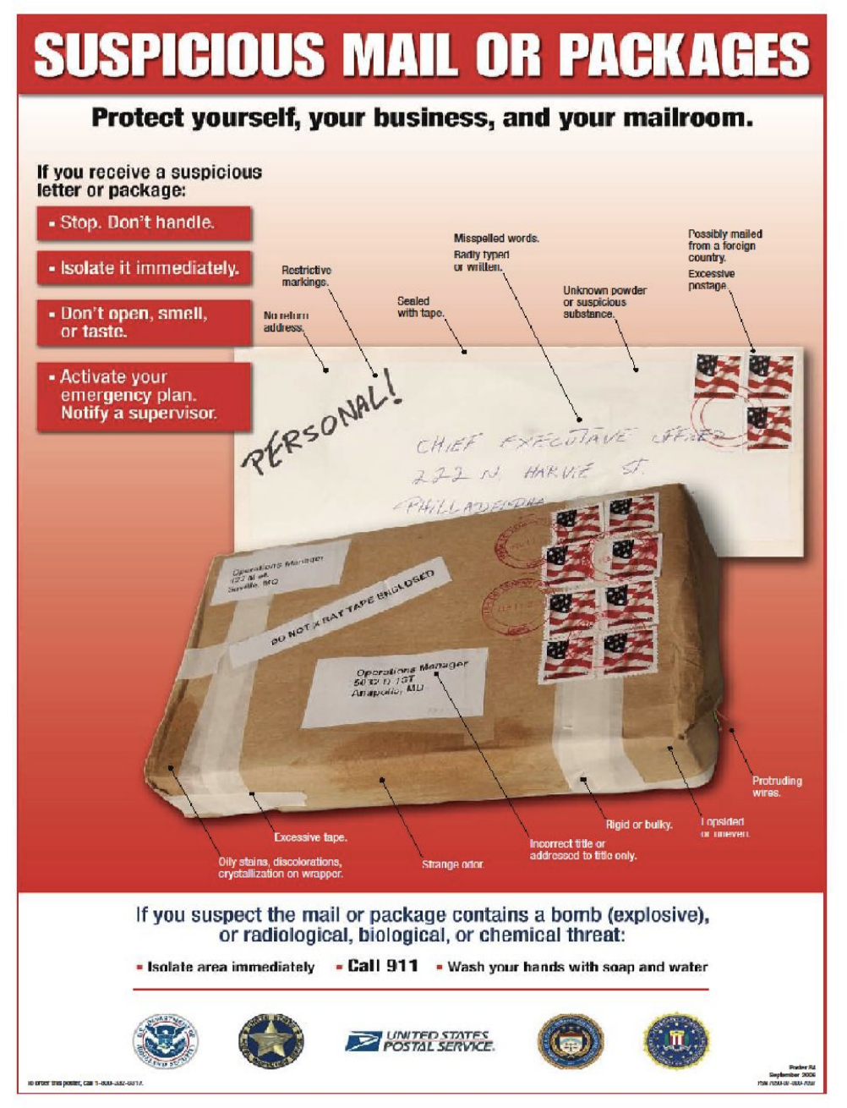

BOMB THREAT/SUSPICIOUS PACKAGE
A bomb threat is the expression of the intent to cause physical harm or damage by the use of an explosive device. In the event that a bomb threat is received, or a suspicious package is found on campus, the following procedure should be followed. Do Not Handle Suspicious Packages (see Anthrax and other Biological Threats on page 6 for additional information).

PROCEDURE
DO NOT EVACUATE UNLESS DIRECTED OTHERWISE BY EMERGENCY RESPONDERS
Notify the building administrator of the threat or suspicious package.
Contact Security, 913-305-3009 (VOIP), Do Not Use 2-way Radio or cell phone if a bomb threat was received. Radio/Cell Phone frequencies may trigger the device.
If a threat is made via telephone keep the caller on the line as long as possible and use the Bomb Threat Checklist on the following page to collect information from the caller.
When instructed by the building administrator visual inspections and searches are to be conducted as follows:
Administrators - building administrators will be charged with directing building searches as outlined, and gathering information on the results.
Administrative Assistants/Building Staff - Visually scan your area, including under furniture, for anything out of the ordinary. Begin your visual scan at the bottom of your room/area and work your way up to the ceiling. Visually scan the ceiling tiles for anything out of the ordinary. Do Not Touch Anything. After you have completed your visual scan, report the results to the building administrator. Stay in your area until otherwise directed by emergency responders or administrator.
Security
- Call 9-1-1 and follow instructions. Staff notification will be determined upon instructions from dispatch. Some devices can be triggered by radio/cell phone frequencies. Escort emergency responders to the scene.
Maintenance
- Visually scan the public areas inside the building as outlined above. Visually scan the perimeter of the building. Check shrubs, flower beds, garbage cans, parking lot, etc. Report results to the building administrator.

BOMB THREAT CHECKLIST

Date:

Exact time of call:

Person taking the call: ( ) Voice ( ) Relay ( ) Other

Exact words of caller:

Questions to ask:
- When is the bomb going to explode?
- Where is the bomb?
- What does it look like?
- What kind of bomb is it?
- What will cause the bomb to explode?
- Did you place the bomb?
- Why was it placed?
- Where are you calling from?
- What is your address?
- What is your name/group?

Caller’s voice: (circle or underline all that apply)
Calm Normal Stutter Accent Slurred Deep
Stressed Disguised Excited Sincere Lisp Giggling
Crying Rapid Nasal Angry Broken Slow
Squeaky Loud

Misc. information
If voice sounds familiar, who does it sound like?:
Describe any background noise:
Remarks:

UNCLASSIFIED
Bomb Threat Stand Off Distances

Description of Graphic on page 12: Unclassified Bomb Threat Stand-off Distances
Threat Description | Explosives Capacity (TNT Equivalent | Building Evacuation Distance | Outdoor Evacuation Distance
Pipe Bomb | 5 lbs / 2.3 KG | 70 FT / 21 M. | 850FT / 259 M
Briefcase/suitcase bomb | 50 lbs / 23 KG | 150 FT / 46 M. | 1,850FT / 564 M
Compact Sedan | 500 lbs / 227 KG | 320 FT / 98 M. | 1500FT / 457 M
Sedan | 1000 lbs / 454 KG | 400 FT / 122 M. | 1750FT / 533 M
Passenger / Cargo Van | 4,000 lbs / 1,814 KG | 600 FT / 183 M. | 2750FT / 838 M
Small Moving Van/Delivery Truck | 10,000 lbs / 4,536 KG | 860 FT / 262 M. | 3750FT / 1,143 M
Moving Van/Water Truck | 30,000 lbs/13.608 KG | 1240 FT / 378 M. | 6500FT / 1981 M
Semi-Trailer | 60,000 lbs/27,216 KG | 1500 FT / 457 M. | 7000FT / 2134 M
This table is for general emergency planning only. A given building's vulnerability to explosions depends on its construction and composition. The data in these tables may not accurately reflect these variables. Some risk will remain for any person closer than the outdoor evacuation distance.
The preferred area is beyond the outdoor evacuation distance for evacuation of people in buildings and mandatory for people outdoors.
All personnel in the area between the building evacuation distance should seek shelter immediately inside a building away from windows and exterior walls. Avoid having anyone outside - including those evacuating - in this area.
All personnel must evacuate, both inside of buildings and out when in the area near the bomb.
- Based on maximum volume or weight of explosive (TNT equivalent) that could reasonably fit in a suitcase or vehicle.
- Governed by the ability of typical US commercial construction to resist severe damage or collapse following a blast. Performances can vary significantly, however, and buildings should be analyzed by qualified parties when possible.
- Governed by the greater fragment throw distance or glass breakage/falling glass hazard distances. Note that pipe and briefcase bombs assume cased charges that throw fragments farther than vehicle bombs.
- A known terrorist tactic is to attract bystanders to windows, doorways and the outside with gunfire, small bombs or other methods and then detonate a larger more destructive device, significantly increasing human casualties.

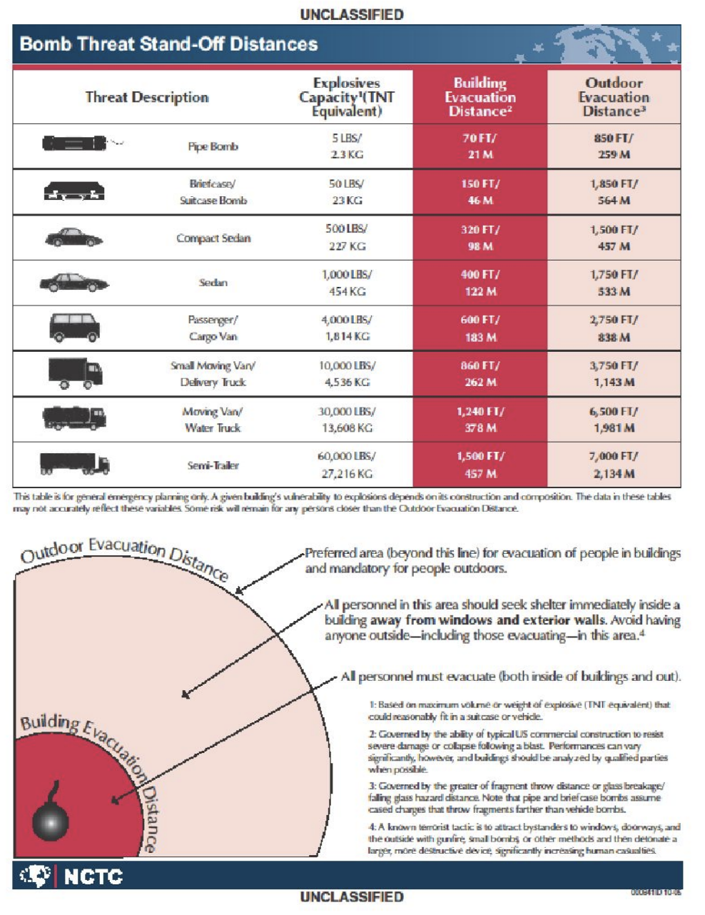

ARMED AGGRESSOR/VIOLENT INTRUDER
(Intruder Lockdown)
Disruptions/Intruders/Missing Child/Abductions - A group of emergencies where school personnel or an individual is placed in imminent danger. These emergencies always require immediate and decisive actions.
No weapons of any kind (including licensed guns, concealed or openly carried) are allowed on school property [K.S.A. 75-7c01 et. seq., K.S.A. 75-7c20(k)].

PROCEDURE
- Call 9-1-1
- Call Security, 913-305-3009 (VOIP) or 2-way radio if available, AFTER 9-1-1 has been contacted. For the sake of time, these calls should be made by two separate individuals if possible. Emergency response and notification will be delayed if both 9-1-1 AND Security and not notified.
- As notification is received in each building staff and students will follow procedure.
- Move quickly into a classroom, office or other securable location.
- Lock the door, turn off the lights, cover the door windows, close and cover the windows (blinds).
- If there is time, barricade the door with heavy objects (desks, chairs, cabinets, etc).
- Hide in an area of the room that cannot be seen from the door.
- Keep quiet and place cell phones on silent mode.
- Monitor mass notification for updates.
- DO NOT evacuate your area if the fire alarm is activated. Remain in cover. Fire alarms may be activated by intruder as a ploy to get you out of your safe area.
- Remain in your location until released by Law Enforcement ONLY.
- All off-campus staff and students are to avoid the campus upon being notified of the incident. Wait for the “all clear” message before returning to the school.

Administration
- Coordinate reunification and intervention plans once the incident has safely concluded.
- Contact the school counseling team to assist in the efforts.

Security
- Activate mass notification and provide updates as available.
- Call 9-1-1 and coordinate response.
- Open gate for emergency responders.
- Send “all clear” message when the incident has safely concluded.
- Assist in post-incident efforts as directed by administrators.

UNARMED OR NON-VIOLENT INTRUDER
Disruptions/Intruders/Missing Child/Abductions - A group of emergencies where school personnel or an individual is placed in imminent danger. These emergencies usually require immediate and decisive actions.

PROCEDURE
- Notify building administrator or designee.
- Do Not approach the intruder alone. Ask another staff member to accompany you.
- Politely greet the intruder and identify yourself.
- Ask the intruder the purpose of his/her visit.
- Inform the intruder that all visitors must sign in at Security. If the intruder’s purpose is not legitimate, ask him/her to leave. Accompany him/her to the exit.

If the intruder refuses to leave:
- Consider placing the impacted building into a Restricted Access condition (see page 14). Initially, you may desire to restrict student/staff movement outside of the classroom.
- Contact Security, 913-305-3009 (VOIP) or 2-way radio if available.
- Advise the intruder of the consequences for remaining on school property. Actions are now considered trespassing.
- Call 9-1-1 and advise that the intruder refuses to leave. Provide a full description of the intruder. Keep the intruder unaware of this call if possible.
- Walk away from the intruder if he/she indicates a potential for violence. Be aware of the intruder's actions at all times.
- Initiate Armed Aggressor/Violent Intruder (Lockdown) procedure (see page 12), if it is felt that there is an imminent threat to the general safety of the building/campus or occupants.

Security
- Respond to the scene and assess the situation. Follow procedure. Wait for emergency responders, if dispatched.

RESTRICTED INSTRUCTION
(Lockout)
If administrative staff and/or Security determines that there is a threat in the immediate area (nearby school goes into lockdown, criminal activity in the vicinity, etc) the campus will be placed in a Restricted Access (Lockout) condition, limiting movement of individuals.
Once the determination has been made, Security will:
- Activate mass notification advising of the Restricted Instruction condition.
- Have maintenance assist in making sure that everyone has gone indoors before the campus becomes secure.
- Lock all exterior electronic door locks (card reader access).
- Close the main gate.
- Contact 9-1-1 and advise of the situation, if dispatch has not already made contact.
- Monitor the situation.
- Provide staff updates via mass notification.
- Send an “all clear” message when the situation has safely concluded.
- Open the main gate and reset the exterior doors.

PROCEDURE
- As building administrators receive the Restricted Instruction notification they will direct building staff to check nearby exterior manually locking doors, such as fire exit doors in classrooms, to ensure that they are locked and secure.
- Account for all students and staff. Notify building administrator of anyone missing.
- All off-campus staff and students are to avoid the campus upon receiving notification of the Restricted Instruction condition. Wait for the “all clear” message before returning to campus.
- If you are outdoors, return quickly to your assigned building. Visitors should be directed indoors, or allowed to leave campus as appropriate.
- Close windows and blinds in each room.
- Unless letting in staff, students or visitors, stay away from building entrances where there is a lot of exterior visibility.
- Resume normal activities within each building.
- DO NOT go outdoors unless authorized by the building administrator. If authorized, notify Security and go quickly and directly to your destination. Movement in groups is not recommended. There should be as little outdoor activity as possible.
- Monitor mass notification for updates.
- Once the “all clear” message has been received staff and students may resume normal campus activity.

Maintenance
- Assist Security in making sure that everyone has gone indoors before the campus becomes secure.

MEDICAL EMERGENCIES

PROCEDURE
- Contact 9-1-1 if warranted.
- Contact Health Center, 913-305-3030 (VOIP), and advise of the situation.
- Notify building administrator or designee.
- Contact Security, 913-305-3009 (VOIP) or two-way radio if available
- Provide immediate medical attention including performing necessary life-sustaining measures (first aid, CPR, AED, etc), until emergency responders arrive.
- Do not move patient unless he/she is in immediate danger of further injury.
- Keep the patient comfortable and protect his/her privacy.
- After immediate needs have been met, remain to assist emergency responders with pertinent information about the incident.
- Minimize the gathering of crowds and curious onlookers.
- Non-incapacitated patients should be taken to the building office or Health Center for assistance.
- Contact parents/guardians as appropriate to seek follow-up services if needed.
- Complete appropriate documentation.
- Contact Housekeeping if the scene need to be cleaned.

Nurses
- Respond to the scene, with student information, and render assistance if able to do so.
- Take charge of the scene upon arrival.
- In accordance with HIPPA privacy laws only nursing staff and emergency medical personnel will be allowed to handle student medical files/information.

Security
- Respond to the scene to assist with crowd control & direct emergency responders to the scene.

Other suggested preventative/supportive actions
- Post in the main office the names of building staff who have completed first aid, CPR, AED, or other special medical training (form can be found in Appendix D of the KSSB Emergency Operations Manual).
- Provide in-service training in basic first aid for staff (utilize school nurses or other trained health professionals).
- Provide each teacher with information about students in his/her classroom having special medical or physical needs; such conditions might include allergies, fainting, seizures, or diabetes; include procedures that the teacher may follow in these specific emergencies.

Do Not
- Move an ill or injured person until evaluated.
- Give anything by mouth to an unconscious person.
- Attempt to reduce dislocations.
- Diagnose or try to give medical advice.
- Send a student home before consulting the parents.
- Discuss the incident afterwards.

POISONING

Procedure
- Call the Poison Control Center Hotline 1-800-222-1222 and follow instructions.
- Follow Medical Emergencies procedure (see page 15).
- Refer to the building Safety Data Sheets (SDS) (formerly referred to as Material Safety Data Sheets - MSDS).
- In the event that a staff member has been poisoned, a school official will notify spouse, or next of kin, as applicable.

Preventative Measures
- Keep poisonous materials in a locked and secure location.
- Post the Poison Control Center Hotline number in the main office of each building.
- Post the names of building staff who have special emergency medical training (form can be found in Appendix D of the KSSB Emergency Operations Manual).
- Familiarize staff with the building Safety Data Sheets (SDS).
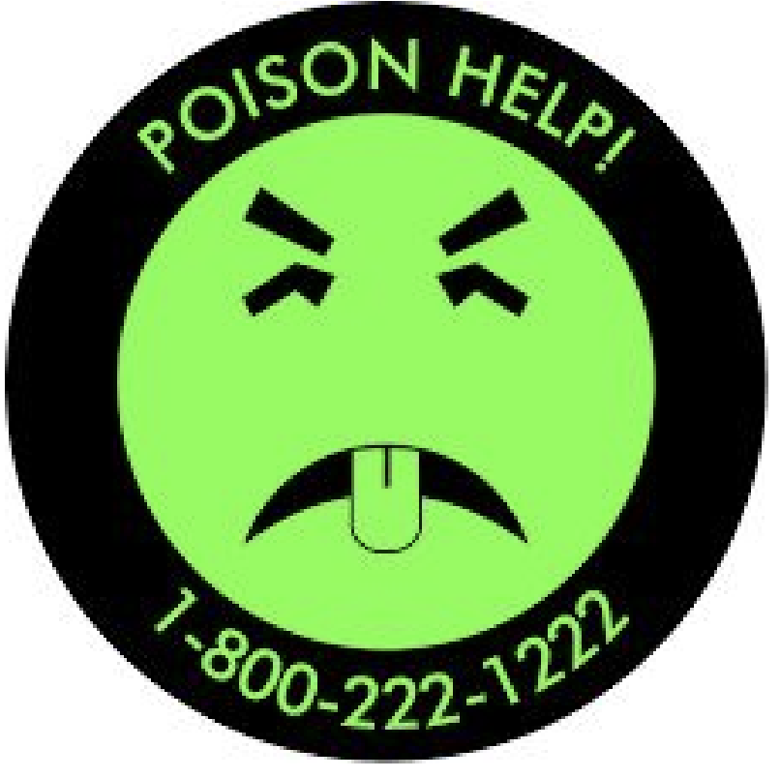
- Keep the building SDS binder in an accessible location.

EARTHQUAKE
Because earthquakes can strike without warning, the immediate need is to protect lives by taking the best available cover. All other actions must wait until the tremor subsides. If persons are protected from falling objects, the rolling motion of the earth may be frightening, but may not be dangerous.

Procedure

If Indoors
  - Drop, Cover, Hold On!
  - If no cover is available, get against an inside doorway or crouch against an inside wall and cover your head; stay away from outside walls, windows, or other large panes of glass, potential falling objects.
  - Leave doors open to minimize jamming if the building shifts.
  - Do not attempt to run through the building or outside due to risk of falling objects.
  - If in a room with no desks or furniture, get against an inside wall or inside doorway & crouch.
- After the initial shock, evacuate the building and account for all students and staff.

If Outdoors
  - Move quickly away from the building and overhead electrical wires.
  - Lie flat, face down, and wait for shocks to subside.
  - Do not attempt to enter a building until authorized to do so.
  - Do not light fires (possible gas leaks) or touch fallen wires (possible electrocution).
- Wait for instructions from building administrator or Security.

Evacuation Assembly Areas
- Keep away from buildings and overhead electrical wires.
- Keep away from underground gas and sewer lines.
- Contact 9-1-1
- Contact Security, 913-305-3009 (VOIP) or two-way radio if available
- In the event of aftershocks, students should be encouraged to remain calm and remain sitting close to the ground.
- Administer first aid as needed.
- Do not re-enter buildings until given the “all clear” by emergency responders. Structural damage may not be visible, but may be present.

Additional
- Remember: school facilities may be used to shelter others who have also been impacted by the earthquake.

FIRE
In the event that fire or smoke is observed in a building the following procedure is to be followed:

PROCEDURE
  - Activate the nearest fire alarm pull station.
  - Contact 9-1-1
  - Contact Security, 913-305-3009 (VOIP) or two-way radio if available.
  - Implement evacuation procedures to the assembly area(s). DO NOT use elevators.
  - Assembly areas: Dining Hall (primary). If the dining hall is affected then use Johnson Gym (secondary).
  - Ensure that each room has been cleared.
  - Implement plan for any students needing special assistance. Students with mobility issues should be taken by staff to an uninvolved building exit. Contact Security for assistance if needed.
  - Account for students and staff.
  - Keep driveways and sidewalks clear for emergency responders.
  - Do not re-enter the building until being given the “all clear” to do so. In the event of an actual fire, only fire department personnel are authorized to permit re-entry of the building.
  - If needed, staff and students will be relocated to other buildings for shelter.
  - All off-campus staff and students are to avoid the campus upon receiving notification. Wait for the “all clear” message before returning to campus.
  - Determine if arrangements need to be made for a campus evacuation, or if school is to be dismissed.
- Make certain a reunification plan is in place for students/teachers and students/parents.

Security
- Respond to the affected building upon notification.
- Contact 9-1-1 if there is visible fire or smoke as confirmation.
- Activate mass notification. Update as information become available.
- Direct emergency responders to the scene as needed.
- Assist staff and students with mobility issues as advised.

LIGHTNING SAFETY TIPS
In the event that lightning is observed in the vicinity Security will monitor conditions and send updates via mass notification.
- PLAN in advance your safety measures. When you first see lightning or hear thunder, activate your emergency plan. Now is the time to go into a building or a vehicle. Lightning often precedes rain, so don’t wait for rain to begin before suspending outdoor activities.
- IF OUTDOORS, avoid water. Avoid the high ground. Avoid open spaces. Avoid all metal objects including electric wires, fences, machinery, motors, power tools, bleachers, etc. Unsafe places include underneath canopies, small picnic or rain shelters, or near trees. Where possible, find shelter in a substantial building or in a fully enclosed metal vehicle, such as a car, truck or van, with windows completely shut. If lightning is striking nearby when you are outdoors, you should:
  - Crouch down. Put your feet together. Place your hands over your ears to minimize hearing damage from thunder.
  - Avoid proximity (minimum 15 feet) to other people.
- IF INDOORS, avoid water. Evacuate swimming pool immediately! Stay away from doors and windows. Do not use the telephone. Take off headsets. Turn off, unplug and stay away from appliances, computers, power tools and TV sets. Lightning may strike exterior electric and phone lines, including shocks to inside equipment.
- SUSPEND ACTIVITIES for 30 minutes after the last observed lightning strike, or audible thunder clap.
- INJURED PERSONS do not carry an electrical charge and can be handled safely. Apply first aid procedures to a lightning victim if you are qualified to do so. Contact 9-1-1 or send for help immediately.
“if you can see it, flee it. If you can hear it, clear it”

SEVERE WEATHER EMERGENCIES
Tornado - Severe Thunderstorm
Severe weather means meteorological conditions are developing or present for weather that is potentially disruptive to normal procedures and/or may develop into conditions that are threatening to persons or property. In the event that there is a risk of severe weather Security will monitor conditions and send weather updates, or activate severe weather procedures as the situation dictates.
Weather advice from the National Weather Service is categorized into three (3) significant terms:
- An “ADVISORY” is issued when the weather is expected to disrupt normal routines but not be life threatening.
- A “WATCH” means weather conditions are favorable for the development of severe weather.
- A “WARNING” means severe weather conditions are occurring in your area.
For a “SEVERE THUNDERSTORM WARNING” each building should be on a heightened alert status ready to respond immediately if protective action is needed. Students should not be released during a severe thunderstorm warning. Parents/ guardians may take custody of their children but should be encouraged to remain sheltered in the school facility.
For a “TORNADO WARNING” (outdoor sirens activated or alert given by media) each building will take immediate protective action. Parents/guardians may take custody of their children but should be encouraged to remain sheltered in the school facility.

PROCEDURE
- When the severe weather alarm is activated ALL building occupants are to proceed in an orderly manner to the designated shelter. DO NOT use the elevators.
- Occupants of the dining hall should evacuate to the lower level Edlund shelter
- Ensure that each room has been cleared.
- If you are outdoors when the alarms are activated seek immediate cover in the nearest designated shelter:
  - Irwin - lower level KIRC
  - Johnson/Vogel - FEMA shelter in Gym
  - Edlund - lower level restrooms
  - Brighton - lower level pool restrooms
  - Cottage - restroom
  - MMaxwell - lower level shelter
  - Account for students and staff.
  - Assume a safe position; seated with head lowered.
  - Monitor mass notification for updates.
  - Remain in the shelter until an “all clear” message has been received.
  - If exiting the shelter is not possible due to building damage remain calm and wait for emergency responders to safely escort you from the building.
  - In the event that exiting the shelter area is delayed for a long period of time, use the building emergency kit that is located in the shelter. Kits include flashlights, emergency radios, first aid supplies, water and other items needed for short-term sheltering. The kit for Edlund is in the computer lab.

Security
  - Activate mass notification and direct activation of alarms.
  - Contact maintenance for assistance as needed.
  - Provide staff updates via mass notification.
  - Send “all clear” message when the event has safely concluded.
- Contact 9-1-1 if emergency assistance is needed.

Maintenance
- Assist Security as needed.
- Quickly check the campus exterior for staff, students and visitors, and direct them to shelter (if time permits).

CHEMICAL/HAZARDOUS MATERIAL RELEASE
Chemical accidents may originate inside or outside the building. Examples include: toxic leaks or spills caused by tank, truck or railroad accidents; water treatment/waste treatment plants; industry or laboratory spills, etc.

Accidents Outside the Building

PROCEDURE
- Notify building administrator.
- Close windows.
- Move students away from the immediate vicinity of danger (if outside, reverse evacuation).
- Observe wind direction by observing flags or leaves and move students upwind.
- Contact 9-1-1.
- Contact Security, 913-305-3009 (VOIP) or two-way radio if available.
- Contact Superintendent Jon Harding, 913-305-3014 (VOIP) or 913-645-5456 (v/t)
- Initiate Shelter-in-Place procedure (see page 24).
- Account for students and staff.
- Do Not leave the building unless instructed to do so. If you must evacuate, take care to avoid fumes.

Security
  - Contact 9-1-1
  - Activate mass notification (Shelter-in-Place procedure). Provide updates as available.
  - Advise Maintenance of the situation.
- Direct emergency responders to the location. Maintenance
  - Turn off campus HVAC systems.

Accidents Inside the Building

PROCEDURE
  - Notify building administrator.
  - Refer to the building Safety Data Sheets (SDS) to determine severity of the situation.
  - Initiate evacuation plan. Avoid the area where the chemical accident occurred and any fumes which are present.
  - Follow standard student assembly, accounting and reporting procedures; modify assembly area if needed to be upwind, uphill, and upstream from the location of spill.
  - Contact 9-1-1 if warranted.
  - Contact Security, 913-305-3009 (VOIP) or two-way radio if available.
  - Contact Superintendent Jon Harding, 913-305-3014 (VOIP) or 913-645-5456 (v/t)
  - Wait for instructions from emergency responders.
  - Do not take unsafe actions such as returning to the building before it has been declared safe.
- Refrain from lighting matches, candles, or other fires which could cause an explosion or ignite volatile fumes.

Security
  - Contact 9-1-1 if warranted.
  - Activate mass notification. Provide updates as available.
  - Advise maintenance of the situation.
- Direct emergency responders to the location.

Maintenance
  - Turn off building HVAC system.

SHELTER-IN-PLACE
In the event that Administration and /or Security determines that there is an immediate threat in the area (such as a chemical release or physical threat to building occupants) the Shelter-in-Place procedure will be activated.
Once the SIP determination has been made:

Security
- Activate mass notification advising of the Shelter-in-Place condition.
- Have maintenance assist in making sure that everyone has gone indoors before the campus becomes secure.
- Lock all exterior electronic door locks (card reader access).
- Close the main gate.
- Contact 9-1-1 and advise of the situation, if dispatch has not already made contact.
- Monitor the situation.
- Provide staff updates via mass notification.
- Send an “all clear” message when the situation has safely concluded.
- Open the main gate and reset the exterior doors. Maintenance
- Quickly check the the campus exterior and direct staff, students and visitors to the nearest SIP location (see below).

PROCEDURE
- As building administrators receive the Shelter-in-Place notification they will direct building staff to check nearby exterior manually locking doors, such as fire exit doors in classrooms, to ensure that they are locked and secure.
- All off-campus staff and students are to avoid the campus upon receiving notification of the Shelter-in-Place condition. Wait for the “all clear” message before returning to campus.
- ALL building occupants are to proceed in an orderly manner to shelter area. Do not go outside.
- Do not use the elevators if the incident is due to a chemical spill (fumes can travel through the elevator shaft).
- Ensure that all rooms have been cleared.
- If you are outdoors when the notification is received seek immediate cover in the nearest designated shelter:
  - Irwin - lower level KIRC
  - Johnson/Vogel - FEMA shelter in Gym
  - Edlund - lower level restrooms
  - Brighton - lower level pool restrooms
  - Cottage - restroom
  - Maxwell - lower level shelter
- Account for students and staff.
- Monitor mass notification for updates.
- Remain in the shelter until an “all clear” message has been received.
- If exiting the shelter is not possible due to building damage remain calm and wait for emergency responders to safely escort you from the building.
- In the event that exiting the shelter area is delayed for a long period of time, use the building emergency kit that is located in the shelter. Kits include flashlights, emergency radios, first aid supplies, water and other items needed for short-term sheltering. The kit for Edlund is in the computer lab.
- If the incident is due to an exterior chemical release, staff is to remove the plastic sheeting and duct tape from the emergency kit and follow the instructions provided in the kit for sealing the doors.

EXPLOSION

PROCEDURE
- Follow Fire procedure (see page 18) once it is safe to leave cover.

Be Informed - Explosions

If there is an explosion...
- Take shelter against your desk or a sturdy table.
- Exit the building as quickly as possible.
- Do not use elevators.
- Check for fire and other hazards.
- Take your emergency kit if time allows.
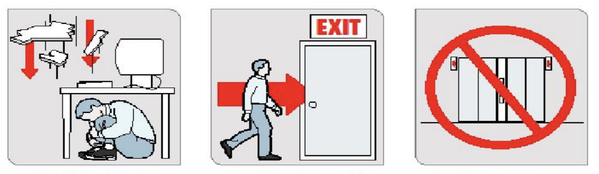

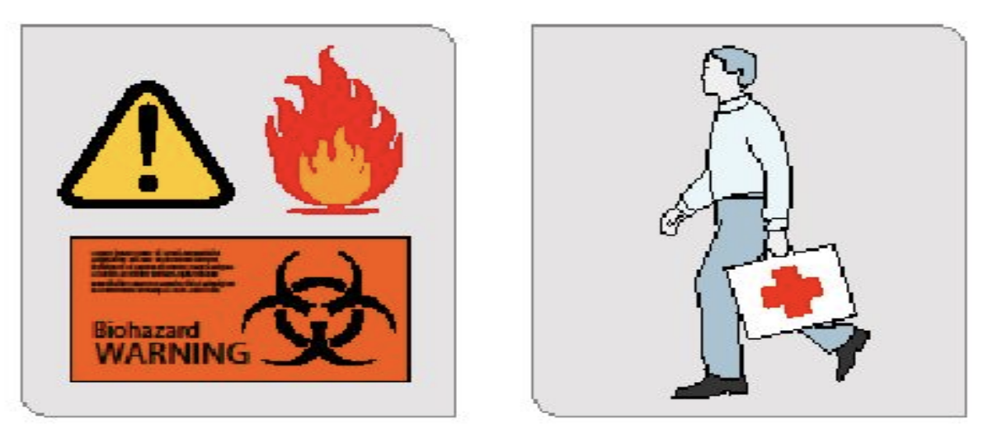

UTILITY DISRUPTION

Natural Gas - Electricity - Water
All school personnel shall immediately report any suspected natural gas leak to the building administrator.

PROCEDURE
- Notify the building administrator.
- If there is an element of danger, move staff and students away from the vicinity of danger.
- Assess the situation.
- Contact 9-1-1 if warranted.
- Implement appropriate procedure (evacuation, shelter-in-place, etc).
- Contact Security, 913-305-3009 (VOIP) or two-way radio if available.
- If evacuation procedure has been implemented do not re-enter the building until given the “all clear” by emergency responders.
- Account for staff and students. Security
- Notify maintenance.
- Activate mass notification and update as available.
- Direct emergency/utility responders to the scene.
Maintenance
- Contact the appropriate utility provider and report the situation.
- Provide utility service assistance as needed.

CAMPUS EVACUATION

Comprehensive
In the event that KSSB has to evacuate the campus for reasons such as a lengthy power outage or water supply interruption, gas leak, nearby environmental issue, unsafe conditions, etc, staff and students will be evacuated to one of two evacuation sites:

Short-term Site
John F. Beatrice L. Lee Community Center, 1310 N. 10th Street, KCK

Long-term Site
Kansas School for the Deaf, 450 E. Park Street, Olathe
The evacuation site will depend on the cause of the evacuation, expected time length, and whether or not one of the sites is affected as well. Follow the evacuation procedure that is announced.
If KSSB administrators determine that there is cause to evacuate the campus Brian Allen, Safety and Security Manager, will be contacted 913-912-2642 (v/t) and an evacuation site will be determined.
As soon as an evacuation order has been given the following departments will complete the following tasks:

Security
- The Safety & Security Manager, or designee, will contact the evacuation site coordinator.
- Activate mass notification and advise staff and students of the evacuation, mode of evacuation, and the evacuation site. Update information as available. Building alarms will not be activated.
- Contact 9-1-1 dispatch and advise of the evacuation. A request for traffic control assistance will be made if the group is walking.
- Remain on campus, if safe, to provide security and assist any outside agencies that may be responding (police, fire, gas, electric, etc.)

KSSB Administrators
- (1) One administrator will drive to the evacuation site to meet with receiving staff and coordinate reunification efforts.
- (1) One administrator will report to the staging area at Johnson Gym, or other designated staging area as needed, to coordinate evacuation efforts.
- Direct movement of the evacuation.
- Assign staff drivers for KSSB vehicles, if needed.

Maintenance
- Take a vehicle to the Health Center for nursing staff use.
- Tend to any maintenance issues related to the evacuation.
- Walk through buildings to make sure everybody is out. Coordinate with Security.
- Remain on campus, if safe, to provide security and assist any outside agencies that may be responding (police, fire, gas, electric, etc.)

Nursing Staff
- Transport students under Health Center care to the evacuation site, or call 9-1-1 for transport.
- Transport student medication that may be needed to the evacuation site.
- Vehicle will be delivered by maintenance staff.

KSSB Staff Drivers (assigned to drive by administrator)
- Check out vehicle keys.
- Ensure safety of vehicle while in possession.
- Return vehicle and keys to KSSB when the evacuation event has concluded.

Building Administrators
- Ensure that all staff and students have been cleared from the building.
- Keep staff/students as calm as possible and in a group.
- Account for staff and students.

Procedure - Beatrice L. Lee Community Center, KCK
- Upon receiving notice of an evacuation ALL staff and students will secure their areas and proceed in an orderly manner to the evacuation staging area in the Johnson Gym, or other designated location as instructed. A head count will be conducted and any missing staff or students are to be reported immediately to the building administrator.
- A member of the KSSB administrative staff will be at the staging area to coordinate evacuation efforts.
- Staff who are not responsible for the direct supervision of students may be released to drive home after checking in with their supervisors, unless needed to transport/escort students.
- Evacuation:
  - WALKING: Staff and students will proceed in an orderly manner to the John F. Beatrice L. Lee Community Center located at 1310 N. 10th Street (see route map in the Appendix section). The group will be met at the main entrance by an administrator. If needed, vehicles will be available to transport staff and students with mobility issues ONLY. Drivers will be assigned by an administrator.
  - DRIVING: Staff and students will be loaded into all available KSSB vehicles and transported to the Beatrice L. Lee Community Center located at 1310 N. 10th Street (see route map in the Appendix section). This may take several trips. Drivers will be assigned by administrative staff and will be responsible for checking out the keys. Drivers will also be responsible for returning the vehicle and keys to KSSB after the evacuation event has concluded.
- Once staff and students have been relocated to the Beatrice L. Lee Community Center the KSSB administrator will take charge of the group and direct reunification efforts. Another head count is to be completed.
- Staff who are off-campus with students when notification is received will check-in with their supervisor(s) for instructions.
- Staff who are traveling to KSSB when notification is received are to avoid the campus.
- KSSB administrators will coordinate the return of staff and students to the campus.

Procedure - Kansas School for the Deaf, Olathe
- Upon receiving notice of an evacuation ALL staff and students will secure their areas and proceed in an orderly manner to the evacuation staging area in the Johnson Gym, or other designated location as instructed. A head count will be conducted and any missing staff or students are to be reported immediately to the building administrator.
- A member of the KSSB administrative staff will be at the staging area to coordinate evacuation efforts.
- Staff who are not responsible for the direct supervision of students may be released to drive home after checking in with their supervisors, unless needed to transport/escort students.
- Evacuation:
  - STAGING AT Beatrice L. Lee COMMUNITY CENTER: If there are not enough vehicles to transport staff and students directly to KSD in one group, the group will stage at the Beatrice L. Lee Community Center located at 1310 N. 10th Street (see route map in the Appendix section). Administrative staff will contact Jay Ray, Operations Manager 913-645-5895 (v/t), or designee, to coordinate KSD vehicle response. Staff and students will be loaded into all available KSSB vehicles and transported to to the Beatrice L. Lee Community Center. This may take several trips. Drivers will be assigned by administrative staff and will be responsible for checking out keys. Drivers will also be responsible for returning the vehicles and keys to KSSB after the evacuation event has concluded. Once KSD vehicles arrive the group will be loaded into all of the vans and transported to KSD located at 450 E. Park Street, Olathe (see route map in the Appendix section).
  - DRIVING DIRECTLY TO KSD: Staff and students will be loaded into all available KSSB vehicles and transported to the Kansas School for the Deaf located at 450 E. Park Street, Olathe (see route map in the Appendix section). The group will be met by administrative staff. Drivers will be assigned by administrative staff and will be responsible for checking out keys. Drivers will also be responsible for returning the vehicles and keys to KSSB after the evacuation event has concluded.
- Once staff and students have been relocated to the Kansas School for the Deaf an administrator will take charge of the group and direct reunification efforts. Another head count is to be completed.
- Staff who are off-campus with students when notification is received will check-in with their supervisor(s) for instructions.
- Staff who are traveling to KSSB when notification is received are to avoid the campus.
- KSSB administrators will coordinate the return of staff and students to the campus.

KSSB EVACUATION SITE CONTACTS

Unified Government of Wyandotte County and Kansas City KS
John F. Beatrice L. Lee | Business Hours | After Hours
Community Center | Office: 913-573-8329 | Shelly Boyd
1310 N. 10th Street, KCK |  | Program Coordinator
 | (alt) Jeremy Rogers | cell: 913-544-8556
 | Parks & Recreation Director
 | office: 913-573-8304 | (alt) Jeremy Rogers
 |  | Parks & Recreation Director
 | (alt) Shelly Boyd | cell: 816-830-5498
 | Program Coordinator
 | cell: 913-544-8556

Kansas School for the Deaf
Campus  450 E Park St, Olathe KS | School Hours  Main Office: 913-210-8200 | After Hours  Luanne Barron  Assistant Superintendant cell: 913-375-0477 (text)
 |  | (alt) Campus Security cell: 913-915-8109

APPENDIX

Following Pages
KSSB Crisis Calling Tree
KSSB Campus Directory
KSSB Campus Map
Evacuation Maps
- Beatrice L. Lee Community Center Evacuation Map
- Kansas School for the Deaf Evacuation Route Map
- Kansas School for the Deaf Campus Map

