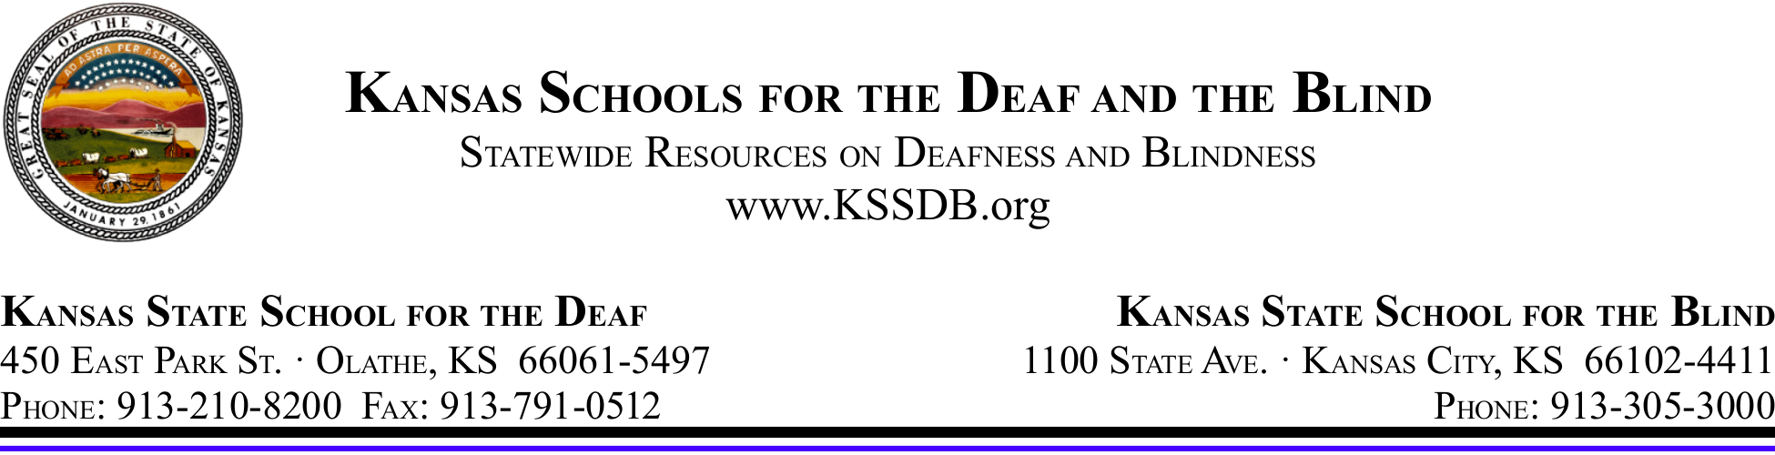

March 10, 2020

Dear Parent or Guardian:

Again this year, Kansas will be administering state assessments. The assessments include both general assessments and the Dynamic Learning Maps (DLM) alternate assessment. The assessments are based on the Kansas College and Career Ready Standards, which increased rigor and elevated standards to better prepare today’s students for success after high school. Throughout this school year at KSSB, your student has been provided academic instruction in English language arts, mathematics, science, and social studies using the KCCR Standards.

The spring testing window for all content areas for our state is March 23 – May 1, 2020. The approximate length of time for testing may vary depending on the content, the grade-level, and each student’s individual needs. The materials used in administration of the test has been adapted to meet your student’s needs. Although the tests must be completed during our state’s testing window, your student may be tested over a period of several days during that window, depending on their grade level.

Testing can be stressful for some students. To prepare your student mentally and physically for any test, make sure they are getting plenty of rest and nutritious food. Also, if your student experiences an extremely upsetting event outside of school, please contact me so that we might make other arrangements, if necessary, in the testing schedule.

If you have questions, please contact me at 913-305-3025 or via e-mail scraig@kssdb.org.

Thank you for your continued support of your student’s education!

Sandra Craig
District Testing Coordinator

