Join Us for a Family Forum!
Families - you are invited to a 1-day dynamic and interactive conference - just for you - the families of children who are blind or visually impaired.
April 25, 2020 - 9:30-3:15 Registration Deadline: April 1, 2020.
Memorial Union, Emporia State University - 1200 Commercial St, Emporia, Kansas.
Campus Map
Please use the Family Forum Google Form to register for this event. Registration and Lunch are provided free of charge. Please note: No Childcare is provided. All children remain in the care of the parent/guardian. For additional information about this event, go to our KSSB Family Events page on our website.

Keynote Speaker Kristin Smedley
Author of - Thriving Blind: Stories of Real People Succeeding Without Sight

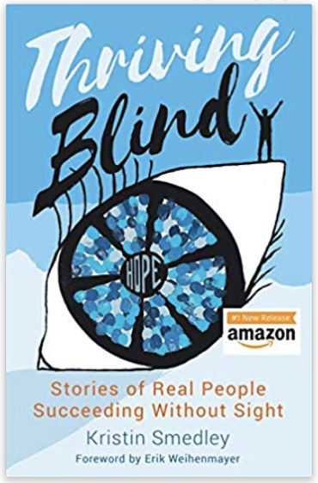
Kristin’s original plan to be a teacher took an unexpected turn when two of her three children were diagnosed as blind. She had to overcome her fear and equip them for their extraordinary journeys. Kristin’s two blind sons are now thriving in high school and college. They are baseball championship winners, International Braille competition finalists, a recording artist, and a future Paralympian. Kristin currently works with educators and parents to ignite new perceptions and outcomes for blind children and all students that learn differently.
Participants will:
- Understand how perceptions of blindness/disability are directly related to outcomes
- Understand how expectations impact people
- Receive the strategies Kristin uses to put her Thriving Formula into action
- Be ignited to use strategies that incorporate the Thriving Mindset

Anthony Blades, TSVI/COMS
A TSVI & COMS who is currently in his 15th year as a Blindness Skills Specialist in MO. In addition to his experience as a service provider for students with severe differences, Anthony was also the parent of a son with multiple disabilities. Nelson Blades passed away in March 2018, at the age of 13. But his influence and memory continue to impact his father’s passion for improving the educational outcomes for students with severe differences.

Title - Incorporating Tactile Object Calendar Systems into Daily Routines
- Learn how object calendar systems are used to encourage a foundation for students who have emerging communication skills.
- Learn how an object calendar system to provide a student with structure and routines in their day.
- Learn basic principles for developing an object calendar system that is individualized for a student’s unique needs.

Madeline Bowen - Working Healthy Program Benefits
She serves in social services working with various programs providing support to people with mental illness, Developmental Disabilities, and juveniles. I currently assist people with disabilities, agencies, and Stakeholders to understand the work incentives provided that encourage employment and increased self-sufficiency. I obtained my professional qualification in Britain. I have Benefits Planning, Assistance and Outreach Certification, SOAR Certification, and continue to learn from my customers and colleagues.

Title: Working Healthy Program
- Learn how Working Healthy, a KanCare program, provides full coverage insurance to those determined disabled and competitively employed.
- Explore how Working Healthy Benefits Specialists assist adults with Individual Benefits Planning so he/she can test their ability to work without jeopardizing their benefits and maintain KanCare.
- Understand the basics of the Social Security Work Incentives that cover SSI, SSDI, and CDB programs, including Working Healthy. (SSI = Supplemental Security Income, SSDI = Social Security Disability Insurance, CDB = Childhood Disability Benefits.)

KSSB Transition Students
The students embarked on an adventure in Entrepreneurship through the Transition Program. Chandler Smith and additional transition-age students at KSSB will describe the student-led “Eagle Enterprises”.

Title: Developing Entrepreneurship through Student-led “KSSB Enterprises.”
- Learn about the KSSB Transition program.
- Learn about the KSSB Maker-Space and how it related to starting a personal business or obtaining skills to work in a similar business in their local community.

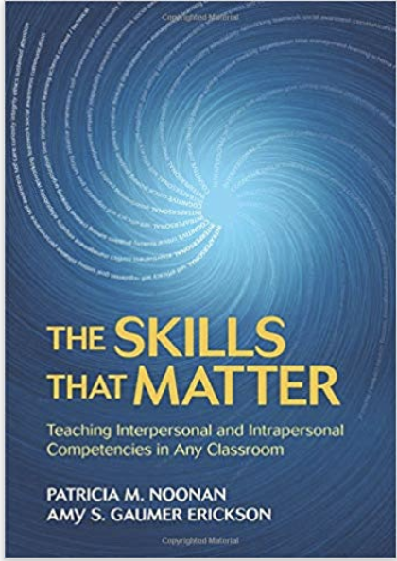
Amy Gaumer Erickson, Associate Research Professor
Associate research professor at the University of Kansas. Co-author of The Skills That Matter: Teaching Intrapersonal and Interpersonal Competencies in Any Classroom. Her focus is on teaching social-emotional skills, guiding educators to embed social-emotional instruction within content-area coursework, and evaluate students’ social-emotional growth. She has taught at the middle and high school levels in urban, suburban, charter and alternative schools.

Title: Developing a Confident and Independent Child
- Explore research-based techniques to promote independence & self-confidence.
- Learn about neuroplasticity and how recent brain research can change a child’s perspective and willingness to take on challenges.
- Leave with simple research-based strategies you can put in place immediately.

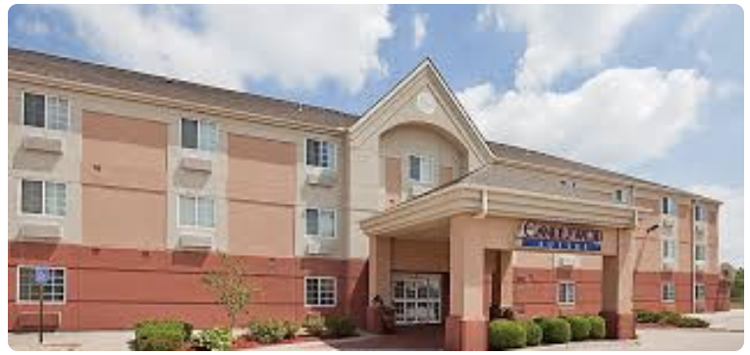
Lodging
A small number of rooms are set aside for this event. If you need lodging, contact the Candlewood Suites Emporia, Kansas, as soon as possible.
2602 Candlewood Drive Emporia, Kansas 66801. Phone: 1-602-343-7756

Schedule
9:00 | Check-in
9:30-10:45 | Keynote speaker - Kristin SmedleySkyline Room
11:00-12:15 | Break Out Session  - 1a: Anthony Blades  - 1b: Working Healthy
12:15-1:45 | Lunch and Vendor Viewing  (Vendors from 12:00-2:00)
1:45-3:00 | Break Out Session  - 2a: KSSB Students  - 2b: Amy Gaumer Erickson
3:00-3:15 | Wrap-Up

Community Vendors, Services and Information Fair
- ACB - Kansas Chapter
- Alphapointe - Kansas City
- Center for independent living
- Envision, Inc - Wichita
- Families Together
- Kansas Deafblind Project
- Kansas Talking Books
- KSSB Transition Program
- KU Radio Reader Service
- NanoPac
- NFB - Kansas Chapter
- Working Healthy

"Sponsorship of presenters/workshops by KSSB does not imply endorsement of a particular philosophy, product, or procedure. The educational material and techniques presented at this meeting reflect the views of the presenters and have been made available by KSSB "as is" for educational and informational purposes only and not as professional advice for specific cases or circumstances. The material and techniques discussed in these presentations reflect the best practices at the time of their development and should be used with the clear understanding that continued new knowledge or recommendations could emerge."

