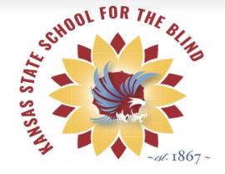
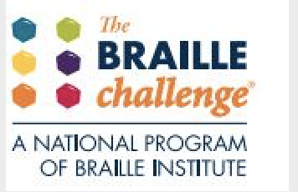
Leap for Braille!!!
November 6, 2019
Hello TSVIs, families, et al. - - The official kickoff of the 2020 Kansas Sunflower Regional Braille Challenge is now upon us. Please read the information below as KSSB begins registration for this signature event!

There are two regional events in Kansas: Register for ONE regional location only.
  - February 14th in Kansas City (on KSSB’s campus)
  - February 29th in Wichita (Derby Middle School)
- Registration is PAPER ONLY! The attached registration form must be submitted. Please note - there is additional information on the 2020 forms. Email completed form directly to: ashermer@kssdb.org
- TSVI/COMS/Volunteers - Link to order official Kansas t-shirts/sweatshirts with a picture: COMING SOON!!! Participants will receive one FREE t-shirt. All others will need to purchase.
- Either a parent or TSVI can register their participant. However, please note the following: The Braille Institute requires a parent signature on the registration form. This form will be attached (by the Regional Coordinator) to each contest submission after the event.
- ALL levels of the Braille Challenge will be in UEB. TSVIs, please be sure to mark the appropriate category for your student on the registration form. (For example, if your student is in middle school but taking an apprentice test, PLEASE mark the correct test on the form)
- TSVIs - if your student is going to participate in the SPELLING ONLY portion of the event, please make sure to write that on the registration form. This will assist in a more efficient organization of the rooms on the day of the event. Remember, these students will not qualify for the national competition.
- For students who are new to braille, both regional events will have a ‘Rookie’ session in 2020. These sessions are for ANY age beginning braille learner and we encourage these students to come join us in our celebration of braille. A registration form and parent signature are required for this group and please write ROOKIE SESSION on the registration form. These students will not qualify for the national competition, but they will have a phenomenal day!
- KSSB will offer practice sessions during January in Kansas City, Wichita AND Garden City. Watch for more information on these practice sessions!
- More on the Braille Challenge: http://www.brailleinstitute.org/braille-challenge-homepage.html
- The Kansas Sunflower Regional Braille Challenge does not award 1st, 2nd or 3rd place finishes at the regional level. All tests and scores will be sent to the Braille Institute in California. Participants eligible for the national competition will be notified by the Braille Institute when the finalists are announced (around May 1, 2020). Participants from Kansas invited to California may receive funding for one (1) round trip airline ticket to Los Angeles. Any funding provided is at the discretion of the KC Blind All-Stars Foundation.

The 2020 Kansas Sunflower Braille Challenge is a celebration of braille literacy. KSSB welcomes ALL students and families regardless of their braille reading/writing skills to join us. If a student or family would like to volunteer at either region or come see what this signature event is all about, please let the coordinator know.
Please do not hesitate to contact Aundrayah Shermer at
ashermer@kssdb.org or 913-209-0986 with any questions.
The deadline to register is December 20, 2019!

