Kansas State School for the Blind

Extended School Year 2020

K-S.E.E. PROGRAM, Ages 5-15
June 8-26, 2010

VOCATIONAL PROGRAM, Ages 16-21
June 8-26, 2020

KS - P.R.E.P. PROGRAM, Ages 16-18
June 8-26, 2020

HAYS - L.I.F.E. PROGRAM, Ages 10-18
June 21-26, 2020

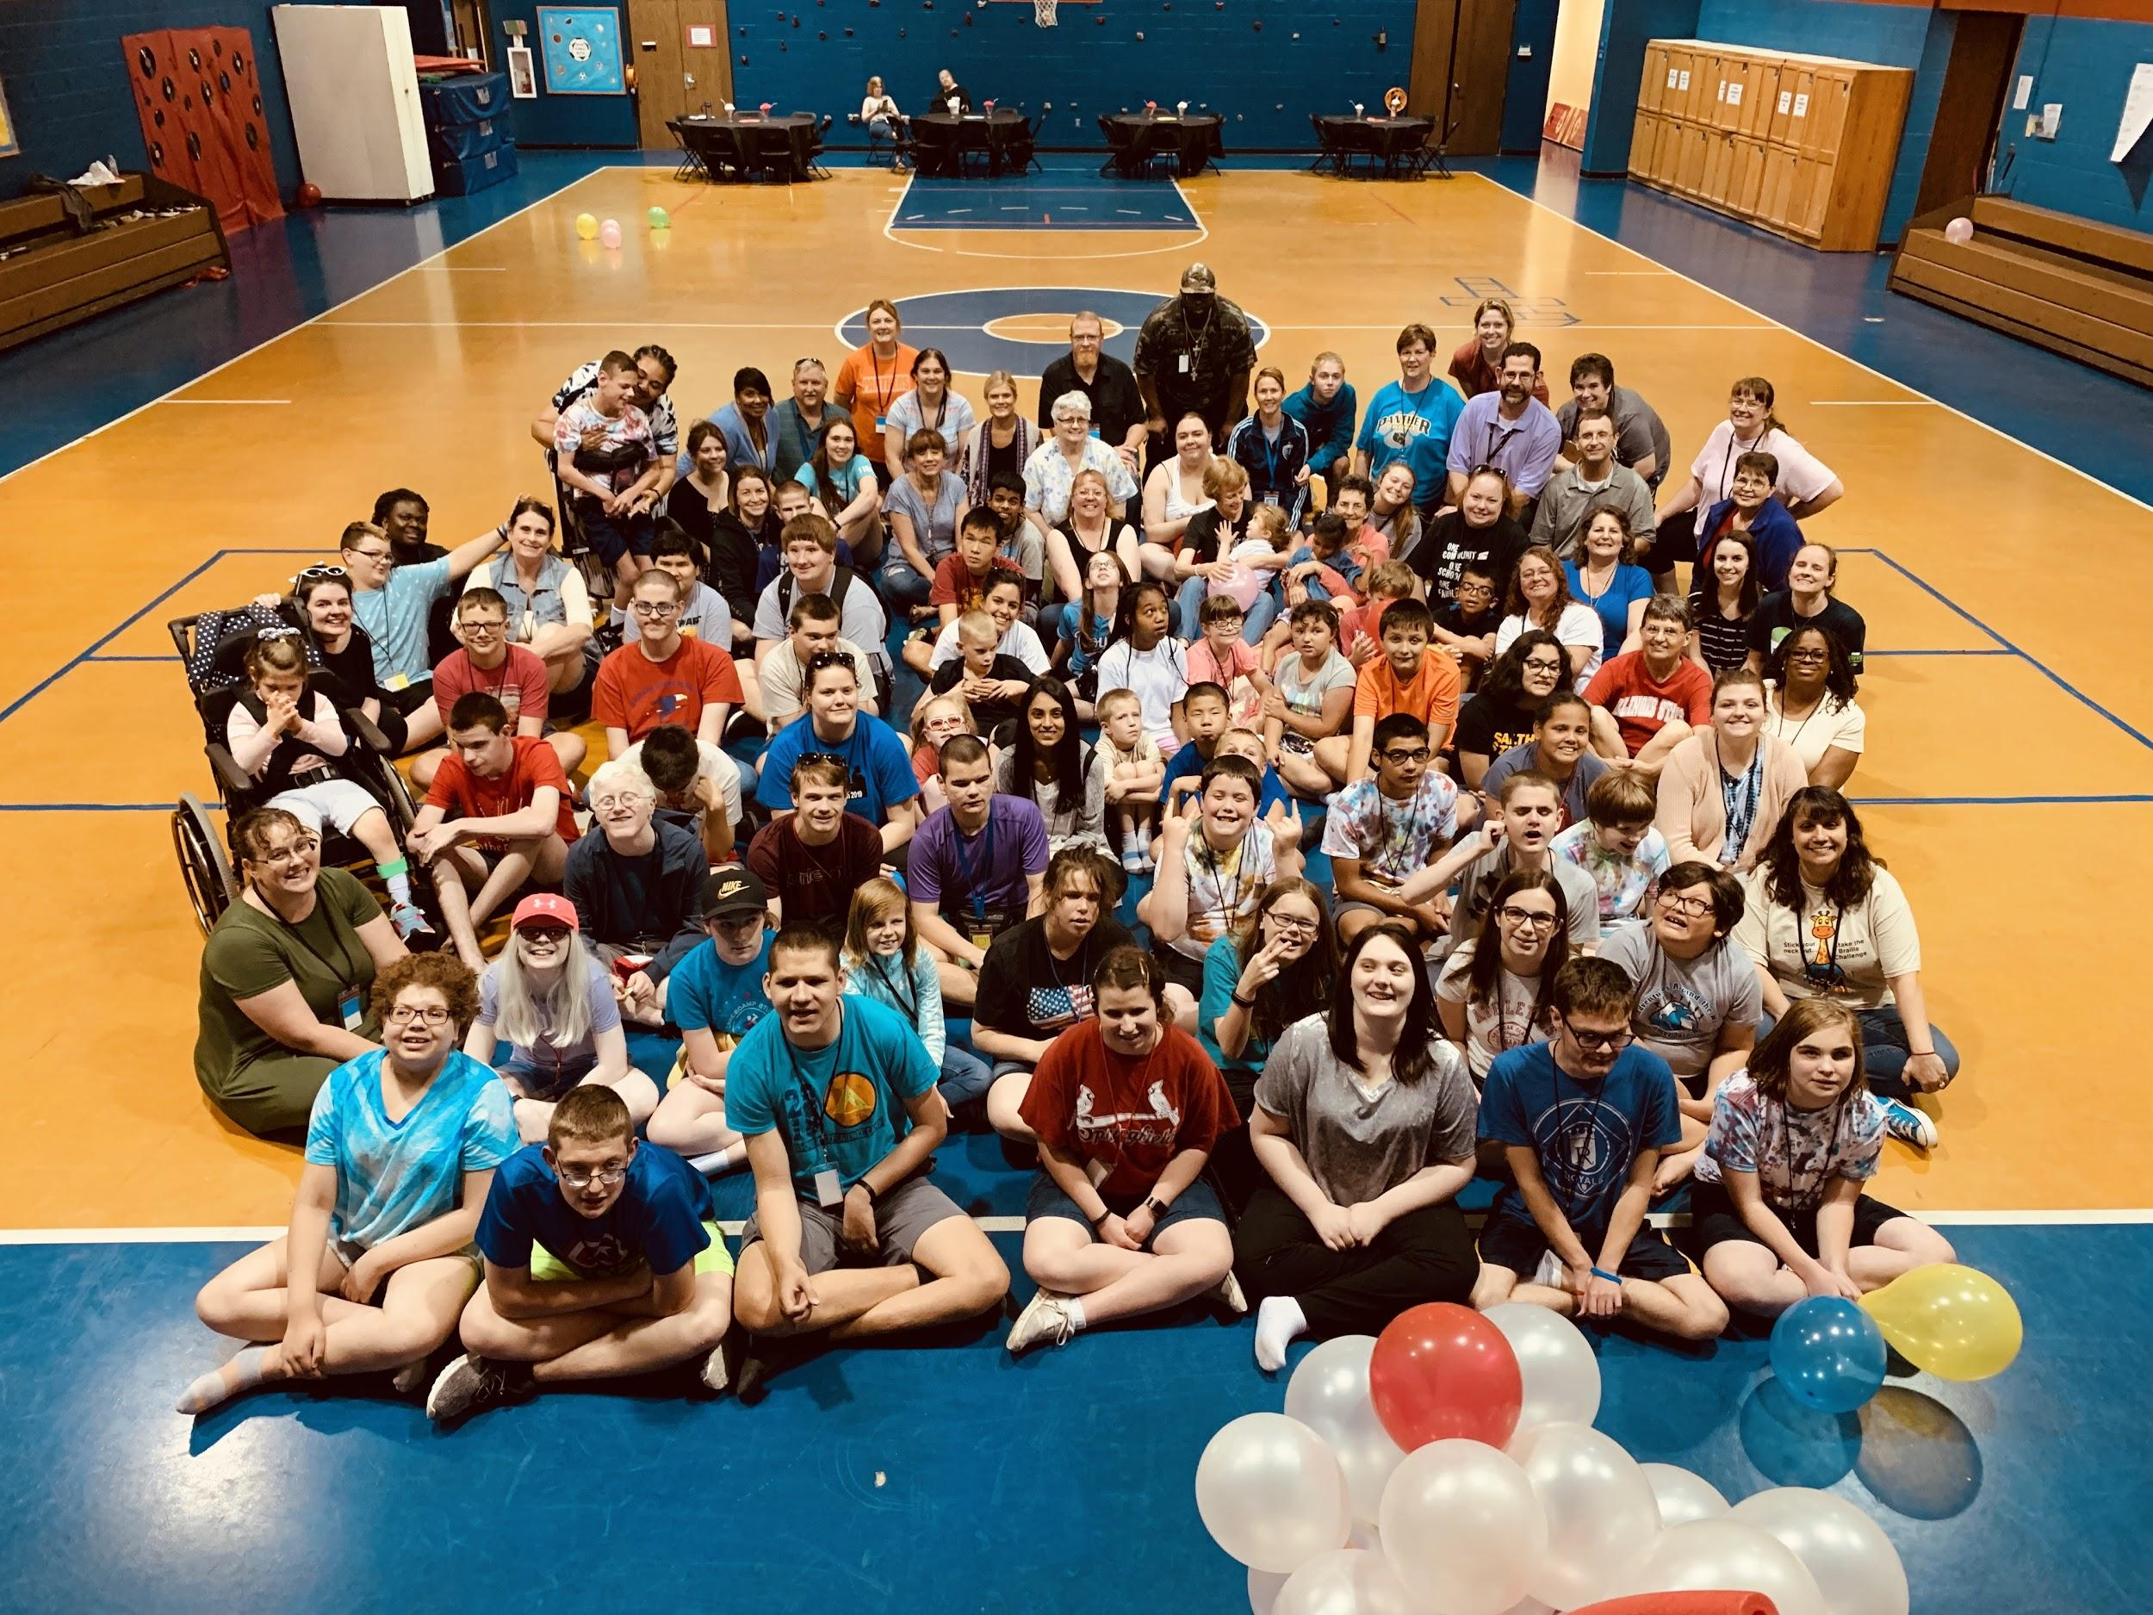

“Never bend your head. Always hold it high.
Look the world straight in the eye.”
― Helen Keller

K-S.E.E. PROGRAM 2020

Kansas Summer Expanded Education

Expanded Core Curriculum (ECC) Domains
- Activities of Daily Living: Activities will develop daily living skills including: self-care, cooking, eating and etiquette skills, home maintenance, organization skills and much, much more.
- Assistive Technology (Weeks 1 and 2): technology including: IOS (iPad, iPhone), OS (Macintosh or Windows Computers), Android (Amazon Fire or Kindle, Google Nexus), refreshable Braille displays, Braille notetakers (Polaris, BrailleNote Touch)
- Career Exploration (Week 3): Participants will have opportunities to explore strengths and interests in a systematic, well-planned manner.
- Recreation and Leisure: A physical education program designed to develop habits in fitness, health, and expose participants to new experiences.

Embedded ECC Domains
- Compensatory Skills: The use of Braille (reading and writing), tactile graphics and labeling skills are all embedded throughout all KSSB Summer 2020 programs.
- Social Skills/Self-Determination: Participants will learn strategies and interventions to promote greater inclusion of these critical skills for positive outcomes in the educational curriculum.
- Orientation and Mobility: Dynamic Orientation and Mobility lessons with a Certified Orientation & Mobility Specialist. Focus on travel skills unique to a larger city (bus, trolley, Uber, etc.)

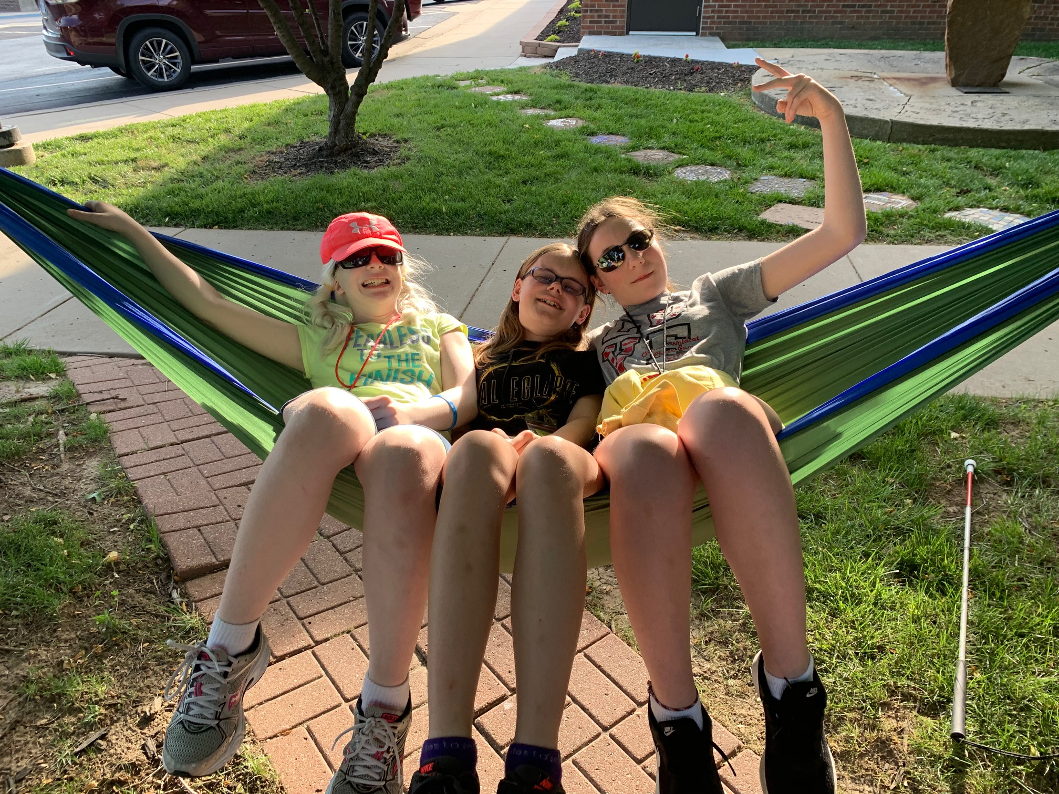

K-S.E.E. Participant Eligibility Requirements
- Participants must be at least 5 years old by June 1, 2020.
- Participants must be no older than 15 on June 1, 2020.
- Participants must meet eligibility criteria of visual impairment under the Kansas guidelines.
- Parents must arrange for transportation with their local school district or provide their own transportation to and from the day program.
- Participants must commit to all three weeks of the program. Due to the high demand, dorm housing will only be provided for participants attending entirety of program.
- Participants are expected to follow directions and be respectful

Important K-S.E.E. Program Reminders for 2020
- Total cost for K-S.E.E. for Kansas participants is $900 (KS) / $2,700 (out of state)
- The K.-S.E.E. program is limited to 50 participants on a first-come, first-serve basis
- The FIRM DEADLINE for submission of completed application forms is (March 10th).
- Application/Enrollment forms sent in after March 10th will be placed on a waitlist.
- Applications must be complete, including local district approval to attend.
- Participants age 10 or older will be able to stay in the dormitory during the week.
- No parent roommate requests will be honored for the dormitory experience.
- There will be no weekend stays for K-S.E.E. participants.
- Priority given to out of town K-S.E.E. participants for dormitory residence.
- Parents/TSVIs of participants accepted into the program are notified by April 1, 2020.
- TSVIs should work closely with parents to complete all application forms

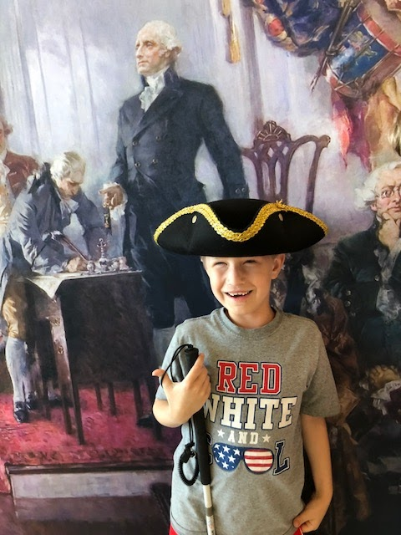

VOCATIONAL PROGRAM
The goal of the KSSB Summer Vocational program is to offer experiential learning related to job exploration, development of job skills, and understanding workplace culture. All areas of the Expanded Core Curriculum are embedded within the KSSB Summer Vocational Program.
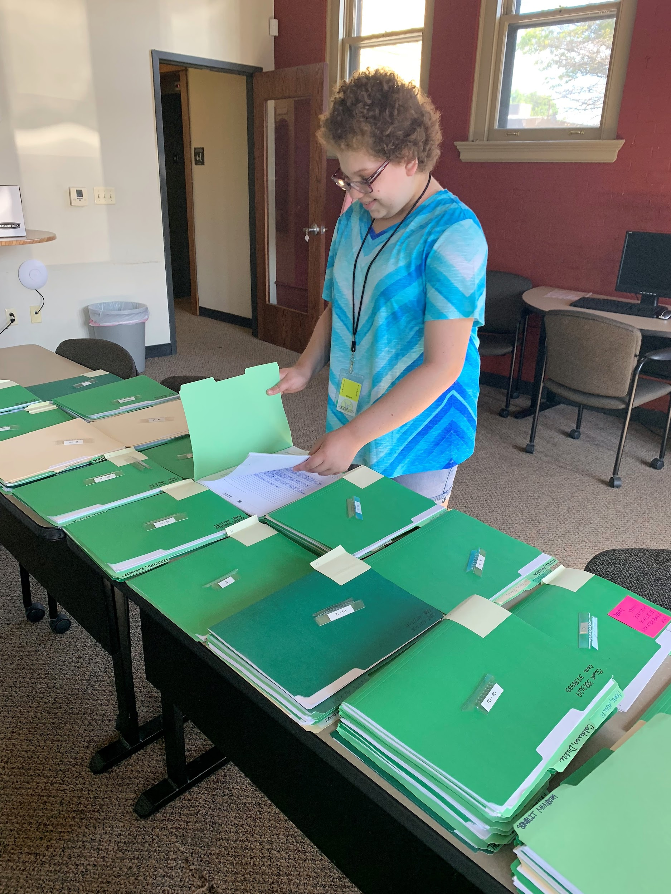

Vocational Program Participant Eligibility Requirements
- Participants must be 16 years old by June 1, 2020.
- Participants must meet eligibility criteria of visual impairment under the Kansas guidelines.
- Parents must arrange for transportation with their local school district or provide their own transportation to and from the day program.
- Participants must commit to all three weeks of the program.
- Participants must fully participate in the program and expect to receive benefit from the Program description and Expanded Core curriculum.
- Participants are expected to follow directions and be respectful.

Important Vocational Program Reminders for 2020
- Vocational program cost: $1,000 (KS) / $3,000 (out of state)
- Current KSSB Transition Program Participants cost: $200.00 (KS) / $600.00 (out of state)
- Cost includes room and board: Sunday – Thursday evenings, Monday – Friday days.
- Vocational program participants are eligible to stay in the dorm Sunday – Thursday only.
- The Vocational program is limited to 10 participants.
- Once allotted spots are filled, applications will be placed on a waitlist.
- A FIRM DEADLINE (March 10th) for submission of completed application forms.
- Parents/TSVI accepted into the Vocational program are notified by April 1, 2020.
- Participant applications must be complete, including approval of Local Education Agency.

KS-PREP

Kansas Summer Preparatory Residential Enrichment Program
The KS-PREP program is a special focus program for KSSB. Participants accepted to this program must be a current High Schooler, ages 16-18. This program provides advanced Expanded Core Curriculum experiences in a residential setting for participants who plan to live independently post-secondary.

Weekday Program Experiences Include:
- Resume Writing and Mock Employment Interviews
- Career Exploration
- Part-time Employment Opportunities
- Guest Speakers (Adults living/working independently in metro area)
- Community Access
- Social/Recreational Activities
- Individualized O&M Instruction
- Individualized Activities of Daily Living

Weekend Residential Component Features:
- Independent Living Experiences (Preparation of meals, laundry, home maintenance).
- Community Access
- Social/Recreational Activities
- Parent Information Day
- Community Service / Volunteerism Projects

Comprehensive Orientation and Mobility (O&M) Instruction:
- Day and night-time instruction
- Focused use of Public Transportation
- Non-Driver Education
- ADA Rights Education
- Dog Guide Exposure/Education
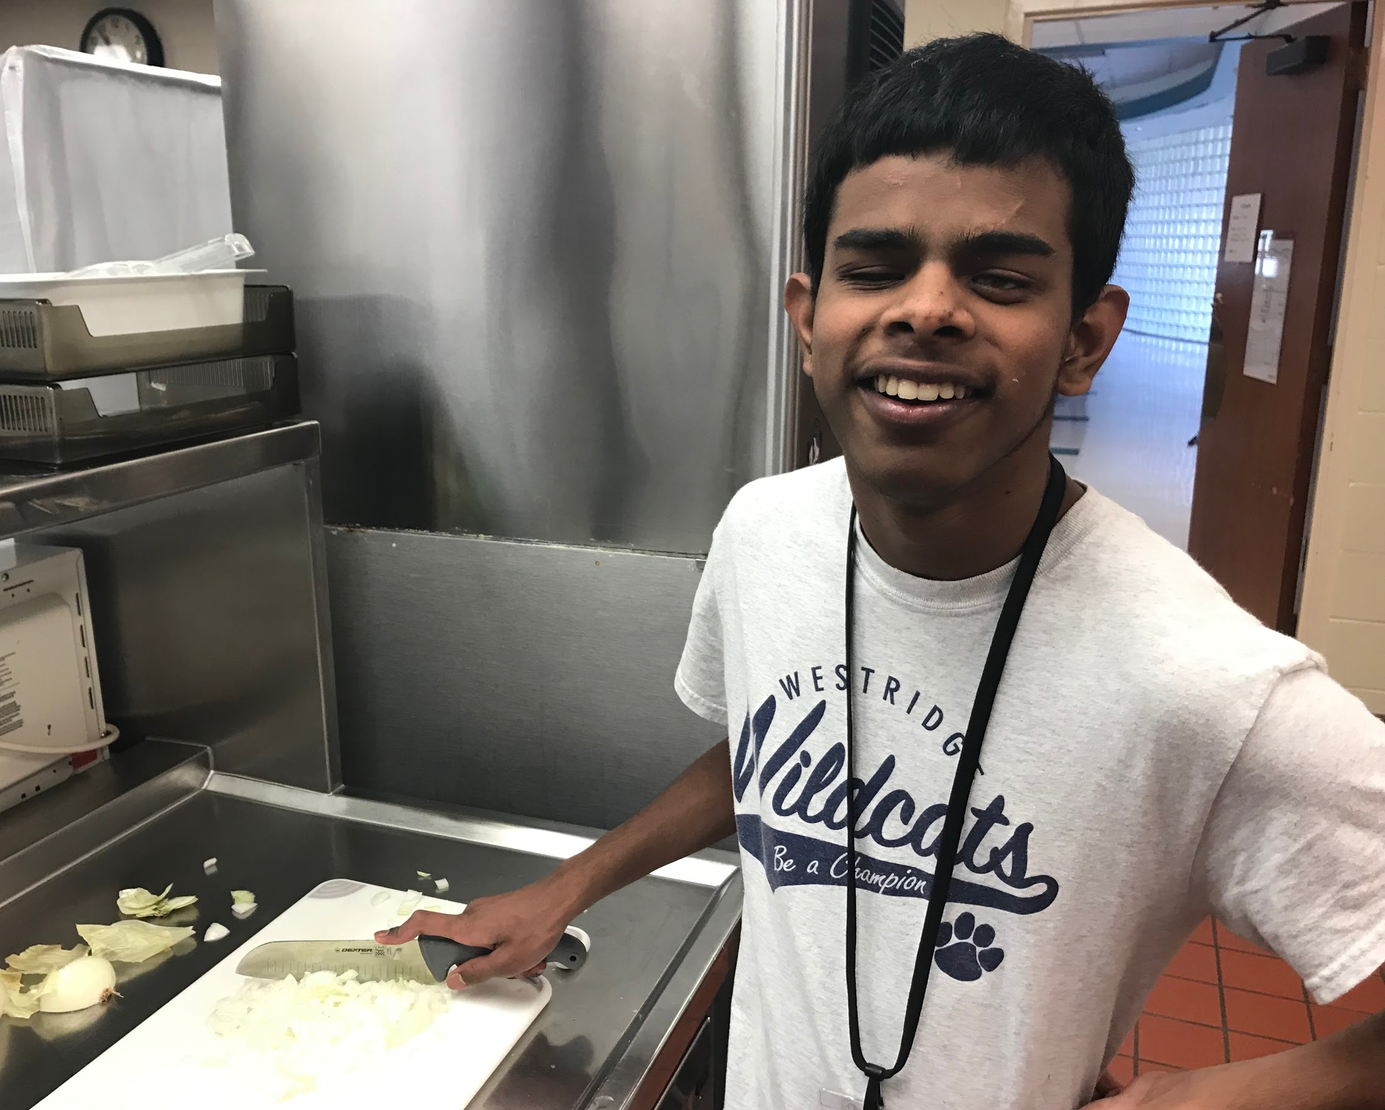

Important KS-PREP Program Reminders for 2020
- Total cost of KS-PREP program is $1,200 (KS) / $3,600 (out of state)
- KS-PREP program is Limited to 10 Participants. Only completed applications by the deadline will be accepted for this program.
- KS-PREP program participants must attend their local district full time during the Academic Year.
- KS-PREP program participants must have completed freshman year of High School.
- Expectation of the KS-PREP program participants is to live independently.
- KS-PREP program participants plan to seek competitive employment and/or attend a vocational training program or college upon graduation from secondary school.
- FIRM DEADLINE (March 10th) for submission of completed application forms.
- Parents/TSVI accepted into the KS-PREP program are notified by April 1, 2020.
- Once allotted spots are filled, applications will be placed on a waitlist.
- Participant applications must be complete, including approval of Local Education Agency.
- Parents and siblings will not be offered lodging in the dormitory.
- All participants accepted for the KS-PREP program must stay in the dorm beginning June 8th through Friday June 26th (This includes weekends!).
- KS-PREP participants must commit to attending the entire 3-week program.

Additional Information:
- Kansas State School for the Blind staff will be responsible for the selection of instructors, employees, participants, practicum instructors, and interns.
- Kansas State School for the Blind ESY team will conduct training of all staff hired. This will include mandated reporting, ECC domains and O&M guide techniques. A mandatory training session will be held Thursday, June 4, 2020, 9:00 a.m. - 3:00 p.m.
- Questions?: Contact Jon Harding, Superintendent, jharding@kssdb.org, 913-305-3014 or Aundrayah Shermer, Coordinator ESY Program, ashermer@kssdb.org, 913-305-3016

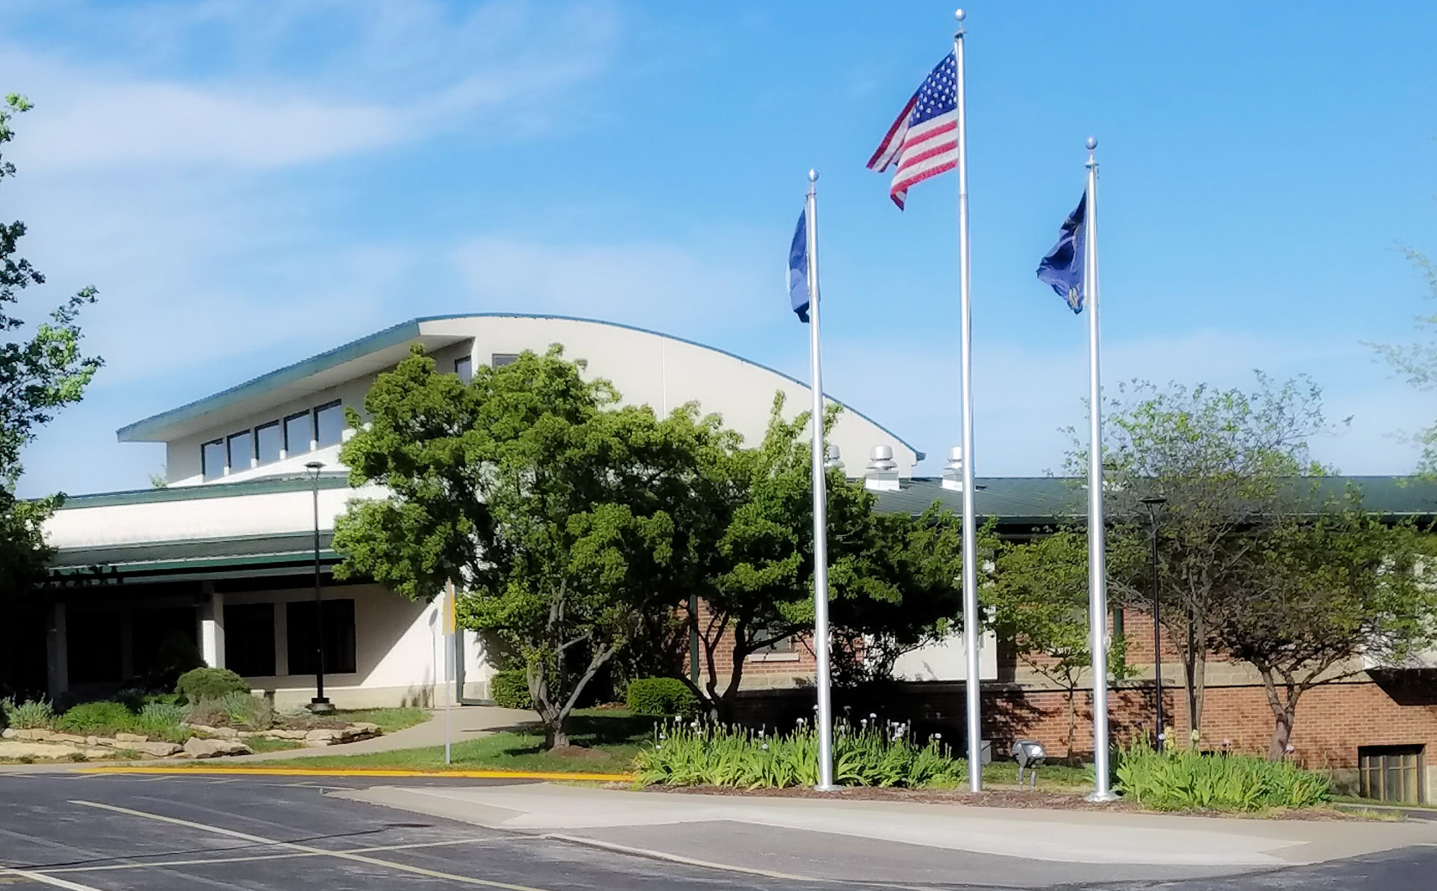

KSSB MISSION STATEMENT
Kansas State School for the Blind (KSSB) is a catalyst and leader in the
development of exemplary programs and practices in vision services in Kansas.
We build local capacity throughout the state via strategic partnerships to ensure learners with visual impairments are able to assume responsible roles in society and lead fulfilling lives.

Hays L.I.F.E. 2020
Lifetime Independence Focused Education
June 21-26, 2020
Fort Hays State University – Hays, KS

Daily Schedule
Schedule | Track 1 | Track 2
7:30 - 8:15 | Daily Exercise Routine | Daily Exercise Routine
8:15 - 9:00 | Breakfast | Breakfast
9:00 - 11:30 | Lunch preparation | Work Experience
11:30 - 12:30 | Lunch | Lunch
12:30 - 2:30 | Recreation and Leisure Choice Time | Recreation and Leisure Choice Time
2:30 - 5:00 | Pre-Vocational Skills | Dinner Preparation
5:00 - 6:00 | Dinner | Dinner
6:00 - 8:30 | Evening Program/Outings | Evening Program/Outings
8:30 - 9:30 | Showers & Bedtime routines | Showers & Bedtime routines

Expanded Core Curriculum (ECC) Domains
- Activities of Daily Living: Daily routines will develop self-care and organization skills. In addition, participants will have instruction in preparation and cleanup of at least one meal each day.
- Career Exploration: Track 1 students will participate in daily Career Exploration and Pre-Vocational skills training. Track 2 participants will apply for a job shadowing program and participate in a daily work experience on the campus of FHSU or in the Hays community with a trained job coach.
- Orientation and Mobility: Instruction in safe, efficient and independent travel skills will be incorporated throughout the program with activities and routes designed by Certified Orientation and Mobility Specialists.
- Recreation and Leisure: Daily activities designed to develop habits in fitness, health, and expose participants to new experiences.
- Social Skills/Self-Determination Participants will learn strategies and interventions to promote greater inclusion of these critical skills for positive outcomes in the educational curriculum and post-school employment.
- Assistive Technology/Sensory Efficiency: Participants will utilize their current assistive technology and low vision devices to access the daily activities and will be exposed to new strategies with current devices to increase independence across all domains.
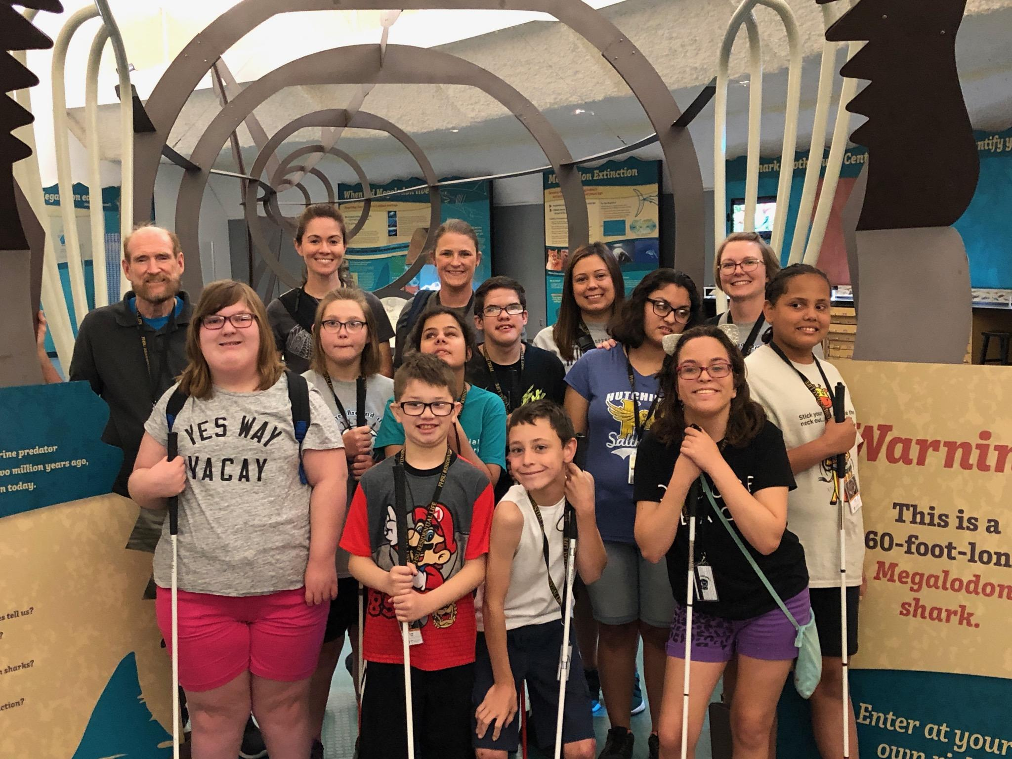

HAYS - L.I.F.E. Participant Eligibility Requirements
- Participants 10 years - 18 years (4th-11th grades completed) by June 1, 2020 will be considered.
- Participants must meet eligibility criteria of visual impairment under the Kansas guidelines.
- Participants must commit to all six days of the program, including staying in the dormitory.
- Parents must make arrangements with local school district or provide their own transportation to and from the program.
- Participants are expected to follow directions and be respectful.

Important HAYS-L.I.F.E. Program Reminders for 2020
- Total cost for Hays - L.I.F.E. participants is $300 (KS) / $900.00 (out of state)
- The Hays L.I.F.E. program will be limited to 10 participants.
- Participants will be assigned to Track 1 or Track 2 based on age and skills to be addressed.
- A FIRM DEADLINE (March 10th) for submission of completed application forms.
- Application/Enrollment forms sent in after this date will be placed on a waitlist.
- Participant applications must be complete,
- TSVIs should work closely with parents to complete all application/enrollment forms.
- Students will arrive on Sunday at 3:00 pm and are to be picked up on Friday at 1:00pm
- Transportation is the responsibility of the local district.
- Parents, TSVI, and accepted applicants will be notified by April 1st, 2020.
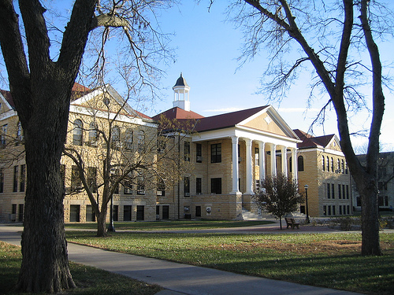
The campus of Fort Hays State University

Additional Information
- Kansas State School for the Blind staff will be responsible for the selection of employees, participants, practicum students, and interns.

- Kansas State School for the Blind ESY team will conduct training of all individuals hired. This will include mandated reporting, ECC domains and O&M guide techniques. A mandatory staff training session will be held Sunday, June 21, 2020 from 12:00 p.m. - 2:30 p.m. (Location TBA)

- Contacts for Hays L.I.F.E. Program Questions:
  - Jon Harding, Superintendent, jharding@kssdb.org, 913-305-3014 or

  - Aundrayah Shermer, ESY Program Coordinator, ashermer@kssdb.org,
913-305-3016

Applications
RETURNING STAFF ONLY: Link to online application available 12/1/19 for 2020 ESY

NEW STAFF APPLICANTS: All new applicants for KSSB Summer staff positions MUST complete a paper application. Contact Aundrayah Shermer (ashermer@kssdb.org) for application materials.

STUDENT APPLICATIONS: Applications will be available beginning 1/6/20. All application materials, including current IEP, and LEA approval, must be received by March 10, 2020.

