Emergency Safety Intervention Parent Information

If an emergency safety intervention was used with a student, we invite and strongly encourage parents to schedule a meeting to discuss the incident and how to prevent future use of emergency safety interventions. A parent can request and schedule this meeting by going to the back page for the person to contact who will work to schedule this meeting with the required participants. This meeting will be scheduled no later than 10-school days from when the parent makes the request unless the parent cannot meet
within that time frame.

Kansas School for the Blind
www.kssb.net

Jon Harding
Interim Superintendent
913-305-3014
jharding@kssdb.org

Table of Contents

Standards of When ESI May Be Used Page 3

Parents’ Rights Flyer Pages 5-8

Local Dispute Resolution Process ………………… Page 9

Local Dispute Resolution Guide for Parents Page 10
State Board Administrative Review Process Page 11-12 State Board Administrative Review Guide for Parents Page 13 Contact Information Page 14
KSSDB Policy letter Page 15-16

Standards of When Emergency Safety Intervention May Be Used

Emergency safety interventions law sets forth standards for the use of restraint and seclusion to ensure that all Kansas students and staff have a safe learning environment. The standards found in the emergency safety intervention statutes and regulations are required to be followed in all Kansas public school districts and accredited private schools.
An emergency safety intervention is the use of seclusion or physical restraint. The use of an emergency safety intervention shall cease as soon as the immediate danger of physical harm and violent action ceases to exist.
Before using an emergency safety intervention, a school employee witnessing the student’s behavior must have determined that less restrictive alternatives to emergency safety interventions, such as positive behavior interventions support, were inappropriate or ineffective under the circumstances.
An emergency safety intervention shall be used only when a student presents a reasonable and immediate danger of physical harm to such student or others with the present ability to effect such physical harm. Violent action that is destructive of property may necessitate the use of an emergency safety intervention if there is a reasonable and immediate danger of physical harm. An emergency safety intervention may not be used for purposes of discipline, punishment, or for the convenience of a school employee.
Physical restraint means bodily force used to substantially limit a student’s movement.

Physical restraint is NOT:
- Consensual, solicited or unintentional contact and contact to provide comfort, assistance or instruction;
- physical escort;
- prescribed treatments for a student’s medical or psychiatric condition by a person appropriately licensed to issue these treatments;
- protective or stabilizing devices either ordered by an appropriately licensed professional or required by law;
- any device used by a law enforcement officer in carrying out law enforcement duties; and
- seatbelts and any other safety equipment when used to secure students during transportation.

Prohibited types of restraints:
- Prone, or face-down, physical restraint;
- supine, or face-up, physical restraint;
- any physical restraint that obstructs the airway of a student;
- any physical restraint that impacts a student’s primary mode of communication;
- chemical restraint (‘‘chemical restraint’’ means the use of medication to control a student’s violent physical behavior or restrict a student’s freedom of movement.); and
- mechanical restraint (‘‘mechanical restraint’’ means any device or object used to limit a student’s movement).

Seclusion means placement of a student in a location where:
- The student is placed in an enclosed area by school personnel;
- the student is purposefully isolated from adults and peers; and
- the student is prevented from leaving, or the student reasonably believes that such student will be prevented from leaving, the enclosed area.

An emergency safety intervention may not be used with a student if the student is known to have a medical condition that could put the student in mental or physical danger as a result of the use of an emergency safety intervention unless not using an emergency safety intervention would result in significant physical harm to the student or others. The medical condition must be indicated in a written statement from the student’s licensed health care provider, and a copy of which shall be provided to the school and placed in the student’s file. When a student is placed in seclusion, a school employee shall be able to see and hear the student at all times.

If a seclusion room has a locking door it must be designed to ensure that the lock automatically disengages when the school employee viewing the student walks away from the seclusion room, or in cases of emergency, such as fire or severe weather.
A seclusion room must be a safe place. The room must have good ventilation and lighting, and be free of any condition that could be a danger to the student. The room must also be similar to other rooms where students frequent. Seclusion is not time-out, which is a behavioral intervention in which a student is temporarily removed from a learning activity without being confined.

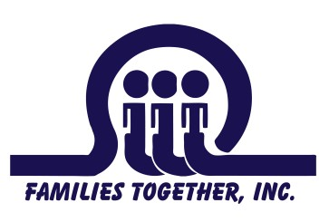
Where can I find out more
information about
Emergency Safety Interventions (Seclusion and Restraint)?
Families Together, Inc.
Topeka Parent Center- 1-800-264-6343 topeka@familiestogetherinc.org

Wichita Parent Center- 1-888-815-6364 wichita@familiestogetherinc.org

Garden City Parent Center- 1-888-820-6364 gardencity@familiestogetherinc.org
Kansas Parent Information
Resource Center (KPIRC)
1-866-711-6711
www.kpirc..org
Kansas State Department
of Education (KSDE)

1-800-203-9462
www.ksde.org www.ksdetasn.org

A Family Guide to the Use of
Emergency Safety Interventions
(Seclusion and Restraint) in Kansas

What are Emergency Safety Interventions?
Emergency Safety Interventions (ESI) are seclusion and restraint that are used when the student presents a reasonable and immediate danger to self or
Why focus on Positive Interventions?
Positive Interventions help build positive relationships and encourage new

others.

What is Seclusion?
Seclusion means placement of a student in a
location where all the following conditions are met:
  - the student is placed in an enclosed area by school personnel;
  - the student is purposefully isolated from other adults and peers; and,
  - the student is prevented from leaving, or the student reasonably believes that such student will be prevented from leaving, the enclosed area.
Time-out is not the same as seclusion. Time-out is when a student is temporarily removed from the learning activity, but is not confined.

What is Restraint?
Restraint can take form in different ways. Mechanical restraint is defined as
behaviors. Positive interventions also reinforce
new skills and increase self-satisfaction and optimism among youth, parents and teachers. All students need to be recognized and rewarded
when they are meeting the expectations that have been established. Current research suggests
positive recognition (rewards, reinforcements,
praise) must occur more frequently than negative recognition. A well-developed behavior
intervention plan should include many positive interventions in order to effectively change behavior. The first consideration should be the appropriateness of the interventions. The team
should select interventions that are based upon the student’s developmental level, motor ability,
communication mode and other factors relevant to the student and the disability. Environmental and
Behavioral strategies,
particularly when
implemented as part of a school-wide program of positive behavioral supports, can be used to address the underlying
causes of dangerous behavior and reduce the likelihood that restraint or seclusion will need to be used.
U.S. Department of Education Restraint and Seclusion: Resource
Document

any device or object used to limit a person’s movement. The use of mechanical restraint is prohibited in Kansas except those protective or
stabilizing devices ordered by a person appropriately licensed to issue the
order for the device. Mechanical restraint used by a law enforcement officer in carrying out law enforcement duties is allowed. Seatbelts and/or other safety equipment when used to secure students during transportation are also allowed.
The definition of physical restraint is bodily force used to substantially limit a student’s movement. The use of prone physical restraint (face-down) and supine physical restraint (face-up) are prohibited. Physical restraint may not obstruct the airway of the student or impact the student’s primary mode of
communication.
Chemical restraint is prohibited in Kansas. A student may take prescribed
treatments for a medical or psychiatric condition when they are prescribed by a person who is properly licensed to prescribe medication.
Consensual, solicited, or unintentional contact and contact to provide
context related factors should also be considered. These might include things
such as classroom seating, noise levels, peer issues, instruction that is too hard or too easy, transitions, and changes in the setting.

Replacement Behaviors
A replacement behavior is when a student replaces an inappropriate behavior with an appropriate one that continues to serve the same function for the
student. When selecting replacement behaviors, the team should address the following questions:
- Does the replacement behavior work as well as the challenging behavior in meeting the student’s needs?
- Will it be an acceptable alternative to the challenging behavior?
- Will the replacement behavior be something the student will choose to do and that his or her family and teachers support?
- Will the replacement behavior help build a positive reputation for the student?
Students should be recognized and rewarded for choosing to utilize

Functional Behavioral Assessments
All behaviors are functional and are maintained in environments that support them. If your child’s behavior impedes the learning of self or others, you
may consider requesting a functional behavioral assessment. A Functional Behavioral Assessment can help teams determine the when, where, how and why problematic behavior occurs. A comprehensive assessment includes interviews, record reviews,
observation and data collection, graphing data collected, testing hypotheses, curriculum analysis, implementation of interventions and evaluation of effectiveness of the
plan. Assessments should identify antecedents (what happens just before the behavior occurs), a very clearly
defined picture of the behavior that is occurring, and the reinforcers (what happens just after the behavior occurs). If a behavior meets a function for
the student, the behavior will continue. Teams need to determine what the function of the behavior is so that they may provide successful interventions or teach replacement behaviors that meet the same function for the student.

Behavior Intervention Plans
Behavior Intervention Plans (BIP) should be positive and instructive and based upon a functional behavioral assessment. A BIP should address:
- The function of the behavior
- Effective teaching of the expected behavior
- Rewards and consequences that are meaningful to the student
- Opportunities to self-manage behaviors

TIP
A functional behavioral assessment can be conducted at any time for a student who does not respond to school-wide behavioral interventions. Following the assessment, a behavior intervention plan may be developed. As a parent, you have the right to request a functional behavioral assessment. Contact Families Together for further assistance.

When May Emergency Safety Intervention be Used?
  - May only be used when a student presents a reasonable and
immediate danger of physical harm to such student or others with the present ability to cause physical harm.
  - Less restrictive alternatives, such as positive behavior interventions support, must be deemed inappropriate or
ineffective under the circumstances by the school employee witnessing the
student’s behavior prior to the use of any ESIs.
  - The use of ESI must stop as soon as the immediate danger of physical harm ends.
  - ESI cannot be used is used for purposes of discipline, punishment, or for the convenience of a school employee.
  - A student may not be subjected to seclusion if the student is known to have a medical condition that could put the student in mental or
physical danger as a result of seclusion. The existence of this medical condition must be indicated in a written statement from the student’s licensed health care provider that is provided to the school and is
placed in the student’s file. Note that this exception does not apply to restraint.
  - Violent destruction of property may also prompt the use of ESI.

What are the Requirements for Seclusion?
When a student is placed in seclusion, a school employee must be able to see and hear the student at all times.
All seclusion rooms that have a locking door must be designed to make sure that the lock automatically
disengages when the school employee watching the student walks away from the seclusion room, or in cases of
emergency, such as fire or severe weather.
A seclusion room must be a safe place with proportional and similar
characteristics as other rooms where students frequent. A seclusion room must be free of anything that could be a danger to the student and must be well-ventilated and sufficiently lighted.

When Must a Parent be Notified an ESI has been Used?
  - The school must notify the parent the same day the ESI was used. If the parent cannot be notified, then the
school must notify an emergency contact person for the student.
  - Documentation of the ESI used must be
completed and provided to the parent by the school day following the day on
which the ESI was used.
  - The parent must be provided with the following information in
writing after the first ESI incident in a school year and provided with this information after subsequent ESI incidents through a web
address that contains this information:
    - A copy of the standards of when ESI can be used;
    - A flyer on the parent’s rights under ESI law;
    - Information on the parent’s right to file a complaint through the local dispute resolution process and the complaint
process of the Kansas State Board of Education; and
    - Information that will assist the parent in navigating the complaint process, including contact information for
Families Together and the Disability Rights Center of Kansas.

What Can I Do if I Feel that ESI has been Used Inappropriately with My Child?
If a parent believes that ESIs have been used that violate the ESI statute,
ESI regulations, or the district’s ESI policy, then the parent may file a
complaint through the local dispute resolution process within 30 days of the use of ESI.
A parent may file a complaint through the Kansas State Board of
Education’s complaint process within 30 days from the date that a parent receives a final decision through the local dispute resolution process or after 30 days have passed since the parent filed a complaint through the
local dispute resolution process, if the parent has not received the local board’s final decision.

Requirements if there is a Third ESI Incident with a Student within a School Year
If there is a third ESI incident within a school year on a student with an IEP or a Section 504 plan, then the student’s IEP or Section 504
team must meet within 10 days after the
incident to discuss the incident and consider the need to conduct a functional behavioral
analysis (FBA), develop a behavior intervention plan (BIP), or amend the student’s BIP if the student already has one. These requirements must be
followed unless the student’s IEP or Section 504 team agrees on a different process.
If there is a third ESI incident within a school year on a student without an IEP or a Section 504 plan, then the student’s parent and school employees must meet within 10 days after the incident to discuss the incident and consider
the appropriateness of a referral for a special education evaluation or the need for a FBA or BIP. The school employees involved in this meeting must
include a school administrator for the school where the student attends, one of the student’s teachers, a school employee involved in the incident, and any other school employees designated by the school administrator as
appropriate to attend the meeting.

The student must be invited to any of the meetings referred to previously in this section.
The meetings referred to in this section may be extended beyond the 10-day requirement if the parent of the student is unable to attend within that time period.

TIP

If your child has a history of seclusion and restraint or
challenging behavior, he or she could be eligible for additional supports and interventions. Parents are welcome to contact Families Together, Inc. to discuss possible options.

Local Dispute Resolution Process

From KSSB's 2016-2017 Handbook:

MEDIATION

In the event of disagreements between the family and the school, it is hoped that these can be worked out through the IEP process or through subsequent discussions with the local school district. If the problem persists, mediation is another way of resolving disagreements in an informal and quick way. By no means does mediation deny or delay the parent’s right to a due process hearing or any other parental rights.
A mediator is an impartial third party who works to facilitate communication between the family and the school. Parents may inquire further with the Kansas State Department of Education: (800) 203-9462. Additional information regarding Procedural Safeguards is included in the Kansas State Department of Education Parent Rights in Special Education notice, provided to each parent annually.

Local Dispute Resolution Guide for Parents
You may file a written complaint to your local board of education within 30
If findings are not agreeable, you may proceed to the state administrative
Upon receiving the report, you may determine the findings are

You feel emergency safety intervention was used inappropriately or
You receive documentation and feel emergency safety intervention
Emergency Safety Intervention Incident Occurs,

If this is effective, the building administrator should provide written
You are strongly encouraged to schedule a meeting, using the contact
Upon receiving a complaint, the local board will desginate an individual to

Upon receiving the report, you may determine the findings are
The local board must mail the written findings of fact and proposed

State Board Administrative Review Process

Refer to K.A.R. 91-42-5 for complete information. The following provides a summary of the regulations regarding an administrative review initiated with the Kansas State Board of Education (KSBE).

      - If a parent believes an emergency safety intervention was used in violation of K.S.A. 2016 Supp. 72-89d01 through -89d09 or K.A.R. 91-42-1 through -7 and the parent filed a written complaint with their local board of education, then this parent may request an administrative review of the local board’s decision from KSBE.
        - The request for administrative review must include the following information:
          - Name of the student and contact information;
          - Names and contact information for all involved parties (teachers, aides, administrators, and district staff), to the extent known;
          - A detailed statement of the reason for requesting an administrative review;
          - Any supporting facts and documentation; and
          - A copy of the complaint filed with the local board, the local board’s final decision (if issued).
          - The written request for administrative review must be typed or legibly written and signed by the parent.
          - Relevant documents must be attached or, if unavailable, the documents must be referenced in the request for administrative review.
          - Written consent to disclose any personally identifiable information from the student’s education records necessary to conduct an investigation

      - The request for administrative review must be filed with the Commissioner of Education within 30 days of the local board issuing its final decision OR within 60 days from the date the parent filed a complaint with the local board, if the local board did not issue a final decision. You may mail this request to the Kansas State Department of Education, Landon State Office Building, 900 SW Jackson Street, Office of General Counsel, Room 102, Topeka, Kansas 66612.

      - A Hearing Officer will be designated by KSBE. The Hearing Officer must send a copy of the request for administrative review to the local board.

      - The Hearing Officer will consider the local board’s final decision and may initiate an investigation that could include:
        - A discussion with the parent, during which additional information may be gathered;
        - Contact with the local board or other district staff to allow the local board to respond to the request with information supporting its final decision; and
        - An on-site investigation by Kansas State Department of Education staff.

      - If new information is discovered that was not made available to both the parent and the local board during the dispute resolution process, the Hearing Officer may send the issue back to the local board.
        - If sent back to the local board, the Hearing Officer’s case will be closed and the local board has 30 days to issue a written amended final decision.
        - If the parent feels the local board’s amended final decision does not adequately address the issue, the parent may file a new request for administrative review with the commissioner by following the above process for requesting administrative review. This must be done within 30 days of the local board issuing its amended final decision. If the local board does not issue an amended final decision within 30 days, then the parent has 30 days from the date the Hearing Officer sent the issue back to the local board to file a request for administrative review with the commissioner.

      - Within 60 days of receiving the request for administrative review, the Hearing Officer will, in writing, inform the parents, school administrator, district superintendent, local board clerk, and the state board of the results of the review. This time frame may be extended for good cause upon approval of the commissioner.

      - The results of the administrative review will contain findings of fact, conclusions of law, and any suggested corrective actions. The Hearing Officer’s determination will include one of the following:

        - The local board appropriately resolved the complaint.
        - The local board should re-evaluate the complaint with suggested findings of fact.
        - The Hearing Officer’s suggested corrective active is necessary to ensure that local board policies meet legal requirements.

State Administrative Review Guide for Parents
Written request must include:
- Name and contact information of student that emergency safety intervention was used with
- Name and contact information for all people involved
- Statement describing the

You filed a complaint with the local board and you are not satisfied with the final decision about the use of an emergency safety intervention (ESI).
File a request for administrative review with the Kansas State Board of Education. You must do this within 30 days of the local board's final decision or, if the local board failed to issue a final decision, within 60 days of the date you filed a complaint with the
The Kansas State Board of Education will designate a Hearing Officer to conduct a review of the local board's final decision.

a
ded tor, rd, the uest
The Hearing Officer may initiate a separate investigation that may include:
- A discussion with the parent;
- Contacting the local board or other staff involved; and
- An on-site
Mail this request to the Commissioner of Education, Kansas State Department of Education, Landon State Office Building, 900 SW Jackson Street, Office of General Counsel, Room 102, Topeka, Kansas 66612
A request for an administrative review may include, but is not limited to, the following allegations:
- An emergency safety intervention was used with your child when your child did not present a reasonable and immediate danger of physical harm to themselves or others with the present ability to effect such physical harm.
- The district used a form of banned restraint including prone, supine, physical restraint that obstructs the airway of your child, physical restraint that impacts your child’s primary mode of communication, chemical or mechanical restraint that does not meet an exception.
- Less restrictive alternatives to emergency safety intervention were not deemed inappropriate or ineffective before emergency safety intervention was used.
- The use of emergency safety intervention with your child did not stop as soon as the immediate danger of physical harm stopped.
- emergency safety intervention was used with your child for discipline, punishment, or convenience.
- Emergency safety intervention was used with your child and you have provided school staff with documentation from your child’s licensed health care provider that seclusion could put your child in mental or physical danger.
- Seclusion was used with your child and school staff could not see and hear your child at all times.
- Your child was put in a seclusion room with a locking door that does not automatically disengage when school staff walk away or in an emergency.
- Your child was put in a seclusion room that was unsafe, not well- ventilated, or not sufficiently lighted.
Investig to the p district | tion results will be provi arents, school administra superintendent, local boa
and state board within 60 days of
commissioner's receipt of the req for administrative review.

Local Contact Information

District Administrator Contact for Emergency Safety Intervention Questions
Jon Harding 913.305.3014
jharding@kssdb.org

School Administrator Contact for Emergency Safety Intervention

Jon Harding 913.305.3014
jharding@kssdb.org http://www.kssb.net/home/emergency-safety-interventions State

General Emergency Safety Intervention Information:
http://ksdetasn.org/tasn/emergency-safety-interventions-esi-resources

Emergency Safety Intervention Questions: Laura Jurgensen or Julie Ehler
Kansas State Department of Education ljurgensen@ksde.org or jehler@ksde.org 785-296-5522 or 785-296-1944

Parent Training and Information Center: Families Together http://familiestogetherinc.org/
888-815-6364

Protection and Advocacy System: Disability Rights Center of Kansas http://www.drckansas.org/
877-776-1541 or 785-273-9661

KANSAS ScuooLs FOR THE DEAF AND THE BLIND
STATEWIDE RESOURCES ON DEAFNESS AND BLINDNESS
www.KSSDB.org

KANSAS STATE SCHOOL FOR THE DEAF

450 EAST PARK ST. · OLATHE, KS 66061-5497 PHONE: 913-210-8200 FAx: 913-791-0512
KANSAS STATE SCHOOL FOR THE BLIND 1100 STATE AvE. · KANSAS CrTY, KS 66102-4411
PHONE:913-305-3000

Dear Parents and Guardians:

The Kansas School for the Blind (KSSB) serves students with a variety of needs. Regardless, any student at some point in time could have problem behaviors. Creating a safe environment for all our students is our primary concern. Through the use of best practices, prevention and de-escalation strategies, most behaviors are addressed without incident. However, on extremely rare occasions, a student's actions may possibly cause harm to others. We make every effort to address the behavioral needs of a student to prevent the need for Emergency Safety Interventions - ESI (seclusion and restraint).
Effective April of 2013, Kansas law (K.A.R. 91-42-1 and K.A.R. 91-42-2) requires that schools have procedures for the use of ESI for all students. Seclusions are not used at this school. In 2015, the Kansas Legislature passed statutes on ESI, which became law on June 4, 2015. The only time physical restraint is permitted at KSD is when a student presents an immediate danger to himself or others, or destroys property. The use of ESI is discontinued the moment immediate danger has passed.
KSSB trains school employees in the Crisis Prevention and Intervention (CPI) program. We have two certified CPI trainers who are available to train school employees annually.
Physical restraint means bodily force used to substantially limit a student's movements. The use of prone (face down) or supine (face up) restraint, or any physical restraint that impacts a student's primary mode of communication is PROHIBITED. Chemical restraint and mechanical restraint are PROHIBITED at KSD (except those protective or stabilizing devices either ordered by a person appropriately licensed to issue the order for the device or required by law, any device used by a law enforcement officer in carrying out law enforcement duties, and seatbelts and any other safety equipment when used to secure students during transportation). Physical restraints are never used for discipline or punishment.
Physical restraint does not include physical escort (temporary holding the hand, wrist, arm, shoulder, or back of a student who is acting out, for the purpose of inducing the student to walk to a safe location).

EQUAL EMPLOYMENT/EDUCATION OPPORTUNITY SCHOOLS
• • ••
•• • ••• •

15

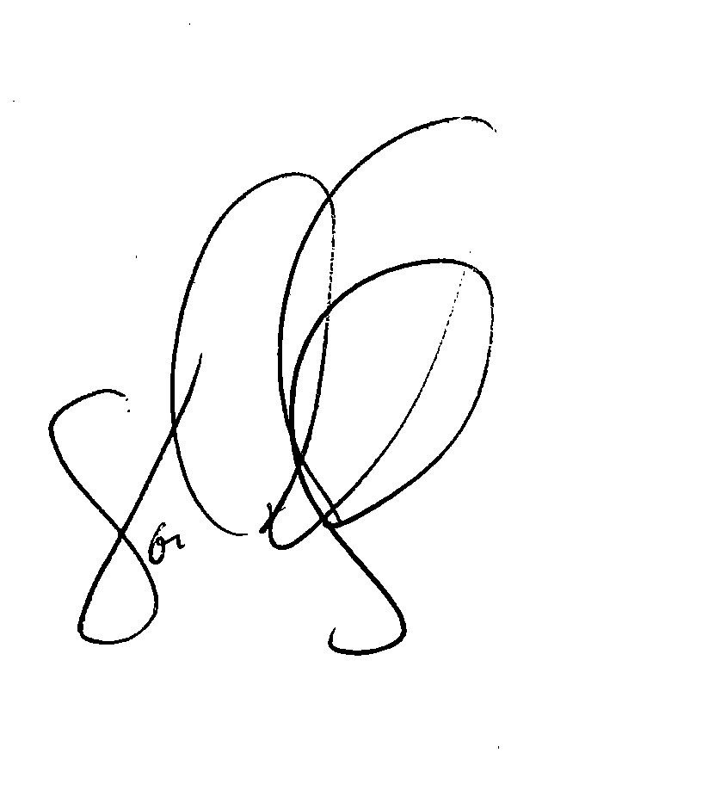
In-school suspension is not seclusion because the student is not isolated from adults and peers.

Time-out is not seclusion. Time out is defined in the regulations as a behavioral intervention in which the student is temporarily removed from a learning activity without being confined.
If an ESI is used with a student, it must be documented, reviewed by school administration, and reported to the Department of Education. School personnel will notify you about the use of ESI on the same day when ESI is used with your child.
Go to our website (kssb.net) and find the ESI policy. Please visit http://ksdetasn.org/ to access the ESI law, guidance documents, webinars, and handouts.
If you are concerned about the use of Emergency Safety Interventions, please call your child's principal or director of instruction. You ultimately have the right to file a formal complaint with the superintendent about your concerns.
Sincerely Yours,

Jon Harding Superintendent

16

