Resources for General Elementary Ed Teachers who Have a
Student with a Visual Impairment in Their Elementary Classrooms
Conducted by: Dr. Tina Herzberg, University of South Carolina Upstate
Dr. L. Penny Rosenblum, University of Arizona

***FREE ***SELF-PACED ***ONLINE

This online training is for elementary teachers in grades 2-6 who have a student with a visual impairment in their classrooms. The training will be open for 6 weeks followed a month later with a survey.

What teachers will be asked to do:

- Complete a short demographic survey
- Take a pre-test
- Complete 10 units each 8-12 minutes on topics related to having a student with a visual impairment in the elementary classroom. Some of the topics include:

- How Do You Use Your Vision?
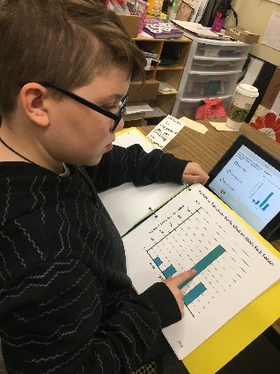
- Understanding the Numbers Behind a Student’s Visual Impairment and the Use of Functional Vision
- What is Braille and How Do Students Read It?
- Who’s on My Student’s Educational Team?
- How Does the Student Use Technology in My Classroom?
- Take a post-test
- Complete 2 activities you select to demonstrate your own learning
- Complete a follow-up survey 1 month after completing the post-test
- Some teachers will be invited to take part in a short interview

Gift Cards: The first 30 teachers completing all activities (other than the interview) will receive a $20 gift card.

Certification of Completion: Teachers who complete the follow-up survey will receive a certificate of completion, regardless of if they are one of the first 30 teachers who complete all activities.

How to Participate in the Study or Get More Information:

- Go to https://uarizona.co1.qualtrics.com/jfe/form/SV_dhyNU7De4nCbz0h and complete the consent form and short demographic survey. Dr. Rosenblum will contact you with additional information on how to access the training if you qualify.
- For more information contact:

Dr. L. Penny Rosenblum Dr. Tina Herzberg
520-621-1223 864-503-5572
rosenblu@email.arizona.edu therzberg@uscupstate.edu

